



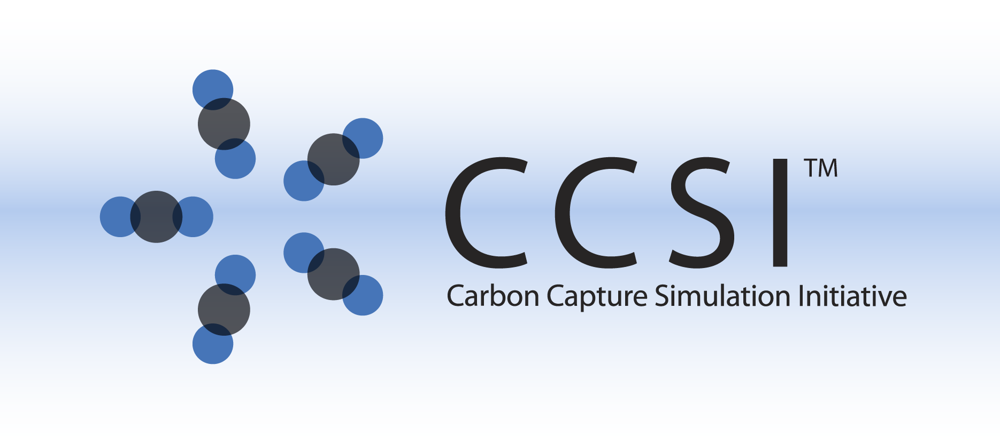

CCSI Process Models

User Manual

Version 2017.10.00

November 2017

This material was produced under the DOE Carbon Capture Simulation Initiative (CCSI), and copyright is held by the software owners: ORISE, LANS, LLNS, LBL, PNNL, CMU, WVU, et al. The software owners and/or the U.S. Government retain ownership of all rights in the CCSI software and the copyright and patents subsisting therein. Any distribution or dissemination is governed under the terms and conditions of the CCSI Test and Evaluation License, CCSI Master Non-Disclosure Agreement, and the CCSI Intellectual Property Management Plan. No rights are granted except as expressly recited in one of the aforementioned agreements.

Table of Contents

CCSI Process Models 1

1.0 Abstract 1

2.0 Reporting Issues 2

3.0 Version Log 2

Solid Sorbent Process Models 3

Bubbling Fluidized Bed (BFB) 3

1.0 Introduction 3

2.0 General Information 3

2.1 Overview 3

2.2 Model Assumptions 4

2.3 Liquid Density of Water 5

3.0 Model Structure 5

3.1 IO Structure and Reactor Dimensions 6

3.2 Run Mode Selectors 6

3.3 Component List and Physical Properties 8

3.4 Pressure Drop 8

3.5 Three-Region Mass and Energy Balances 9

3.6 Hydrodynamics 9

3.7 Heat Exchanger Model 9

4.0 Tutorial 10

4.1 Pre-Solved Cases 10

4.2 Model Inputs 11

4.3 ACM Implementation 16

4.4 gPROMS Implementation 20

5.0 Discretisation Study 26

5.1 Study Conditions 28

5.2 Summary 30

6.0 Changing Reaction Kinetics 31

7.0 Installation Requirements 32

8.0 References 32

BFB-D-ROM 33

1.0 Introduction 33

2.0 Methodology 33

3.0 Test Tutorial 34

3.1 Dynamic Simulation 34

3.2 Comparison of Simulation Cost and Accuracy 37

4.0 References 38

Moving Bed 39

1.0 Introduction 39

2.0 General Information 39

2.1 Overview 39

2.2 Model Assumptions 40

3.0 Model Structure 41

3.1 IO Structure and Reactor Dimensions 41

3.2 Component List and Physical Properties 41

3.3 Mass Balance and Pressure Drop 41

3.4 Energy Balance 42

3.5 Initialization Strategy 43

3.6 Other Features 43

4.0 Tutorial 44

4.1 Steady-State Model 44

4.2 Dynamic Model 48

4.3 Implementation of Model in gPROMS 49

5.0 Installation Requirements 53

6.0 Reference 53

Integrated Solid Sorbent CO2 Capture System Model 54

1.0 Introduction 54

2.0 Integrated Model Structure 54

2.1 IO Structure 54

2.2 Component List and Physical Properties 55

3.0 ACM Integrated Model Tutorial 56

4.0 Implementation of Integrated Model in gPROMS 58

5.0 Installation Requirements 63

6.0 Reference 64

Solvent Process Models 65

MEA Steady State Model 65

1.0 Model Development 65

1.1 Model Background 65

1.2 Physical Property Models 65

1.3 Mass Transfer and Hydraulic Models 66

1.4 Development of Process Model 66

1.5 Model Features 67

2.0 Tutorial 68

2.1 Predicting System VLE 68

2.2 CO2 Capture Process Simulation Base Case Setup 70

2.3 CO2 Capture Process Simulation Example 71

3.0 Usage Information 74

3.1 Environment/Prerequisites 74

3.2 Support 74

4.0 References 74

MEA Dynamic Model 75

1.0 Model Background 75

2.0 General Information 75

2.1 Overview 75

2.2 Thermodynamic Properties Package 76

2.3 Controllers Configuration 77

3.0 Tutorial 78

3.1 Reaching an Initial Steady-State 78

3.2 CO2 Capture Dynamic Response Simulation 82

4.0 Reference 83

2-MPZ Model 84

1.0 Introduction 84

1.1 Predicting CO2 Solubility 84

1.2 Features List 86

2.0 Tutorial 87

2.1 Absorber Simulation 87

2.2 Stripper Simulation 94

3.0 Usage Information 100

3.1 Environment/Prerequisites 100

3.2 Support 100

3.3 Restrictions 100

3.4 Next Steps 100

4.0 Debugging 101

4.1 How to Debug 101

4.2 Known Issues 102

4.3 Reporting Issues 102

5.0 Model History 103

5.1 Thermodynamic Model 103

5.2 Kinetic Model 106

6.0 References 112

Solvent Crossflow Heat Exchanger 113

1.0 Installation Requirements 113

2.0 Introduction 113

2.1 Features List 113

3.0 Tutorial 113

3.1 Setup: Property Sets 114

3.2 Setup: Flowsheet 116

3.3 Setup: Calculator Blocks 117

3.4 Setup: Optimization Block 117

3.5 Running the Simulation 117

4.0 Usage Information 117

4.1 Support 117

4.2 Restrictions 117

4.3 Known Issues 117

5.0 Debugging 118

5.1 How to Debug 118

5.2 Reporting Issues 118

6.0 Model History 119

6.1 Block Descriptions 119

7.0 References 129

Other Process Models 130

Membrane Model 130

1.0 Introduction 130

2.0 General Information 130

2.1 Overview 130

2.2 System/Installation Requirements 131

2.3 Model Assumptions 131

3.0 Model Structure 132

3.1 IO Structure and Reactor Dimensions 132

3.2 Membrane Transport Model 133

3.3 Membrane Module Model 134

3.4 Hollow Fiber Module Properties 135

4.0 Tutorial 136

5.0 References 140

Compressor Model 141

1.0 Introduction 141

2.0 Compressor Stage Calculations 141

2.1 Dimensionless Numbers 142

2.2 Efficiency 143

2.3 Constraints 144

3.0 Multi-Stage Compressors 146

3.1 Integral Gear 146

3.2 Inline 146

4.0 TEG CO2 Drier 147

5.0 Property Methods 148

5.1 Compression 148

5.2 Drying, Aspen Properties 150

6.0 ACM Model 152

6.1 Compressor Stage Calculations 152

6.2 Intercoolers 152

6.3 Multistage Compressor Models 153

6.4 Multistage Flash Model 153

6.5 Integral Gear Compressor with Drier Simulation 154

6.6 Inline Compressor with Drier Simulation 155

7.0 Results 156

7.1 Validation 156

7.2 Results for Typical Feed 157

8.0 Dynamic Simulations 160

8.1 Performance Curves 161

8.2 Surge Line 164

9.0 References 175

List of Figures

Figure 1: BFB reactor model schematic. 3

Figure 2: Three-region structure mass transfer schematic. 9

Figure 3: Classification of the BFB models. 10

Figure 4: Model Forms menu in ACM. 16

Figure 5: Flowsheet LocalVariables in ACM. 17

Figure 6: Changing simulation run mode in ACM. 19

Figure 7: gPROMS explorer and flowsheet model. 20

Figure 8: gPROMS model parameter input. 21

Figure 9: gPROMS flowsheet variable input parameter specification interface. 22

Figure 10: gPROMS “Simulate” window. 24

Figure 11: gPROMS simulation results tree. 25

Figure 12: Dependence of CO2 removal on number of discretization points. 29

Figure 13: Dependence of predicted inlet pressure on number of discretization points. 30

Figure 14: Dynamics of percent CO2 removed for disturbances in flue gas flowrate, temperature, and solid temperature. 35

Figure 15: Dynamics of sorbent loading for disturbances in flue gas flowrate, temperature, and solid temperature. 36

Figure 16: Schematic of the MB reactor. 39

Figure 17: Temperature profile plot. 46

Figure 18: Gas composition profile plot. 47

Figure 19: Exit solid sorbent loading after ramp in solid sorbent flowrate. 48

Figure 20: Specification box for MB model. The process flowsheet model “process_MB” is highlight in the “project tree” menu on the left. 49

Figure 21: Click “Play” (the green button on the top of the toolbar) while the “process_MB Model” window is open to open the “Simulate” window. The “Initialisation Procedure” drop-down menu enables the user the option to run the initialization procedure. Select the “Ignore schedule and intrinsic tasks” check box to run a steady-state model. 50

Figure 22: After a simulation begins, the “Results” folder displays at the end of the “project tree.” Navigate to the “Trajectories” → “Flowsheet” → “MB” → “Variables” folder to examine the results of a successful simulation. 51

Figure 23: Steady-state profile of component solid flow through the reactor. 52

Figure 24: Dynamic profile of physiorbed H2O solid flow through the reactor from a simulated ramp in the inlet solid temperature. 52

Figure 25: Gas flowrate to compressors. 56

Figure 26: Percent CO2 removed from the flue gas during step changes. 57

Figure 27: Power requirement of CO2 compressors during step changes. 57

Figure 28: Specification box for MB model. The process flowsheet model “Integrated_process” is highlighted in the “project tree” menu on the left. 58

Figure 29: Click “Play” (the green arrow on the top toolbar) while the “process_MB Model” window is open to open the “Simulate” window. The “Initialisation Procedure” drop-down menu enables the user the option to run the initialization procedure. Select the “Ignore” option. 59

Figure 30: Data selection window for gRMS template. 60

Figure 31: A plot that results from loading template “stage12.gpt.” This plot shows the dynamic power requirements of the stage 1 and stage 2 compressor. Note: The data will be added as the simulation to continue, therefore the generated plot may contain more or less time series data than is shown here. 61

Figure 32: gPROMS simulation power requirement for CO2 compressors during ramped decrease in flue gas. 62

Figure 33: gPROMS simulation inlet flue gas flowrate and percent CO2 removed. 63

Figure 34: CO2 partial pressure as a function of loading and temperature (30 wt% MEA). 69

Figure 35: Setup of the “FLOW” sensitivity block for the case study. 72

Figure 36: Results of the “FLOW” sensitivity block for the case study. 72

Figure 37: Absorber temperature profile for the case study. 73

Figure 38: Regenerator temperature profile for the case study. 73

Figure 39: Equilibrium model and rate-based model comparison. 76

Figure 40: “LeanSolvent_FC” configuration window. 78

Figure 41: Opening a form. 79

Figure 42: Run options. 80

Figure 43: Lean solvent flowrate behavior during step change to a new steady-state. 80

Figure 44: Lean solvent flowrate behavior during step change to a new steady-state (0.5 h). 81

Figure 45: Lean solvent flowrate into absorber. 82

Figure 46: CO2 capture percentage. 83

Figure 47: CO2 solubility in 8 m 2MPZ. 86

Figure 48: A simple absorber. 87

Figure 49: Excerpt of stream results. 92

Figure 50: Design specification REMOVAL results. 93

Figure 51: Packed column rating results. 93

Figure 52: Stripper simulation flowsheet. 94

Figure 53: Excerpt of stream results. 98

Figure 54: The design specification results. 98

Figure 55: Excerpt from packed column rating results. 99

Figure 56: Thermodynamic heat of absorption of 8 m 2MPZ calculated from Equation 1. 104

Figure 57: Calorimetric heat of absorption of 8 m 2MPZ calculated from Equation 2. 104

Figure 58: The absolute differences between the two heat of absorption calculations, which agree well until a loading of 0.25 mol CO2/mol alkalinity, where the zwitterion becomes significant. 105

Figure 59: WWC process flow diagram for Aspen Plus. 106

Figure 60: Boundary layer discretization. The x-axis is fraction through the boundary layer with the gas-liquid interface at left and the bulk liquid at right. 107

Figure 61: Brønsted plot showing the reaction rate constant (kAm-b) versus the pKa of a base for an amine catalyzed by a base, kAm-base. 108

Figure 62: 8 m 2MPZ kinetic fit. There is a linear bias with temperature. Filled points represent absorption, open points desorption. Dashed lines delineate the target range ±20%. 110

Figure 63: 8 m 2MPZ kinetic fit. Model flux ratioed to experimental flux shows no clear trend with loading. Filled points represent absorption, open points desorption. The dashed lines delineate the target range ±20%. 111

Figure 64: Linked heater blocks. 116

Figure 65: HFGP membrane device model schematic. 130

Figure 66: Asymmetric membrane. 133

Figure 67: PermeateM2 stream results. 140

Figure 68: RetenateM2 stream results. 140

Figure 69: Maximum Mach number estimates. 145

Figure 70: ACM integral gear with drying flowsheet. 147

Figure 71: CO2 saturated water content, Aspen Properties LK-PLOCK. 149

Figure 72: CO2 saturated water content, Aspen Properties HYSGLYCO. 150

Figure 73: CO2 solubility in TEG, Aspen Properties HYSGLYCO. 151

Figure 74: ACM flowsheet for an integral gear compressor with drier. 154

Figure 75: ACM flowsheet for an inline compressor with drier. 155

Figure 76: Dimensionless performance curves for Stage 1. 163

Figure 77: ACM dynamic simulation example: Ramp change in inlet flow rate, pressure plot. 168

Figure 78: ACM dynamic simulation example: Ramp change in inlet flow rate, flow rate plot. 168

Figure 79: ACM dynamic simulation example: Ramp change in inlet flow rate, temperature plot. 169

Figure 80: Dynamic simulation example: Ramp change in inlet flow rate, electric power plot. 169

Figure 81: Specification box for compressor model. The process flowsheet model “CO2_process_flowsheet_full” is highlight in the “project tree” menu on the left. Note: Specifying the required variables is done by double-clicking each piece of process equipment under the “Topology” tab of the “CO2_process_flowsheet_full” window. These values are set to default values. 170

Figure 82: Click “Play” (the green arrow on the top toolbar while the “CO2_process_flowsheet_full Model” window is open). This opens the “Simulate” window. The “Initialisation Procedure” drop-down menu enables the user the option to run the initialization procedure. 171

Figure 83: Data selection window for gRMS template. 172

Figure 84: gPROMS dynamic simulation example: Ramp change in inlet flow rate, pressure plot. 173

Figure 85: gPROMS dynamic simulation example: Ramp change in inlet flow rate, flow rate plot. 173

Figure 86: gPROMS dynamic simulation example: Ramp change in inlet flow rate, temperature plot. 174

Figure 87: gPROMS dynamic simulation example: Ramp change in inlet flow rate, electric plot. 174

List of Tables

Table 1: Device Variables 11

Table 2: Sorbent Parameters 12

Table 3: Gas Inlet Specification 13

Table 4: Heat Exchange Fluid Inlet Specification 13

Table 5: Solid Inlet Specification 13

Table 6: Model Parameters 14

Table 7: Equation Scaling Parameters 15

Table 8: Dynamic Simulation Results 37

Table 9: Regenerator Fixed Device Variables 44

Table 10: Regenerator Fixed Sorbent Variables 44

Table 11: Regenerator Gas Inlet Specification 45

Table 12: Regenerator Heat Exchange Fluid Inlet Specification 45

Table 13: Regenerator Solid Inlet Specification 45

Table 14: Suggested Ranges for Variables in Simulation 67

Table 15: Results of PCO2 Sensitivity Block 69

Table 16: Variables for Base Case Simulation 70

Table 17: Selected Stream Table Results 71

Table 18: List of Flowsheet Controllers 77

Table 19: Excerpt of 2MPZ VLE Results 85

Table 20: Boundary Layer Discretization 90

Table 21: Variables for the LOADINGS Calculator 96

Table 22: The Thunder Moon Chemistry Block 103

Table 23: Reaction Set for 2MPZ with Forward Reactions above the Rule 109

Table 24: Diffusivity Parameter Values 109

Table 25: EXPROP Results 114

Table 26: Property Sets 115

Table 27: C-HX Results 116

Table 28: C-HX Variable Definitions 119

Table 29: C-HX Variable Description 121

Table 30: Hollow Fiber Module Properties 135

Table 31: M1 Device Variables 137

Table 32: M1 Gas Feed Specification 138

Table 33: M2 Device Variables 139

Table 34: Gas Sweep Specification 139

Table 35: Maximum Stage Mach Numbers 144

Table 36: Comparison of Property Methods 148

Table 37: Compressor Specifications 156

Table 38: Comparison of Simulations to Compressor Quotes 157

Table 39: Solid Sorbent Capture, CO2 Stream Conditions 157

Table 40: Compressor Comparison Summary 158

Table 41: Integral Gear Compressor Stage Summary 158

Table 42: Inline Compressor Stage Summary 159

Table 43: Estimated Parameters for Stage 1 162

Table 44: Estimated Parameters for Correlation 21 163

Table 45: Estimated Parameters for Stages 3, 5, and 7 164

To obtain support for the products within this package, please send an e-mail to   
[ccsi-support@acceleratecarboncapture.org](mailto:ccsi-support@acceleratecarboncapture.org).

CCSI Process Models

1. Abstract

A suite of process models implemented in both Aspen Custom Modeler and gPROMS Model Builder, as well as models implemented within Aspen Plus® and Aspen Plus Dynamics. The specific types of models include:

* Solvent Crossflow Heat Exchanger Calculator: A Process model in Aspen Plus to optimize the size of the heat exchangers and their log-mean temperature difference (LMTD) to minimize capital and operating expenses.
* Bubbling Fluidized Bed Reactor Model: A unified set of BFB models for various configurations in both steady-state and dynamic versions. This one-dimensional PDE process model is flexible, modular, and computationally efficient. It is suitable for process synthesis and design tasks aimed to facilitate the rapid screening of new concepts and technologies for carbon capture.
* Moving Bed Reactor Model: A solid sorbent moving bed reactor model that is used to simulate an adsorber or a regenerator for a carbon capture process. This one-dimensional partial differential equation (PDE) based process model is a flexible, modular process model of carbon capture equipment that can be used to facilitate the rapid screening of new concepts and technologies.
* Multi-stage Centrifugal Compressor Model: A unified set of compressor models including steady-state design point model and dynamic model with surge detection.
* Membrane Separation Model: A Hollow Fiber Gas Permeation (HFGP) membrane model to simulate membrane stage units in carbon capture processes. This one-dimensional PDE process model is flexible, modular, and computationally efficient. It is suitable for process synthesis and design tasks aimed to facilitate the rapid screening of new concepts and technologies for carbon capture.
* 2MPZ Aspen Plus Process Model: This is an Aspen Plus absorption/stripping model for CO2 capture from natural gas or coal-fired power plants using the solvent 8 molal 2-methylpiperazine (2MPZ). This model can be used for techno-economic assessments, pilot plant data reconciliation, and process design. The solvent has greater oxidative stability than MEA, is thermally stable up to 151°C, has a greater viscosity-normalized capacity (0.89 mol CO2/kg solvent vs 0.62 mol CO2/kg solvent), and has 37% faster mass transfer than 7 molal MEA. The solvent suffers from higher cost than MEA, five-times higher viscosity, and solid precipitation at very low CO2 loading. The model was constructed using sequential regression of bench-scale experimental thermodynamic and mass transfer data. The thermodynamics are modeled using the asymmetric eNRTL model to fit CO2 solubility data. A custom flowsheet simulates the   
  wetted-wall column used for mass-transfer data collection. The diffusion of amine and kinetic rate constants were regressed to match the experimental CO2 flux data. Activity-based kinetics were used to account for the high non-ideality of the system.

1. Reporting Issues

To report an issue, please send an e-mail to [ccsi-support@acceleratecarboncapture.org](mailto:ccsi-support@acceleratecarboncapture.org).

1. Version Log

| Product | Version Number | Release Date | Description |
| --- | --- | --- | --- |
| **CCSI Process Models** | **2015.10.00** | **11/20/2015** | **2015 November IAB Release** |
| Bubbling Fluidized Bed Reactor Models | 2015.10.0 | 10/31/2015 | 2015 October IAB Release |
| CO2 Compressor Simulation | 2015.10.0 | 10/31/2015 | Bug fixes and added gPROMS model |
| Dynamic MEA Model | 2015.10.0 | 10/31/2015 |  |
| Integrated Solid Sorbent CO2 Capture Process | 2015.10.0 | 10/31/2015 | Initial release. |
| Dynamic Reduced Order Models for Bubbling Fluidized Bed Adsorber Model | 2015.10.0 | 10/16/2015 | 2015 October IAB Release – This version includes two dynamic reduced order models for the bubbling fluidized bed adsorber model, with minor changes in the model equations. |
| Steady State MEA Model | 2015.10.0 | 10/16/2015 |  |
| Moving Bed Reactor | 2015.10.0 | 10/10/2015 | Minor bug fixes, increased robustness with dynamic simulation. |
| Bubbling Fluidized Bed Reactor Models | 2015.6.0 | 07/07/2015 | 2015 June IAB Release |
| Hollow Fiber Gas Permeation Membrane Model | 2015.06.0 | 06/30/2015 | 2015 June IAB Release – The manual was updated to reflect modelling of pressure drop in the shell side of membrane model. The results shown in this manual have been generated using ACM V8.4 and Aspen Properties V8.4. |
| Solvent Cross Flow HX | 2015.03.00 | 03/31/2015 | Initial release. |
| 2MPZ CO2 Capture Simulation | 2014.10.0 | 10/31/2014 | 2014 October IAB Release – The Aspen Plus® model is now built in V8.4. |
| Bubbling Fluidized Bed Reactor Models | 2014.10.0 | 10/31/2014 | 2014 October IAB Release – First Revision |
| CO2 Compressor Simulation | 2014.10.0 | 10/31/2014 | Previous ACM model has now been upgraded to Aspen V8.4. |
| Moving Bed Reactor | 2014.10.0 | 10/31/2014 | Earlier ACM model has been revised to correct inconsistencies in the thermal model. The gPROMS version is being released for the first time. |
| 2MPZ CO2 Capture Simulation | 2013.10.0 | 10/10/2013 | Initial release. |

Solid Sorbent Process Models

Bubbling Fluidized Bed (BFB)

1. Introduction

This documentation introduces the steady-state solid sorbent Bubbling Fluidized Bed (BFB) Reactor Model that has been developed within the Carbon Capture Simulation Initiative (CCSI) to simulate the solid sorbent adsorption and regeneration units in carbon capture processes. This one-dimensional partial differential equation (PDE) process model is flexible, modular, and computationally efficient. The model is suitable for process synthesis and design tasks aimed to facilitate the rapid screening of new concepts and technologies for carbon capture. To run BFB simulations, AspenTech® 8.4 and gPROMS® (Process Systems Enterprise Limited) ModelBuilder 4.0 need to be installed on either Windows® or Linux® systems.

1. General Information
   1. Overview

A fluidized bed reactor is characterized by a bed of solid particles that move freely due to the drag force exerted by a working fluid. This reactor model is specifically applicable to the bubbling fluidization regime for a reactive solid-gas contacting fluidized bed device. In this regime the gas flow is large enough to maintain fluidization conditions in the bed of solid particles while forming distinct gas bubbles that travel across the bed. To describe this complex multi-phase behavior, the hydrodynamics and reactivity are defined within a one-dimensional, multi-region model structure. Figure 1 below shows a schematic of a BFB reactor with overflow solids outlet.

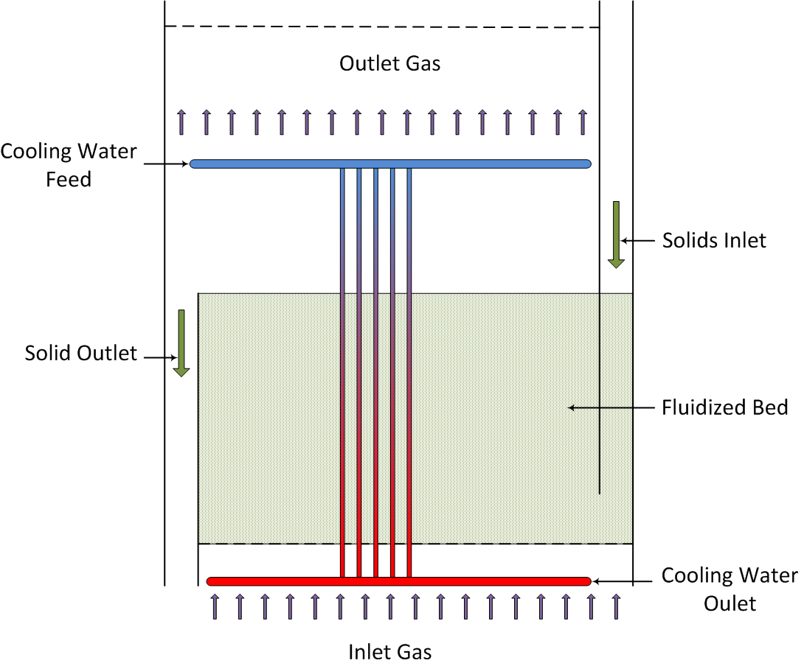

Figure : BFB reactor model schematic.

* 1. Model Assumptions

This first-of-a-kind implementation is the most comprehensive attempt to simulate BFB reactors to date that is not based on multi-dimensional, computationally expensive high fidelity approaches (i.e., computational fluid dynamics (CFD)). Therefore, many correlations are required to describe the governing transport phenomena and hydrodynamics. The main assumptions of the model are listed below:

* Constant bed depth
* Vertical shell and tubes type reactor
* Shell-side: Reactive gas and solid fluidized bed
* Tube-side: Heat exchanging medium
* Radial effects in the vessel are neglected
* Potential effects of reactions in the vessel freeboard are neglected
* BFB reactor is represented by a system of one-dimensional PDEs and algebraic expressions defined in the axial direction corresponding to the depth of the bed
* Three-region multi-phase structure with mass and energy transfer between regions
* Emulsion region: Gas and solid phases
* Cloud-wake region: Gas and solid phases
* Gas bubble region: Only gas, no solids present
* Properties and state variables are constant at each region for each slice of the discretized axial domain
* Pressure drop is characterized by the weight of the bed of solids
* Reaction rates in the solid phase are dictated by a kinetic model developed for   
  amine-impregnated mesoporous sorbents [1]
* Uniform solids temperature (no temperature profile within particles)
* Effects of particle attrition are ignored
* Applicable to steady-state operation, all time-dependent terms are set to zero
* Negligible variance in gas phase heat capacity between regions within the same slice of the discretized axial domain
* Only gas-phase mole fractions and temperatures have a significant time variant term in dynamic mass and energy balances

For a comprehensive description of the model equations please refer to the article by Lee and Miller [2].

* 1. Liquid Density of Water

In the Aspen Custom Modeler® (ACM, Aspen Technology, Inc.) implementation of the model, the   
Peng-Robinson equation of state with the Boston-Matthias alpha function is used for physical property calls. It has been determined that this equation of state gives incorrect values for the density of liquid water, which is used in the in-bed heat exchangers. To maintain consistency with previous versions of the models, the property calls for the liquid density of the heat exchanger fluid have been replaced with a hard coded correlation for the liquid density of water as a function of temperature. For users who wish to use a different heat exchanger fluid, these correlations will need to be replaced with either calls to a physical property package or a suitable correlation. This only affects the ACM implementation, and not the gPROMS implementation.

1. Model Structure

The developed model was implemented in both ACM and gPROMS and all partial-differential equations are solved using method of lines. The spatial domain has been discretized using a 1st order backward finite difference method with the option to choose between uniform, two stage and adaptive discretization schemes and 74 elements are used as a default. A study of the alternative discretization schemes and the dependence of the results upon the number of discretization points used is presented in Section 5.0 Discretisation Style. The ACM and gPROMS files include newly-defined parameter, port, and variable types that complement the reactor model.

In ACM, the code for the model equations can be found in the Custom Modeling library:

1. In the “All Items” pane of the “Explorer – Simulation” window, locate the “Custom Modeling library” and then expand the window to view the contents.
2. Expand the “Models” sub-folder and then click “BFB.”
3. In the “Contents” pane, located below the “All Items” pane, double-click “BFB” to view the model code.

In gPROMS, the code for the model equations can be found in the Models library:

1. In the “Projects” pane on the left side, select the current model and then expand the model to view all of the contents.
2. Expand the “Models” sub-folder and then double-click “BFB.” A window for the “BFB Model” displays.
3. At the bottom of the “BFB Model” window, click the “gPROMS language” tab to view the model code.
   1. IO Structure and Reactor Dimensions

This reactor model contains several input and output ports. Each port has associated variables that correspond to the material connection stream variables.

In ACM, the inlet and outlet ports for gas and heat exchanging fluid are defined using the default “MainPort” port type; Solid inlet and outlet ports are defined by the tailored port type “SorbentPort” which is defined by the mass flowrate, temperature, and loading of each adsorbed species.

In gPROMS, all port types are specified and tailored by users; Gas inlet and outlet ports are defined by the port type “GasPort” which is defined by the molar flowrate, temperature, pressure, and molar fraction of each gas species; Heat exchanging fluid inlet and outlet ports are defined by the port type “HXPort” which is defined by the molar flowrate, temperature, pressure, molar specific enthalpy, and molar fraction of each fluid species; Solid inlet and outlet ports are defined by the port type “SorbentPort” which is defined by the mass flowrate, temperature, pressure, and loading of each adsorbed species.

Given the equation oriented nature of this implementation, this model can be used to perform either rating or design calculations as long as the corresponding variables are specified as fixed to satisfy the degrees of freedom required for the solution.

* 1. Run Mode Selectors

The BFB model includes five Run Mode selectors which allow the user to modify the complexity of the model to suit their purposes. These selectors generally provide a trade-off between accuracy and complexity and give the user the ability to simplify sections of the model to improve the performance and reliability of the model if necessary. Each of the available Run Mode selectors are discussed below.

RM_Discretization

This Run Mode selector allows the user to select between three different discretization schemes for the axial domain (more details are available in Section 5.0 Discretisation Style). The options available are:

* *Uniform* – all discretized slices have the same length. This is the simplest discretization scheme but also the least accurate.
* *2 Stage* – the domain is divided into two sections with different discretization lengths in each section. This allows the user to have a greater number of discretization points in the part of the domain where derivatives are greatest (generally the lower portion of the bed), improving accuracy whilst reducing the number of discretization points in the remainder of the domain. Properly configured, this method provides a significant improvement in accuracy for a very small increase in complexity.
* *Adaptive* – the length of each discretized slice is inversely proportional to the spatial derivative of CO2 in the bubble region gas phase. This automatically increases the number of discrete points in regions where derivatives are greatest, improving the accuracy of the model. However, the length of each discrete slice must now be solved as part of the model increasing the complexity of the model.

RM_HXMethod

This Run Mode selector allows the user to specify the specific heat exchanger fluid used in the internal heat exchangers and the method used to calculate the relevant physical properties of the fluid. Currently the model includes four options. **Note:** The “Condensing” option calculates the required flowrate of HX fluid whilst the other options require the flowrate as an input.

* *Rigorous* – this option provides a general solution for the heat exchanger fluid using flash calculations performed by the inbuilt properties package. This combination allows for any HX fluid specified in the “hexlist” component list and allows for phase changes in the fluid. However, this option makes extensive use of the physical properties package, which increase computational overhead. **Note:** In the ACM implementation, the liquid density of the heat exchanger fluid is calculated using a correlation for liquid water rather than a property call, as discussed in Section 2.3 Liquid Density of Water.
* *Condensing* – this option assumes that the HX fluid is initial in the vapor phase and that all the heat provided to the fluidized bed is due to condensation of the fluid. The fluid is assumed to remain at the saturation temperature determined at the inlet pressure of the fluid (changes in pressure are neglected) throughout the heat exchanger tubes and to leave the system as saturated liquid (100% condensation). Physical property calls are required only at the inlet and outlet, which reduces the computational overhead. **Note:** This option is unique in that the flowrate of HX fluid is calculated based on the assumption of 100% condensation, whereas all other options require the flowrate to be specified. If this is not corrected the model will not solve, with ACM reporting that the model is over-specified, and gPROMS reporting that the model is not well posed.
* *Liquid* – the HX fluid is assumed to be in the liquid state and that no vaporization of the fluid will occur. Physical properties are calculated using the internal physical properties package, thus this method can be used for any HX fluid specified in the “hexlist”component list, as long as vaporization does not occur. This optional allows the use of simpler enthalpy calculations in place of the more complex flash calculations required by the Rigorous method. **Note:** In the ACM implementation, the liquid density of the heat exchanger fluid is calculated using a correlation for liquid water rather than a property call, as discussed in Section 2.3 Liquid Density of Water.
* *Water* – similar to the *Liquid* option, however the physical properties are calculated using algebraic correlations specific for pure water. This reduces computational overhead by not invoking the physical properties package, and provides analytical derivatives for the properties which can improve performance.

RM_MBalance

This Run Mode selector allows users performing steam-state simulations to use a simpler and more flexible expression in place (*Simplified* mode) of the rigorous bubble region total gas balance (*Rigorous* mode). This is not applicable for dynamic simulations as this formulation leaves the temporal derivative of the bubble region total gas phase concentration undefined.

RM_PhysProp

This Run Mode selector allows the user to elect to use either the in-built physical properties package (*Rigorous* mode) or a set of algebraic correlations (*Simplified* mode) to calculate a number of physical properties within the model. Utilizing *Rigorous* mode provides the most accurate result, however the *Simplified* mode has the advantages of reduced computational overhead and providing analytical derivatives for the physical properties which should improve performance and reliability.

RM_SmoothIF

This Run Mode selector provides the user with the option to replace a number of IF statements within the model with Smoothed Maximum approximations. The Smoothed Maximum approximation has the advantages of removing discontinuities and structural changes within the model, which improves performance and reliability and reduces run times, but also introduces some error into the system, especially at conditions close to the switching point of the IF statement. The smoothness and accuracy of the Smoothed Maximum approximation can be controlled through the “SmoothIF_eps” variable, with larger values increasing smoothness at the cost of greater error (Default Value = 1x10-4).

* 1. Component List and Physical Properties

Three gaseous species, carbon dioxide (CO2), water (H2O), and nitrogen (N2) are used in the gas phase. Three species, bicarbonate (Bic), carbamate (Car), and physisorbed water (H2O) are assumed to exist in the solid phase, adsorbed onto the sorbent. The mechanism of the adsorption of the adsorbate, CO2 and H2O, onto an amine-impregnated mesoporous sorbent is defined according to Lee et al., 2011.

Physical properties of the fluids can be calculated using commercial property packages (Aspen Properties® in ACM and Multiflash® in gPROMS) using cubic equations of state. The sorbent properties should be specified by the user. Particle diameter, density, sphericity, minimum fluidization voidage, heat capacity, and heat conductivity are essential. Additionally, a fines fraction can be specified but has limited effect on the model results.

* 1. Pressure Drop

The pressure drop is attributed to the weight of the solid bed. All other potential contributions are assumed to be negligible in comparison. It has been assumed that the pressure drop across the distributor plate located at the gas inlet (the bottom boundary of the discretized axial domain) is equal to the greater of 20% of the pressure drop across the bed or 0.034 bar.

* 1. Three-Region Mass and Energy Balances

In a BFB, the bulk of solids within the bed exist in a dense, fluidized emulsion region. At the bottom of the bed, gas bubbles are formed as the inlet gas crosses the distributor plate. These bubbles rise upwards through the bed carrying with them a surrounding cloud and a wake of gas and solids. Figure 2 shows a diagram for the gas and solid material balances as defined in this model for a differential slice *i* of the bed depth domain.



Figure : Three-region structure mass transfer schematic.

The axial mass and energy fluxes are defined by the plug flow of material for each region. At each differential axial slice, mass balance equations were defined for each phase (gas and solid) and region (bubble, cloud-wake, and emulsion) according to Figure 2 above. In an equivalent fashion, energy balances were defined accounting for the heat transfer provided by the internal heat exchange tubes. For the purposes of mass and energy balances the reaction between gas and solids is assumed to take place in the solid phase, such that the reaction conditions are those of the solids and any heat of reaction is applied to this phase.

* 1. Hydrodynamics

The performance of the BFB reactor is characterized by the size and velocity of the rising bubbles. This model implementation includes detailed correlations for these parameters as a function of bed depth for different types of particles.

* 1. Heat Exchanger Model

The model includes equations to predict the transfer of heat between the fluidized bed of solids and a set of heat exchanger tubes immersed within the bed. The current model contains equations for a single pass of the heat exchanger fluids with the fluid inside the immersed heat exchange tubes traveling in the opposite direction to the gas bubbles. The heat transfer model considers heat exchange between the gas and solids in the bed and the tubes.

1. Tutorial

This section provides detailed tutorials to simulate the performance of adsorber and regenerator units using the BFB model. These tutorials were developed using ACM v8.4 with Aspen Properties and gPROMS v4.0.0 with Multiflash v4.3 – modifications could be required when using different versions.

* 1. Pre-Solved Cases

Due to the complexity of the BFB model, it can often be difficult to achieve an initial solution for the model from a blank state. Thus, a number of pre-solved cases have been prepared to provide a starting point for users in developing models of their systems. Pre-solved cases have been prepared using both ACM and gPROMS for both single beds and two beds in series, with cases for adsorption and regeneration, as well as both overflow and underflow outlets. The directory structure used to store the   
pre-solved cases is shown below in Figure 3.

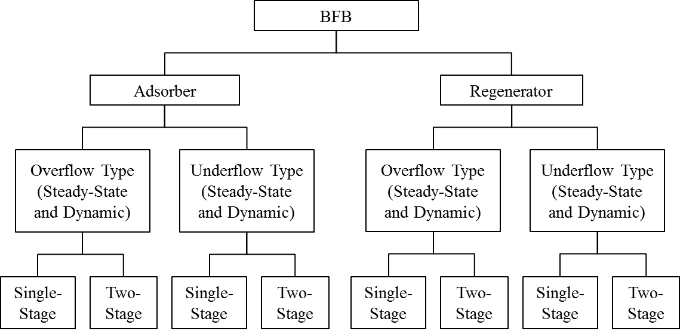

Figure : Classification of the BFB models.

* 1. Model Inputs

The BFB model has a number of input parameters that describe the system that the user needs to provide to obtain a meaningful result. These parameters can be divided into five categories; Device, Sorbent, Stream, Model, and Equation Scaling. A list of model input parameters is given below, along with a default value used in preparing the model.

Device Parameters

Device parameters describe the size and configuration of the reactor, and should be adjusted to match the system to be studied.

Table : Device Variables

| Parameter | Adsorber | Regenerator | Description |
| --- | --- | --- | --- |
| dPhx | 0.01 | 0.01 | Heat Exchanger Tube Pressure Drop (bar/m) |
| Dt | 12.8 | 9.6 | BFB Unit Diameter (m) |
| dx | 0.05 | 0.075 | Heat Exchanger Tube Diameter (m) |
| Lb | 1.2 | 3.6 | Bed Depth (m) |
| lhx | 0.04 | 0.04 | Heat Exchange Tube Spacing (m) |
| nor | 2,500 | 2,500 | Number of Orifices in Distributor Plate (1/m2) |
| SIType | Top/Bottom | | Solid Inlet Type (Top or Bottom) |
| SOType | Overflow/Underflow | | Solid Outlet Type (Overflow or Underflow) |
| wthx | 0.003 | 0.003 | Heat Exchanger Tube Wall Thickness (m) |

Sorbent Parameters

Sorbent parameters describe the characteristics of the solid sorbent to be used in the reactor, and include both the physical properties of the solids (e.g., particle size and density) and parameters describing the adsorption kinetics and equilibrium.

Table : Sorbent Parameters

| Parameter | Value | Description |
| --- | --- | --- |
| A1 | 0.17583 | Arrhenius Constant for Water Physisorption (mol/m3/Pa/K/s) |
| A2 | 0.091098 | Arrhenius Constant for Bicarbonate Formation (1/Pa/K/s) |
| A3 | 141.994 | Arrhenius Constant for Carbamate Formation (1/Pam1/K/s) |
| dH1 | -72,580.3 | Heat of Reaction for Water Physisorption (J/mol) |
| dH2 | -77,079.0 | Heat of Reaction for Bicarbonate Formation (J/mol) |
| dH3 | -109,691 | Heat of Reaction for Carbamate Formation (J/mol) |
| dS1 | -141.425 | Reaction Entropy for Water Physisorption (J/mol/K) |
| dS2 | -216.244 | Reaction Entropy for Bicarbonate Formation (J/mol/K) |
| dS3 | -281.255 | Reaction Entropy for Carbamate Formation (J/mol/K) |
| E1 | 29,622.8 | Activation Energy for Water Physisorption (J/mol) |
| E2 | 83,173.5 | Activation Energy for Bicarbonate Formation (J/mol) |
| E3 | 27,522.3 | Activation Energy for Carbamate Formation (J/mol) |
| M3 | 1.00 | Non-Ideality Exponent for Carbamate Formation Reaction |
| nv | 1,900.46 | Amine Loading of Sorbent (mol/m3) |
| cps | 1.13 | Particle Heat Capacity (kJ/kg/K) |
| dp | 1.5x10-4 | Particle Diameter (m) |
| emf | 0.5 | Bed Voidage at Minimum Fluidization Velocity |
| F | 0 | Fines Fraction (<45 micron) of Solids |
| kp | 1.36 | Particle Conductivity (J/m/K/s) |
| phis | 1.0 | Particle Sphericity |
| rhos | 442 | Particle Density (kg/m3) |

Stream Parameters

Stream parameters describe the conditions of the streams entering (or occasionally exiting) the reactor. There are three pairs of streams in the model; the gas inlet and outlet, the solid inlet and outlet, and the heat exchanger fluid inlet and outlet. In general, all the inlet conditions should be specified in the model, however it is possible in some cases to specify outlet conditions in place of the relevant inlet conditions.

In the presolved cases, inlet flowrates of gas and solids are determined by valves with specified valve coefficients. These valve coefficients were determined to meet nominal inlet flowrates of gas and solids, which are given in Tables 3–5 below.

Table : Gas Inlet Specification

| Parameter | Adsorber | Regenerator | Units |
| --- | --- | --- | --- |
| Flowrate* | 15,203.1 | 1,284 | kmol/hr |
| Pressure | 1.8 | 2.0 | bar |
| Temperature | 51.0 | 146.7 | °C |
| CO2 Mole Fraction | 0.130 | 0.787 |  |
| H2O Mole Fraction | 0.055 | 0.213 |  |
| N2 Mole Fraction | 0.815 | 1.0x10-3 |  |

Table : Heat Exchange Fluid Inlet Specification

| Parameter | Adsorber | Regenerator | Units |
| --- | --- | --- | --- |
| Flowrate | 98,000 | 6,835 | kmol/hr |
| Pressure | 1.12 | 6.9 | bar |
| Temperature | 33 | 170 | °C |
| CO2 Mole Fraction | 0 | 0 |  |
| H2O Mole Fraction | 1 | 1 |  |
| N2 Mole Fraction | 0 | 0 |  |

Table : Solid Inlet Specification

| Parameter | Adsorber | Regenerator | Units |
| --- | --- | --- | --- |
| Flowrate* | 1,240,000 | 1,850,000 | kg/hr |
| Pressure | 1.5 | 1.5 | bar |
| Temperature | 64 | 145 | °C |
| Bicarbonate Loading | 7.6x10-4 | 7.6x10-4 | mol/kg sorbent |
| Carbamate Loading | 0.557 | 1.995 | mol/kg sorbent |
| Water Loading | 0.012 | 0.401 | mol/kg sorbent |

**\*** = Nominal flowrate

Model Parameters

Model parameters include a number of parameters associated with the model, including empirical parameters used in correlations within the model, as well as parameters associated with the discretization of the model. Users should be cautious of changing these parameters without reason, as they have been assigned values based on experimental studies and can have a significant effect on the behavior of the model.

Table : Model Parameters

| Parameter | Value | Description |
| --- | --- | --- |
| ah | 0.8 | Empirical Factor in Heat Transfer Model |
| Cr | 1.0 | Correction Factor for Heat Exchanger |
| Disc_Adpt_Wgt | 1400 | Adaptive Discretization Weighting Factor |
| Disc_Split_Frac | 0.51 | 2-Stage Discretization Split Fraction |
| Disc_Split_Loc | 0.22 | 2-Stage Discretization Split Location |
| fw | 0.2 | Wake to Bubble Regions Volume Ratio |
| hw | 1.5 | Heat Exchanger Tube Wall Heat Transfer Coefficient (kJ/m2/K/s) |
| Kd | 100 | Gas Phase Bulk Flow Coefficient (m3/s) |
| ND | 102 | Number of Discretization Points |
| SmoothIF_eps | 1x10-4 | Smoothing parameter for Smooth Maximum approximation |
| Tref | 0 | Thermodynamic Reference Temperature (°C) |

Equation Scaling Parameters

Due to the need to specify fixed tolerances for the numerical solvers, equations involving very large or very small values can be difficult to accurately solve. To improve the accuracy and reliability of the model, scaling parameters have been added to key equations in the model to keep equation terms as close to order of magnitude 1 as possible. Due to variability in parameters associated with kinetic reactions it is often necessary to adjust the values of these scaling factors, thus the following parameters have been made available for users to adjust if necessary. In general, the value of the scaling parameters should be set such that the scaled variable (variable multiplied by its scaling factor) is as close to order of magnitude 1 across the full range of the model as is possible. If users are having problems with model convergence, and in the absence of better information, it is suggested that these parameters be set to “1.”

Table : Equation Scaling Parameters

| Parameter | Adsorber | Regenerator | Description |
| --- | --- | --- | --- |
| k1sf | 1,000 | 1,000 | Rate constant 1 scaling factor |
| k2sf | 1x1011 | 1x1010 | Rate constant 2 scaling factor |
| k3sf | 1 | 1 | Rate constant 3 scaling factor |
| Ke1sf | 100 | 1,000 | Equilibrium constant 1 scaling factor |
| Ke2sf | 100,000 | 1x106 | Equilibrium constant 2 scaling factor |
| Ke3sf | 10,000 | 100,000 | Equilibrium constant 3 scaling factor |
| r1csf | 1 | 10 | Cloud-Wake reaction 1 rate scaling factor |
| r1esf | 100 | 10 | Emulsion reaction 1 rate scaling factor |
| r2csf | 1x106 | 1,000 | Cloud-Wake reaction 2 rate scaling factor |
| r2esf | 1x106 | 1,000 | Emulsion reaction 2 rate scaling factor |
| r3csf | 1,000 | 10,000 | Cloud-Wake reaction 3 rate scaling factor |
| r3esf | 100,000 | 100,000 | Emulsion reaction 3 rate scaling factor |

* 1. ACM Implementation

Accessing Model Inputs

Most model inputs can be accessed via forms associated with the model instances within the ACM flowsheet. Right-clicking a model within the “Process Flowsheet Window” brings up a drop-down menu of options for that model. Selecting the “Forms” option brings up a menu of predefined forms for the model which includes a number of forms for entering inputs and examining results, as show in Figure 4.

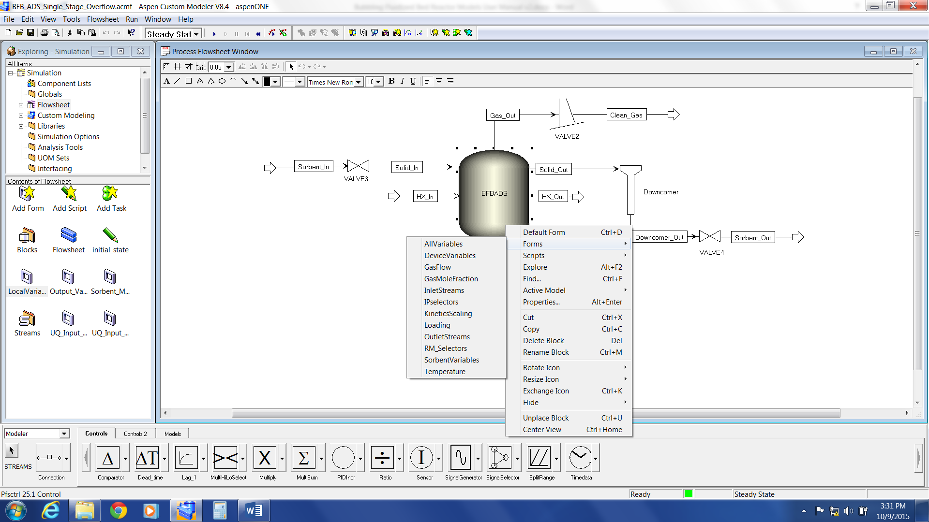

Figure : Model Forms menu in ACM.

For the BFB reactor model, the following forms contain model inputs:

1. *DeviceVariables* – contains all Device Parameters, plus a number of calculated variables relating to the design of the reactor
2. *InletStreams* – contains all Stream Parameters
3. *KineticsScaling* – contains all Equation Scaling Parameters
4. *RM_Selectors* – contains model Run Mode Selectors
5. *SorbentVariables* – contains all Sorbent Parameters, plus some calculated variables concerning particle behavior

In the presolved cases, especially the two bed examples, some parameters are specified at the overall flowsheet level to ensure they are the same in all models. To access these parameters, navigate to the “Exploring” pane, click “Flowsheet,” and then double-click “LocalVariables” in the “Contents” pane, as shown in Figure 5.

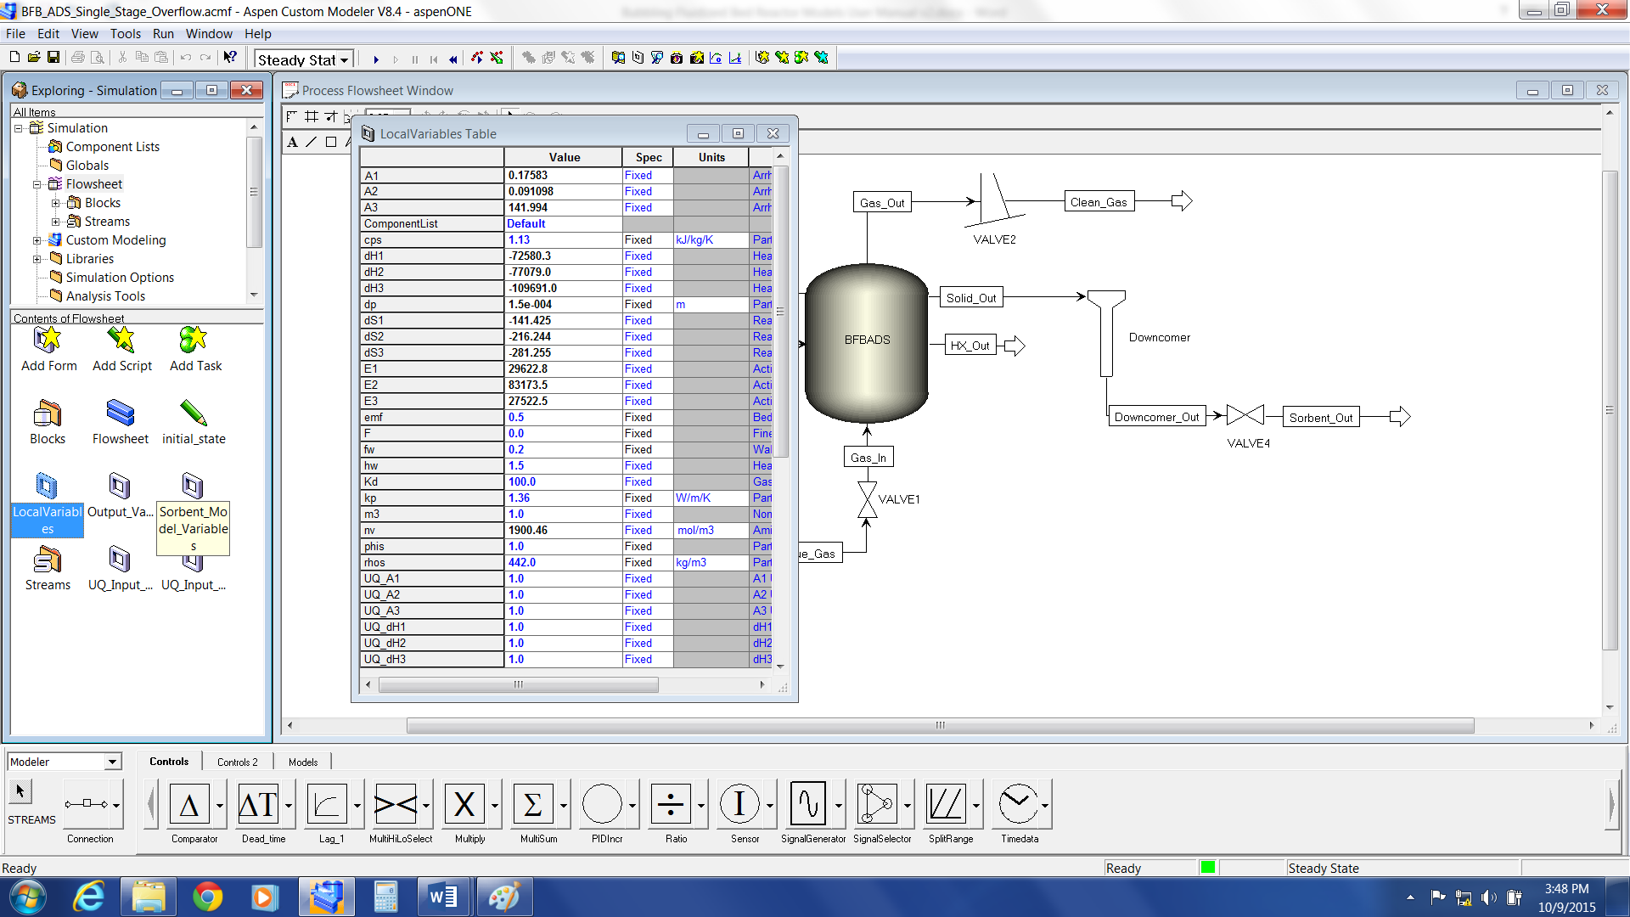

Figure : Flowsheet LocalVariables in ACM.

Any entry described as “Fixed” (the third column of the form) is a model input that can be varied. To enter a new value for a parameter, select the current value of the parameter and then enter the new value.

Parameter and variable values for models and streams can also be accessed by double-clicking the desired model or stream in the “Flowsheet” pane, which opens a default form for that model or stream.

Model Initialization

Due to the complexity of the model equations, it is necessary to initialize the model to successfully obtain a solution. The presolved cases have already been initialized and can be used as a starting point for further simulations. It is recommended to start from one of these simulations when developing cases, as it can be difficult to initialize the model from its default state. Additional reactors can be added by copying an existing model within the flowsheet which will be initialized with the current state of that model.

In cases where it is not possible to use an existing, preinitialized model, the BFB model comes with two initialization scripts to initialize the model from its default state. These work by starting with a simplified form of the model and gradually adding complexity until the full model is solved. Due to differences in the behavior of the model under adsorption and regeneration conditions, there are initialization scripts for both conditions, which differ in the order in which complexity is added.

It is also important to note that the initialization can be extremely sensitive to the operating conditions being used, and that it may be necessary to adjust the initialization procedures in these cases. This requires an understanding of ACM scripting in addition to the model code, and the user is directed to the ACM User Manuals for more information on this topic. It is for this reason that it is recommended to work from a solved case of the model wherever possible.

To access the initialization scripts, right-click the model to be initialized in the “Flowsheet” pane and then select “Scripts” from the drop-down menu. Left-click either “IPsolveADS” (for adsorption conditions) or “IPsolveRGN” (for regeneration conditions) and the script initializes that model. **Note:** This requires solving the model multiple times, and may take a number of minutes to complete.

To improve the chances of successfully initializing the model, it is suggested to use Run Mode Selectors to simplify the model prior to initializations. The suggested settings are:

* *RM_HXMethod* – either *Condensing* or *Liquid* depending on the state of the HX fluid. **Note:** When using *Condensing* the flowrate of the HX fluid must be set to a free variable by   
  double-clicking the “HX Fluid Inlet” stream and then setting “F” to a free variable.
* RM_MBalance – Simplified
* RM_PhysProp – Simplified
* RM_SmoothIF – On

Once the model has been successfully initialized, the Run Mode Selectors can be returned to the user’s desired settings. If the user is still having difficulty initializing the model, check the Equation Scaling Parameters and set them all to “1.”

Running Simulations

In ACM, the run mode of a simulation can be changed via the drop-down list in the menu bar above the “Flowsheet” pane, as shown in Figure 6. If the model is properly specified and all degrees of freedom are met, then a green square displays in the lower right of the program window and the “Run Simulation” button (the blue arrow immediately to the right of the simulation mode drop-down menu) is available. Clicking the blue arrow runs the simulation using the current simulation mode, and on completion, a   
pop-up box displays with a message about whether the simulation converged or not.

For dynamic simulations, it is also necessary to specify a simulation duration and any scheduled events that are to occur during the simulation. Simulation duration, as well as time steps and reporting intervals, can be changed through the “Run Options” button in the menu bar (). Scheduled events can be setup by creating “Tasks” under the “Flowsheets” tab in the “Exploring” pane. A number of simple example tasks, consisting of ramp changes in input conditions, have been provided in the presolved examples. To activate or deactivate a task, double-click the relevant “Task” icon in the “Contents” pane – a “lightning bolt” icon indicates that a task is active.

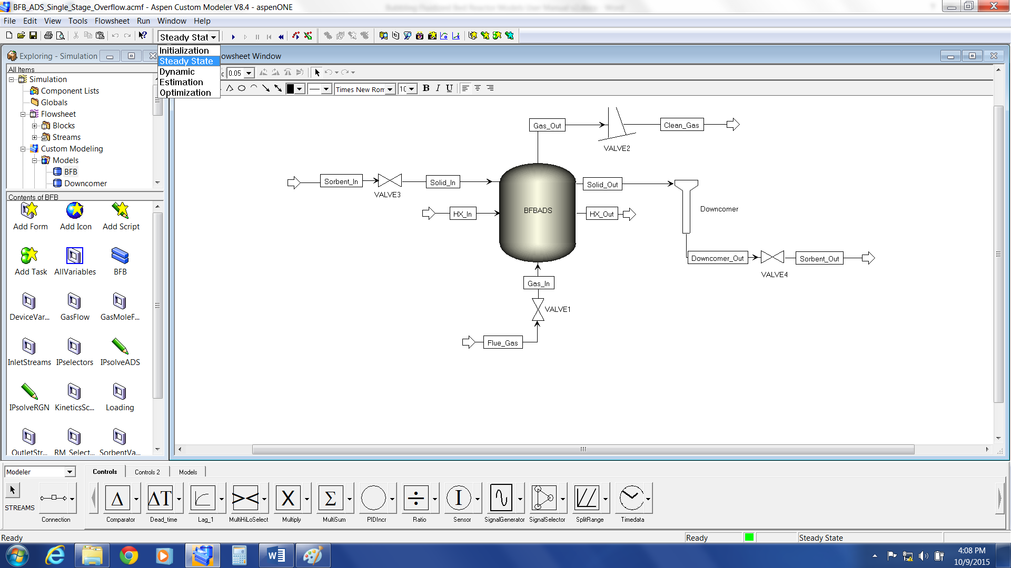

Figure : Changing simulation run mode in ACM.

Reviewing Results

Once a simulation has successfully converged, the results can be reviewed in a number of ways. A number of predefined *Forms*, similar to those used for mode inputs, are available to review key results. These include a number of pre-generated plots of key variables across the depth of the fluidized bed, such as temperature, concentration, and loading profiles. Details of outlet streams can be accessed by   
double-clicking the relevant stream on the “Flowsheet”pane. More detailed information on the internal behavior of the reactor can be accessed via the “AllVariables” form, by double-clicking the “Reactor” icon in the “Flowsheet” pane. **Note:** For plots along the axial domain of the model, results will often be presented in terms of discretization point rather than bed depth, which may result in apparent discontinuities in the plots when using non-uniform discretization schemes. The pre-generated *Forms* are all plotted against bed depth rather than discretization point for convenience.

* 1. gPROMS Implementation

Accessing Model Inputs

To access the model input variables in gPROMS, expand the “Models” branch in the simulation tree in the left pane of the “gPROMS” window. Next, double-click the “Flowsheet”object to open the model flowsheet and then select the “Topology” tab, as shown in Figure 7.

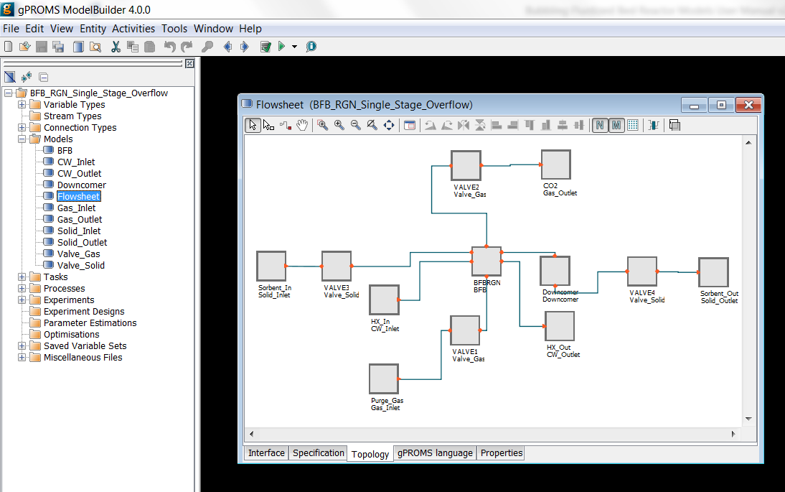

Figure : gPROMS explorer and flowsheet model.

Model inputs can be accessed by double-clicking the relevant entities in the model to display a list of inputs for that entity. For example, double-clicking a reactor entity in the “Flowsheet”displays the window shown in Figure 8. Entries without a checkmark in their check box are not inputs for the model in the current setup and can be ignored (generally these are global parameters specified at the flowsheet level). The value of an input can be changed by simply entering a new value in the box beside the variable name, or selecting a value from the drop-down list.

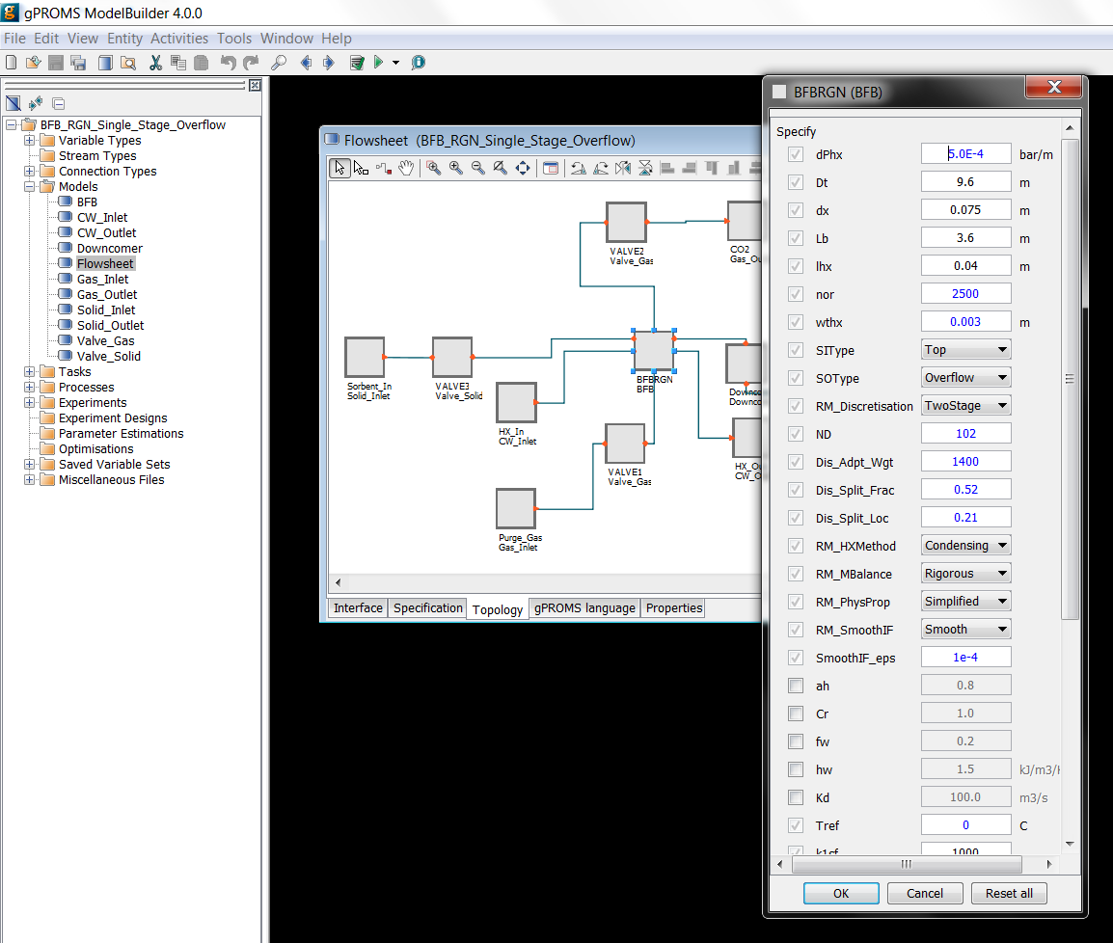

Figure : gPROMS model parameter input.

For global parameters specified at the flowsheet level, navigate to the “Interface” tab of the “Flowsheet” window and then click the “Edit Specification” button, as shown in Figure 9. In the “Public Model Attributes” pane (the top right of the window), double-click the row associated with the parameter the user wished to change to open a dialogue box, enter the desired value for the parameter in the “Default value” box, and then click “OK”. Once the user has finished specifying parameters, click “Finish” in the lower right of the pane.

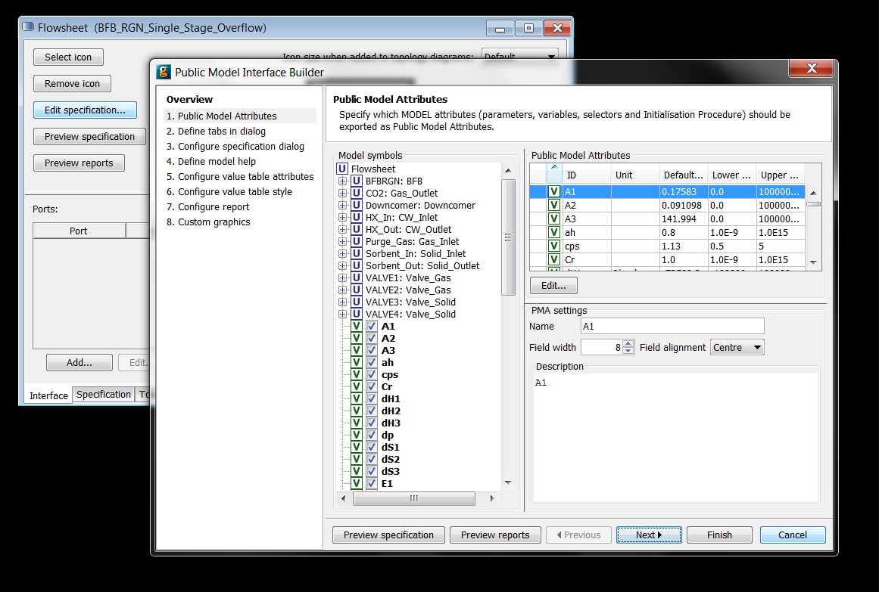

Figure : gPROMS flowsheet variable input parameter specification interface.

Model Initialization

Due to the complexity of the model equations, it is necessary to initialize the model to successfully obtain a solution. The presolved cases have already been initialized and a variable set saved as a starting point for future simulations. It is recommended to start from one of these simulations when developing cases, as it can be difficult to initialize the model from its default state.

In cases where it is not possible to use an existing, pre-initialized model, the BFB model comes with two initialization procedures, defined within the model code, to initialize the model from its default state. These work by starting with a simplified form of the model and gradually adding complexity until the full model is solved. Due to differences in the behavior of the model under adsorption and regeneration conditions, there are initialization scripts for both conditions, which differ in the order in which complexity is added.

It is also important to note that the initialization can be extremely sensitive to the operating conditions being used, and that it may be necessary to adjust the initialization procedures in these cases. This requires an understanding of gPROMS coding in addition to the model code, and the user is directed to the gPROMS User Manuals for more information on this topic. It is for this reason that it is recommended to work from a solved case of the model wherever possible.

To improve the chances of successfully initializing the model, it is suggested to use Run Mode Selectors to simplify the model prior to initializations. The suggested settings are:

* *RM_HXMethod* – either *Condensing* or *Liquid* depending on the state of the HX fluid. **Note:** When using *Condensing* the flowrate of HX fluid must be set to a free variable by clearing the “Flowrate” check box in the HX Fluid inlet in the “Flowsheet” entity.
* RM_MBalance – Simplified
* RM_PhysProp – Simplified
* RM_SmoothIF – Smooth

Once the model has been successfully initialized, the Run Mode Selectors can be returned to the user’s desired settings. If the user is still having difficulty initializing the model, check the Equation Scaling Parameters and set them all to “1.”

Execution of initialization procedures is performed during the execution of a simulation, as described in the next section.

Specifying new initialization procedures in gPROMS requires familiarity with the gPROMS language and environment, thus users wishing to develop more complex models are directed to the gPROMS User Manuals for a more comprehensive discussion. The existing initialization procedures in the presolved cases can be used as starting examples.

Running Simulations

Execution of a simulation run can be done by clicking “Simulate Model Flowsheet” () in the menu bar either from the “Flowsheet” model window from before, or by selecting “Flowsheet”from either the “Models” or “Processes” branches of the simulation tree in the left pane of the “gPROMS” window. Clicking  opens a new “Simulate” window, as shown in Figure 10. In the “Simulate” window, optionally specify a name for the simulation run in the “Case name” text box to easily identify specific simulation runs.

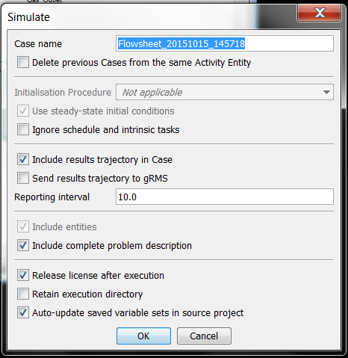

Figure : gPROMS “Simulate” window.

By default, gPROMS runs an initialization procedure if one is present, which includes the provided Steady State cases of the BFB model. In these cases the “Initialisation Procedure” section of the “Simulate”window are not greyed out and the user has the option of executing the initialisation procedure before proceeding with the main simulation. To run the model without using the initialisation procedure (recommended, see the previous section), select the “Ignore” option from the drop-down list beside “Initialisation Procedure.”

Prior to executing a simulation, the user can chose to export the results of the simulation to gPROMS inbuilt plotting software, gRMS. If the user desires to do this, select the “Send results trajectory to gRMS” check box.

Specifying Schedules for Dynamic Simulations

For dynamic simulations, it is also necessary to specify a simulation duration and any scheduled events that are to occur during the simulation. The example cases come with a number of example disturbances (simple ramp changes in input parameters) pre-coded for the user.

In gPROMS, this is done within the model code within a “Process” entity. To access the “Process” entity for the example cases, expand the “Processes” tab of the simulation tree in the left pane of the “gPROMS” window and then double-click “Flowsheet” (the green icon) to open the “Flowsheet” process entity. On the “gPROMS Language” tab, scroll down to the “SCHEDULE” section (line 257) and then examine the various example cases provided. Different cases can be activated and deactivate by commenting out the relevant section of code by surrounding it by braces, {}. By default, only the first case is active.

Running the Simulation

Once the desired run options have been selected, the simulation can be executed by clicking “OK” in the “Simulate” window.

Reviewing Results

Reviewing Results within gPROMS

To access the results of a simulation within gPROMS, expand the “results tree” created by the simulation run in the left pane of the “gPROMS” window, and then expand the “Trajectories” and “Flowsheet” branches, as shown in Figure 11.

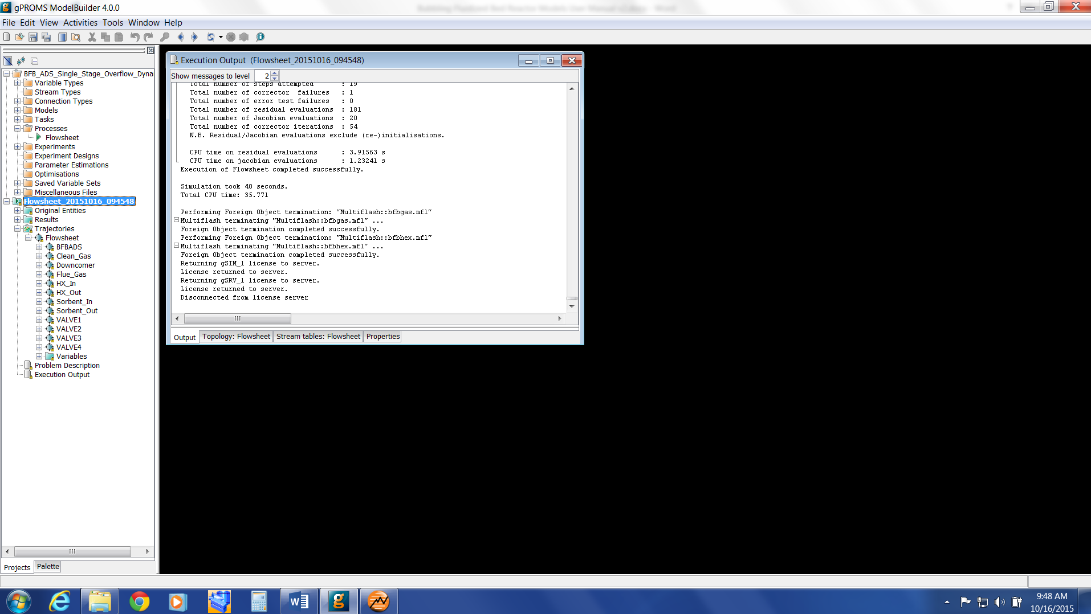

Figure : gPROMS simulation results tree.

Each entity within the flowsheet model, such as reactors, values, inlets, and outlets, has an entry within this tree. The results of a simulation can be accessed by opening the relevant entity and double-clicking the desired variable to obtain the values of that variable from the simulation.

Reviewing Results in gRMS

If the user selected the option to export the simulation results to gRMS, then a new window opens on the desktop. To create a new plot window, click “2D” () in the top left of the window. To add a new plot line to the current plot, click “Add New Line” () in the menu bar. A new window opens displaying the variable explorer tree, similar to that in the gPROMS results tree. Navigate through the tree to select the desired variable to plot and then click “Add.” A dialogue box displays which presents options for naming the variable on the plot, and for selecting what variable use for the x-axis (generally time or discretization point for the BFB model). **Note:** For plots along the axial domain of the model, results will generally be presented in terms of discretization point rather than bed depth, which may result in apparent discontinuities in the plots when using non-uniform discretization schemes.

1. Discretisation Study

To model the variation in conditions along the axial domain of the reactor, the BFB reactor model utilizes numerical approximations to the axial derivatives at discrete locations along the length of the axial domain. The derivatives are approximated using a first order backwards finite difference method, calculated at a defined number of points, “ND,” along the axial domain. Thus, the number and location of these points are key factors in determining the accuracy of the model.

The number of discretization points used in the model, “ND,” is important as it governs the accuracy of the numerical approximations to the true derivatives. As “ND” is increased, the spacing between the point decreases, and the approximations tend towards the true value of the derivatives. However, increasing “ND” also increases the number of equations that must be solved proportionally, increasing the computation demands of the model. Thus, there is a tradeoff between accuracy and complexity.

The accuracy of the numerical approximations to the derivatives is also dependent on the magnitude of the derivatives themselves (or more correctly, upon the rate at which the derivatives are changing (i.e., higher order derivatives)). In areas where the magnitude of the derivatives are large, the rate at which the derivative vary across the axial domain also tends to be large, thus the accuracy of the numerical approximations tends to be lower than for an area where the derivatives are smaller. From this, it can be seen that the benefit of increasing the number of discretization points is more significant in areas where the magnitude of derivatives are larger than in areas where the magnitude is smaller.

This leads to the use of non-uniform discretization schemes, which endeavor to place a greater number of discretization points in areas where the magnitude of the derivatives are larger, and fewer points where the magnitudes are smaller. The BFB reactor model contains implementations of three different discretization schemes for the user to choose from, offering different levels of accuracy and complexity.

The simplest discretization scheme available is a *Uniform* discretization scheme, where all the discretization points are uniformly distributed across the axial domain. This discretization scheme has only one parameter – the number of discretization points, “ND.”

A *2 Stage* discretization scheme is also available, which divides the axial domain into two stages, with different spacings of discretization points in each section. This allows the user to use a greater number of discretization points in the lower portion of the fluidized bed, where the reaction rates, and thus derivatives, are greater. Properly configured, this provides a significant increase in the accuracy of the model for the same number of discrete points, and no increase in the computational requirements of the model.

The *2 Stage* discretization scheme has three parameters which define the distribution of discretization points:

* the number of discretization points, “ND,”
* the fraction of discretization points that occur within the first stage of the domain, “Dis_Split_Frac,”
* the fractional location of the transition between the first and second stages of the domain, “Dis_Split_Loc.”

For example, if *ND* = 100, *Dis_Split_Frac* = 0.5, and *Dis_Split_Loc* = 0.2, then half of the discretization points (i.e., 50 points) will be placed within the first 20% of the axial domain, with the remaining 50 points placed over the remaining 80% of the domain. Thus, the spacing of points in the first stage of the domain will be ¼ of that in the second stage of the domain.

The final discretization scheme available is an *Adaptive* discretization scheme. In this scheme, the spacing of discrete points is inversely proportional to the axial derivative of the CO2 concentration, according to the following equation:

$${dl}_{i}=L_{b}\frac{\frac{1}{\left|{dc_{b,i}}/{dx}\right|}+k}{\sum_{i}{\left(\frac{1}{\left|{dc_{b,i}}/{dx}\right|}+k\right)}}$$

Here, ${dl}_{i}$ is the length of discrete element $i$, $L_{b}$ is the length of the axial domain (bed depth), ${{dc}_{b,i}}/{dx}$ is the axial derivative of the CO2 concentration at point $i$, and $k$ is a weighting parameter which controls the uniformity of the discretisation scheme. The advantage of the *Adaptive* discretisation scheme is that it automatically focusses discretisation points to regions where the magnitude of the derivatives are large, and can adapt to changes in conditions in the system without input from the user. However, as the spacing of the discrete points needs to be solved as part of the model, the computational complexity is increased. Additionally, the *Adaptive* scheme is not suitable for *Dynamic* simulations, as the discrete points are able to move during the simulation, which will cause discontinuities in the state variables. The *Adaptive* discretisation scheme has two model parameters which govern the distribution of the discretisation points:

* the number of discretization points, “ND,”
* the weighting parameter ( $k$ in the equation above), “Dis_Adpt_Wgt.”

The value of the weighting parameter controls the uniformity of the discretization scheme by balancing the contribution of the derivative term in the calculation of the spacing of the discrete points. A large value of *Dis_Adpt_Wgt* (>1x106) results in a more uniform spacing of the discrete points, and the weighting term dominates the equation, whilst smaller values result in more focus on the areas with high magnitude derivatives. It must be noted that if *Dis_Adpt_Wgt* is decreased too far (approximately <1000), the accuracy of the model begins to decrease as the discretization focused too much on the areas with high magnitude derivatives at the expense of the rest of the domain.

* 1. Study Conditions

To demonstrate the effect of the different discretization parameters on the model predictions, a study of the predictions of the model using different discretization schemes was used. The conditions used in the study were based on a single bed with typical inlet conditions:

* Inlet Gas: 8300 kmol/hr, 68°C, 13% CO2, 5.7% H2O,
* Outlet Gas: 1 bar,
* Inlet Solids: 669,000 kg/hr, 70°C, 0.13 mol bicarbonate/kg, 0.68 mol carbamate/kg,   
  0.31mol H2O/kg,
* Reactor: 12.4 m diameter, 4 m bed depth, 3355 heat exchanger tubes (17.5 mm diameter), Bottom feed, Overflow outlet.

A series of simulations were run varying the number of discretization points, “ND,” between 10 and 102. Values for the remaining discretization parameters (*Dis_Adpt_Wgt*, *Dis_Split_Frac*, *Dis_Split_Loc*) were determined for each simulation by finding the values that resulted in the maximum predicted CO2 removal for the given number of discretization points. It was found that the optimum values were:

* Dis_Adpt_Wgt = 1400
* Dis_Split_Frac = 0.51
* Dis_Split_Loc = 0.22

**Note:** These optimum values were determined for the system studied, and may vary for other reactor conditions (most significantly *Dis_Split_Frac* and *Dis_Split_Loc*).

Figure 12 shows the effect of varying the number of discretization points on the predicted removal of CO2 from the gas stream using the three different discretization schemes. As can be seen, both the *2 Stage* and *Adaptive* schemes give a significant improvement in the accuracy of the model predictions over the *Uniform* discretization scheme (as demonstrated by the approach to the limit as *ND* increases), especially with few discretization points. However, the difference in accuracy between the *2 Stage* and *Adaptive* schemes is generally small, except at the lowest number of discretization points.

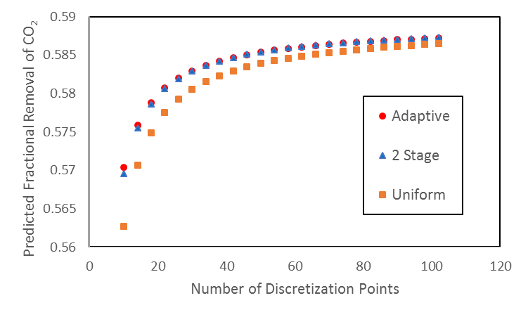

Figure : Dependence of CO2 removal on number of discretization points.

The results shown in Figure 12 suggest that using one of the more advanced discretization schemes would allow the user to achieve the same degree of accuracy in the model using fewer discretization points, thus reducing the computational demands of the model. However, Figure 13 shows the predicted inlet pressure of the reactor as a function of varying the number of discretization points for the three different discretization schemes. Here it can be seen that the predicted inlet pressure is primarily dependent upon the number of discretization points, and that the discretization scheme has a negligible influence on the results. Thus, using a more advanced discretization scheme cannot offset the loss of accuracy incurred by reducing the number of discretization points when it comes to predicting the inlet pressure.

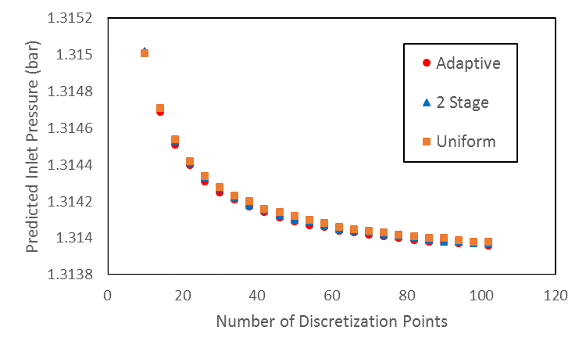

Figure : Dependence of predicted inlet pressure on number of discretization points.

* 1. Summary
* The accuracy of the model is dependent on the number of discretization points used.
* More advanced discretization schemes can improve the accuracy of the predictions regarding the CO2 removal, but the predicted bed inlet pressure is dependent primarily on the number of discretization points.
* Both the *2 Stage* and *Adaptive* discretization schemes perform better than the *Uniform* discretization scheme.
* The results of the *2 Stage* discretization scheme are comparable to those of the *Adaptive* discretization scheme when parameters are optimized, whilst the computational requirements are lower.
* The *Adaptive* discretization scheme is more responsive to change in model conditions than the   
  *2 Stage* discretization scheme without user action, thus may provide better results when significant changes in simulated conditions are expected.

1. Changing Reaction Kinetics

The example models provided contain a kinetic model derived for the solid sorbent NETL32D developed by the CCSI team. For users wishing to study other sorbents, it is necessary to modify the model code to incorporate the relevant reaction kinetics. Due to the wide range of different reactions kinetics that could be considered, this section will give a general overview of how the reaction kinetics are incorporated into the model and the steps necessary to incorporate different kinetics in the future.

Modifying the reaction kinetics necessitates a good understanding of the model code and the modelling language being used. For more details of the modelling languages and the details on the necessary task, users are directed to the User Manuals for the modelling package being used.

Component Lists

The BFB model uses two component lists within the fluidized bed, namely *GasList* for the gaseous species and *AdsList* for the adsorbed species. For users wishing to model systems with species not considered in the current system, it is necessary to add these species to the relevant component lists. The adsorbed species component list, *AdsList*, is a simple string array, and can be simply modified by adding or removing components. On the other hand, *GasList* links directly to the physical properties package incorporated in the modelling package, thus new components need to be added through the physical properties interface.

Thermodynamics and Rate Expressions

The reaction kinetics are modelled using standard rate expressions involving kinetic and equilibrium constants, which are defined as functions of temperature. The relevant code for these calculations is located at lines 1042–1067 in ACM or lines 1228–1253 in gPROMS. In this section of code, three reactions are considered, numbered 1–3. Due to differing conditions between regions, kinetic and equilibrium constants are calculated for each reaction in the cloud-wake and emulsion regions separately. Thus, the first block of code calculates the 6 rate constants for the system (3 reactions x 2 regions) using an Arrhenius type expression. Similarly, the second block of code calculates the six equilibrium constants.

The third block of code calculates the rates of reaction for each of the six reactions, based on the rate expressions from the kinetic model. The reaction rates are based on the solid (adsorbed) phase and are in units of mol/m3.s (volume of solid particles).

Users may easily change these blocks of code to suit their purposes, adding, removing, or modifying equations as needed for the specific reaction kinetics.

Connecting Rate Expressions to Mass Balances

The rate expressions discussed above are all written in terms of specific reactions, not individual components. The next section of the code connects the rate expressions for each reaction to the net rate of reaction for each component via stoichiometry. The relevant lines of code are lines 1069–1095 in ACM and lines 1256–1293 in gPROMS.

The first lines of code calculate the net rate of reaction of each gas species in *GasList* from the rate expressions for each reaction. **Note:** The gas phase reaction rates have units of kmol/m3.s (as opposed to mol/m3.s for the rate expressions), thus the unit conversion factor of 1000. The next section of code does the same thing for the adsorbed species in *AdsList*, which does not require a unit conversion.

Sorbent Enthalpy

The final block of code within the reaction kinetics section estimates the enthalpy of solids with adsorbed species. As this is often poorly characterized the BFB model approximates this using the method of Walton and LeVan [4]. The specific enthalpy of the sorbent with adsorbed species is assumed to consist of three independent parts:

1. The specific enthalpy of the sorbent, currently modelled using a constant heat capacity.
2. The net heat of reaction for each reaction. This is the total amount of species reacted via each reaction, including any that reacts further via another reaction, multiplied by the heat of reaction.
3. The specific enthalpy of the adsorbed solids. This is approximated by determining the total amount of each gas species required to form the adsorbed species present, and using the gas phase heat capacity of these species (and the conditions of the solids) to approximate the specific enthalpy of the adsorbed species.

Users should be careful when incorporating different kinetics to ensure that these calculations are correct, and that all terms in the enthalpy approximation are accounted for correctly.

1. Installation Requirements

The minimum suggested hardware requirement is desktop/laptop running Windows® 7 on Intel Core i-5 family 2.8 GHz or faster and 8 GB of RAM. With lower configuration, the simulation speed can be slower. The ACM and gPROMS models have been tested on Aspen V8.4 and gPROMS ModelBuilder 4.0, respectively.

1. References

[1] Lee, A., Mebane, D.S., Fauth, D.J., and Miller, D.C., “A Model for the Adsorption Kinetics of CO2 on Amine-Impregnated Mesoporous Sorbents in the Presence of Water,ˮ Pittsburgh Coal Conference, 2011.

[2] Lee, A., and Miller, D.C., “A One-Dimensional (1-D) Three-Region Model for a Bubbling Fluidized-Bed Adsorber,ˮ *Industrial & Engineering Chemistry Research*, 2013, 52 (1), 469–484.

[3] Modekurti, S., Bhattacharyya, D., and Zitney, S., “Dynamic Modeling and Control Studies of a Two-Stage Bubbling Bed Adsorber-Reactor for Solid-Sorbent CO2 Capture,ˮ *Industrial & Engineering Chemistry Research*, 2013, 52, 10250–10260.

[4] Walton, K., and LeVan, M.D., *Consistency of Energy and Material Balances for Bidisperse Particles in Fixed-Bed Adsorption and Related Applications*, Ind. Eng. Chem. Res., 2003, 42,   
pg. 6938–6948.

BFB-D-ROM

1. Introduction

This documentation introduces the Dynamic Reduced Order Models for the solid sorbent Bubbling Fluidized Bed (BFB) Adsorber Model that has been developed within the Carbon Capture Simulation Initiative (CCSI) to simulate the solid sorbent adsorption unit in carbon capture processes. The dynamic reduced models are developed to enable fast and accurate dynamic simulation of the BFB reactor. It can provide accurate prediction within large operation ranges, as the rigorous BFB process model, with improved computational efficiency. The dynamic reduced models can give fast prediction of process transient behavior and is suitable for simulation-based time-critical applications such as advanced process control and optimization. It could also be used for applications which require a large number of simulations, such as uncertainty qualification.

This document introduces the general methodology applied to the model reduction and provides a tutorial to use the reduced models for the BFB adsorber. The detailed description about this one-dimensional Partial Differential Equations (PDE) process model is in [1] – [3]. The base model used to generate the reduced models is version 5.2.2 of the BFB process model, which was released in October 2014. Based on that, minor changes have been made to the base BFB model. For example, all the Aspen property functions are replaced by correlation equations. A more detailed description of model updates, as well as the development of reduced models can be found in [4]. The developed models are implemented in Aspen Custom Modeler® (ACM, Aspen Technology, Inc.). ACM 8.4 or higher version is required to be installed to run the models.

1. Methodology

Model reduction seeks to generate models with a reduced number of equations and less simulation time, which maintain nearly the same response characteristics, to replace the original complex systems. Model reduction methods have been applied to generate two reduced models from a temporal and spatial aspect. These techniques are general approaches which can be applied to model reduction of other distributed parameter systems.

For temporally dynamic reduced models, the null-space projection method [5] is used to reduce the reaction kinetics of the adsorption process. The underlying idea is to separate the fast and slow components in a Differential Algebraic Equations (DAE) system by describing the fast components with algebraic equations capturing their quasi-steady states. As a result, the reformulated system becomes less stiff but with the same asymptotic behavior. Based on the simulation results and kinetics data of the rigorous model, the reaction rate of water physisorption is much faster than the other reactions. A   
quasi-steady state approximation was performed by assuming that the water physisorption reaction is always at equilibrium.

For spatially dynamic reduced models, spatial orthogonal collocation on finite elements is applied to discretize the partial differential equations. A certain type of high order polynomial -Lagrange polynomials are used to approximate the states. The approximation using this polynomial has a desirable property that the polynomial is the same as the true solution at the collocation points. Shifted Radau roots are chosen as collocation points. The collocation method is high orders compared with the finite difference method [6]. Thus it needs fewer discretization points, which can reduce the model size and simulation cost. By studying the spatial profiles of the rigorous BFB model, an unevenly distributed finite element scheme is introduced to further reduce the size of the reduced model.

1. Test Tutorial

This section provides tutorials to perform the simulation of the Dynamic Reduced Model Adsorber BFB Model. These models were developed using ACM v8.4.

* 1. Dynamic Simulation

No controller has been used to maintain the overall percent CO2 removed [3]. One case study to test the performance of the Dynamic Reduced Order Models is as follows. In the case study, multiple disturbances are introduced and the simulation cost and key parameters accuracy of the reduced model and original model are compared.

The original BFB Model is named “BFB_original_model.” The model is treated as the base model for simulation cost and model accuracy comparison. The temporally dynamic reduced BFB Model is named “BFB_temporally_drom” while the spatially reduced BFB Model is named “BFB_spatially_drom.”

The following steps/notes can be followed to run/modify the adsorber model with open-loop control:

1. Double-click the ACM input file “BFB_original_model.acmf.”
2. Load the snapshot of the Steady_state_solution to use as a starting point for the dynamic simulations. Click “Snapshot Management” in the menu bar (camera icon), select the snapshot “Steady_state_solution,” and then click “Copy Values.”
3. To run the dynamic simulation, change the “run mode” to “Dynamic” by changing the “run mode” in the menu bar or by clicking “Run” → “Mode” → “Dynamic.”
4. The settings used for the dynamic simulation can be viewed by clicking “Solver Options” in the menu bar. In this example, the integration method used is Implicit Euler. All of the tolerances are kept at the default value of 1e-005.
5. Under “Run Options,” the time units are Seconds to match with the time unit that is used in the model. Under “Communication” → “Time control,” a value of 1 sec is used. This value can be changed, if needed. (**Note:** A small value can slow down the simulation considerably whereas a large value fails to show the dynamics of the fast processes.) To pause the simulation at a specific time, such as at 100 sec, the value in the “Pause at” field located under “Run Options” → “Simulation control” should be changed to “100 sec.” In this example, the simulation pause is at 500s.
6. Five disturbances are introduced in task files under the “FlowSheet” in the “Explorer” panel. The first disturbance is introduced by a script file, “disturbance1,” where a ramp change in the valve opening of the input gas occurs from 85% to 70%. The script file is activated by default. To deactivate the script, double-click the task “disturbance1.” In addition, other disturbances in the flue gas flow, temperature, and solid temperature are introduced in disturbance two–five to test the model’s dynamic response.
7. A plot, “CO2_removal,” is located under “FlowSheet” in the “Explorer” panel. This plot shows the transients of percent CO2 removed. To create an additional plot, select “New form” from the “Menu” and then name the plot. Select the variable of interest by double-clicking a “stream” or an “equipment object,” clicking the “variable,” and then dragging it to the “Y-axis.” (**Note:** There is no data to show in any of the plots until the simulation is run. However, the plots can be configured before running the simulation. Any variable that has been selected for plotting is automatically saved in history by ACM. In addition, another plot, “loading,” is located under “FlowSheet” that represents the solid sorbent total loading, which is also an important variable for the adsorber model.)
8. To edit a plot in ACM, right-click the “plot” and then select “Properties.” Select the run time to change the range of the time axis. Select “Axis” to change the range of the process variable(s) in the plot. The title of the plot and labels of the axes can be changed by clicking “Label” and then entering the text as desired.
9. The simulation can be run for a specified time (500 sec in this example) by clicking “Run” under the “Run” menu or by clicking “Play.” The results can be plotted in ACM or the data can be exported to Microsoft® Excel® for plotting. The plots of the CO2 capture percent and sorbent loading for the original BFB Model are shown in Figures 14 and 15.

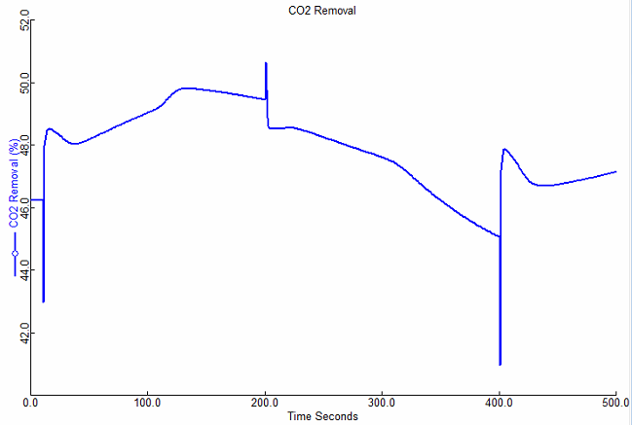

Figure : Dynamics of percent CO2 removed for disturbances  
in flue gas flowrate, temperature, and solid temperature.

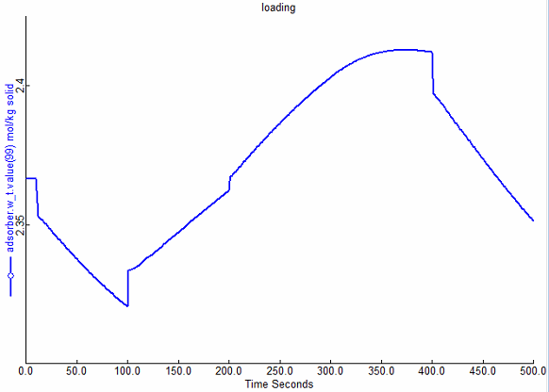

Figure : Dynamics of sorbent loading for disturbances  
in flue gas flowrate, temperature, and solid temperature.

For temporally and spatially reduced model, dynamic simulations can be conducted following Steps 3–9.

**Note:** In the spatially reduced model, the orthogonal collocation is used on the finite elements scheme to discretize the partial differential equations. The states are represented in arrays. For the current model, 12 finite elements with three collocation points within each element are used. For example, the state temperature T at the bottom boundary is represented by T(0,0) and the temperature at the top boundary is denoted by T(12,3). The total number of finite elements is represented by variable M, which can be specified by the user. The overall spatial region is divided into two sub-regions. The spatial derivatives of states are relatively large within the lower region, thus a relatively dense set of collocation points are used in the lower region. The length of the lower region is Lb1, and the number of finite elements in the lower region is M_b. The values for these parameters are decided by studying the spatial profiles of the states in the original model. In current version of reduced model, the length of lower region is 0.5 m and 2 finite elements are placed in the lower region. The following steps are needed to change the parameters in the spatially reduced model:

1. Double-click the ACM input file “BFB_spatially_drom.acmf.”
2. Load the snapshot of the Steady_state_solution to use as a starting point for the steady state simulation. Click “Snapshot Management” in the menu bar (camera icon), select the “snapshot Steady_state_solution,” and then click “Copy Values.”
3. To change the parameters such us the number of finite elements, right-click the reactor icon, select “Form,” and then click the “Number_of_finite_elements table.” The value of M can be changed in this table. For example, the value of M is specified to 13.
4. Right-click the reactor icon, select “Scripts,” and then click the “IPsolve” script. The script automatically runs to obtain the new steady state solution for a different number of finite elements.

After obtaining the new steady state solution, the dynamic simulation can be performed. The first step is to change the run mode to dynamic by following Step 3. Then change the specifications for the initial value since the number of differential equation is changed. From the “Tools” menu, select “Specification Analysis,” and then select “Set spec of all states variables to RateInitial (Steady State),” which makes the dynamic simulation start from the steady state. The dynamic simulation can now be performed by following Steps 4–9.

**Note**: If the increment of M is too large, running the IPsolve script may be slow. Increase M with a small increment and then repeat Steps 10–13 to find the new steady state solution.

The dynamic simulation results of the original and reduced models are summarized in the following section.

* 1. Comparison of Simulation Cost and Accuracy

The dynamic simulations were performed on an Intel® i7-3770 3.40GHz personal computer. Computational costs are subject to change for different hardware. But it is expected to have a similar percentage of reduction in simulation time (Table 8).

From the case study, the temporally reduced model can achieve a 35% simulation time reduction while the spatially reduced model can achieve a 60% reduction. Both the temporal and spatial Dynamic Reduced Order Models for the BFB adsorber run faster than the original model while maintaining reasonable accuracy. They can be easily used for other simulation-based applications and help improve computational efficiency.

Table : Dynamic Simulation Results

|  | Simulation Time(s) | MRE1(%) | MSE1(%2) | MRE2(%) | MSE2(mol2/kg2) |
| --- | --- | --- | --- | --- | --- |
| BFB1 | 168 |  |  |  |  |
| BFB2 | 111 | 0.25 | 3.84e-5 | 0.01 | 4.14e-8 |
| BFB3 | 67 | 0.85 | 0.06 | 0.13 | 9.86e-6 |

BFB1 – Original BFB Adsorber

BFB2 – Temporally Dynamic Reduced Model

BFB3 – Spatially Dynamic Reduced Model

MRE – Maximum Relative Error

MSE – Mean Squared Error

1 – CO2 Removal Percent

2 – Sorbent Loading

1. References

[1] Lee, A., Mebane, D.S., Fauth, D.J., and Miller, D.C., “A Model for the Adsorption Kinetics of CO2 on Amine-Impregnated Mesoporous Sorbents in the Presence of Water,ˮ Pittsburgh Coal Conference, 2011.

[2] Lee, A., and Miller, D.C., “A One-Dimensional (1-D) Three-Region Model for a Bubbling Fluidized-Bed Adsorber,ˮ *Industrial & Engineering Chemistry Research*, 2013, 52 (1), 469-484.

[3] Modekurti, S., Bhattacharyya, D., and Zitney, S., “Dynamic Modeling and Control Studies of a Two-Stage Bubbling Bed Adsorber-Reactor for Solid-Sorbent CO2Capture,ˮ *Industrial & Engineering Chemistry Research*, 2013, 52, 10250-10260.

[4] Yu, Mingzhao, David C. Miller, and Lorenz T. Biegler. “Dynamic reduced order models for simulating bubbling fluidized bed adsorbers.” *Industrial & Engineering Chemistry Research* 54.27 (2015): 6959-6974.

[5] Nie, Yisu, et al. “Reactor modeling and recipe optimization of polyether polyol processes: Polypropylene glycol.” *AIChE Journal* 59.7 (2013): 2515-2529.

[6] Biegler, Lorenz T. Nonlinear programming: concepts, algorithms, and applications to chemical processes. Vol. 10. SIAM, 2010.

Moving Bed

**Intellectual Property Management Plan**

**February 28, 2011**

1. Introduction

This documentation introduces the solid sorbent moving bed reactor model that is used to simulate an adsorber or a regenerator for carbon capture process. This one-dimensional partial differential equation (PDE)-based process model is a flexible, modular process model of carbon capture equipment that can be used to facilitate the rapid screening of new concepts and technologies.

1. General Information
   1. Overview

In a general moving bed reactor, contiguous solid particles move downwards under the influence of gravity, contacting a fluid in countercurrent manner, while the corresponding chemical reaction (adsorption/desorption) occurs. In this model, a vertical shell and tube type reactor is used. Gas-solid contacting takes place in the shell side, and the reactor temperature is controlled by heat transfer with the immersed tubes. The solid particles pass over a distributor at the top to fall onto a series of perforated trays. The perforated trays are assumed to prevent a maldistribution of solid particles and to retard particle velocity to reduce attrition and increase their residence time. Gases enter the reactor through the perforated distributor pipe at the bottom. The following Figure 16 contains a schematic of the reactor.



Figure : Schematic of the MB reactor.

* 1. Model Assumptions

Flow characteristics of gases and solids in moving beds have not been widely studied, so most coefficients were derived by analogy with correlations for fixed and fluidized bed systems. A parameter was used to explain inefficiencies in heat transfer compared to well-compacted fixed bed. The main assumptions of the moving bed reactor model are listed as follows:

* Vertical shell and tubes type reactor
* Shell-side: Reactive gas and solid
* Tube-side: Heat exchanging medium
* The system is represented as one dimensional PDEs in the axial direction
* Gas movement can be approximated as plug flow with axial dispersion
* Solid movement can be approximated as uniform flow with constant velocity
  + Particles are uniformly dispersed through the reactor with constant voidage
* The reactor is fully mixed in the radial direction
* Imaginary internals (e.g., plates) are assumed for solid distribution
  + Particle flow through column plates is unrestricted
  + Gas pressure drop across plates is negligible
* Ergun equation represents pressure drop through bed
* Reaction rate is described using a mass transfer base on a lumped overall resistance, or by a kinetic equation that accounts for both kinetic and diffusion effects
* Uniform solids temperature (no temperature profile within particles)
* Sphere sorbent based on mesoporous substrates impregnated with amines (e.g., polyethyleneimine (PEI), aminosilanes)
* The effects of particle attrition are ignored

1. Model Structure

The developed model was first implemented in Aspen Custom Modeler® (ACM, Aspen Technology, Inc.) and all partial-differential equations are solved using method of lines. The spatial domain has been discretized using a 2nd order forward/backward difference method and 100 elements used as a default. The attached ACM file includes newly-defined parameters, port and variable types in each folder, as well as the main reactor model. The model equations are written in the Custom Modeling library.

To find a moving bed reactor model in the Custom Modeling library:

1. In the “All Items” pane of the “Simulation Explorer,” make sure the “Custom Modeling library” is expanded and then expand the “Models” folder. A list of all models in the current simulation appears.
2. Click “MB.”
3. In the “Contents” pane, double-click the “equals” icon for the model.

The gPROMS® (Process Systems Enterprise Limited) version of moving bed reactor model is also included in the current release.

* 1. IO Structure and Reactor Dimensions

The reactor model contains several input and output ports. Each port has associated variables that correspond to the material connection stream variables. The inlet and outlet for gas and heat exchanging fluid are defined as default main port; solid inlet and outlet are described by the tailored port which includes the mass flowrate, temperature, and loading of each ionic species. There is also one more input main port to describe the gas inlet stream which is refluxed from the gas outlet.

The reactor dimensions are determined by specifying the reactor height and diameter, tube diameter, and pitch (or number of tubes) as input. The average voidage through the reactor should also be given as a fixed operating condition.

* 1. Component List and Physical Properties

Three components, carbon dioxide (CO2), water (H2O), and nitrogen (N2) are used in gas phase; and three ionic species, bicarbonate (Bic), carbamate (Car), and physisorbed water (H2O) are assumed for the solid phase which exists as the adsorbed state on sorbent. The mechanism of the adsorbate, CO2, and H2O, onto an amine-impregnated mesoporous sorbent is shown in reference [1].

Physical properties of the fluids can be calculated using commercial property packages (Aspen Properties® in ACM and Multiflash® in gPROMS) using cubic equations of state. The sorbent properties should be specified by user, particle diameter, density, heat capacity, and heat conductivity. If the diffusion limited options to calculate the reaction rate is selected, the extra information for average pore diameter, intraparticle void fraction, and tortuosity is necessary.

* 1. Mass Balance and Pressure Drop

Gas flow through a reactor is assumed to be axial dispersed plug flow and expressed by convection with the axial dispersion using an effective dispersion coefficient. Solid flow is represented by a plug flow with a constant velocity. The reaction is described using a mass transfer base on a lumped (combined diffusion and reaction rate) overall resistance, or by a kinetic equation that accounts for both kinetic and diffusion effects. The Ergun equation is used to estimate pressure drop through the reactor using the slip velocity between the interstitial fluid velocity and the interstitial particle velocity.

* 1. Energy Balance

In general, the adsorption reaction is exothermic, with the heat effects determined from enthalpies which include heats of formation. The heat of reaction should be specified for constructing the valid energy balance. The energy balance equations are in their most complete form, including axial thermal conduction, heat transfer to the environment, and the effect of chemical reactions. The reactor is considered adiabatic.

The gas phase energy balance includes terms for:

* Convection and Thermal conduction
* Compression
* Heat transfer from gas to solid (expressed in terms of a film resistance, where the heat transfer area is proportional to the area of the adsorbent particles)
* Heat transfer from gas to the internal tubes
* Heat of reaction

The solid phase energy balance includes terms for:

* Convection and Thermal conduction
* Enthalpy in the adsorbed phase
* Heat of reaction
* Heat transfer from gas to solid
* Heat transfer from solid to the internal tubes

The tube side energy balance includes terms for:

* Convection of internal fluid
* Heat transfer from the internal fluid to the inner tube
* Heat transfer from the outer tube to gas and solid

The model has an option for determining the flow direction of heat exchanging fluid inside tubes. In general, the upward direction is used for the adsorber because the cooling water is used to control the temperature of the reactor; the downward direction can be selected for regenerator where the latent heat that is generated by the condensation of steam is used as the heat source.

* 1. Initialization Strategy

The equations for the reactor are highly non-linear and require a comprehensive strategy to solve in steady state. The moving bed reactor model includes its own initialization scheme to allow a convergence of the simulation using Visual Basic scripts in Aspen Custom Modeler.

The reaction equations are highly dependent on the state variables, and are difficult to solve with the mass and energy balance at the same time. The fact that the reactor is adiabatic makes a convergence problematic. The temperature profile must be calculated with the various heat transfer equations; these equations are highly dependent on each other.

When the heat transfer equations are inactive and assume no reaction through the reactor, a steady-state run converges easily. Initially, the model is solved once with modified reactor dimensions, and then with the specified inlet conditions. In a series of homotopy-type runs, the parameters for availability of heat transfer and reaction are changed and the several steady-state runs are performed. The heat transfer with tubes and heat transfer between gas and solid become active in that order. Then the reaction equations are activated by fixing the slack parameter of each reaction to 1 sequentially. The initialization is accomplished with block level Visual Basic Scripts, Initialization.

* 1. Other Features

The moving bed reactor model contains various useful figures and tables which were pre-defined in the block level Forms folder. The “Config” table includes the reactor dimensions, modeling options, and slack parameter for initialization. The information for inlet and outlet streams is shown in the “Inlets” and “Outlets” tables. The profiles of concentration, gas flow (rate), loading, (gas) mole fraction, pressure, reaction rate, temperature, and (gas) velocity have been defined in the figures with each names.

The saved window layout to conveniently arrange the useful figures and tables is also included in the block level Visual Basic Scripts, Layout. **Note:** The layout was made based on the resolution higher than 1680x1050.

1. Tutorial

This section provides detailed tutorials to simulate the regenerator with moving bed reactor model. The following steps are used to set the proper simulation environment before running the simulation:

* 1. Steady-State Model

Open the “ACM/Steady-State/Moving_Bed_Steady.acmf” file.

The steady state model is simulated using the variables shown in Tables 9–13.

Table : Regenerator Fixed Device Variables

| Variable | Base Value | Variable Description |
| --- | --- | --- |
| ah | 0.8 | Empirical Factor in Heat Transfer Model |
| dPtube | 0.01 | Heat Exchanger Tube Pressure Drop (bar/m) |
| Dt | 9.0 | MB Unit Diameter (m) |
| Ht | 1.0 | MB Unit Height (m) |
| Tref | 0 | Thermodynamic Reference Temperature (°C) |
| wthx | 0.003 | Heat Exchanger Tube Wall Thickness (m) |

Table : Regenerator Fixed Sorbent Variables

| Parameter | Base Value | Parameter Description |
| --- | --- | --- |
| A1 | 55594.9 | Arrhenius Constant for Water Physisorption (mol/m3/Pa/K/s) |
| A2 | 0.000191 | Arrhenius Constant for Bicarbonate Formation (1/Pa/K/s) |
| A3 | 58.88 | Arrhenius Constant for Carbamate Formation (1/Pam1/K/s) |
| dH1 | -52,100 | Heat of Reaction for Water Physisorption (J/mol) |
| dH2 | -70,300 | Heat of Reaction for Bicarbonate Formation (J/mol) |
| dH3 | -99,630 | Heat of Reaction for Carbamate Formation (J/mol) |
| dS1 | -78.5 | Reaction Entropy for Water Physisorption (J/mol/K) |
| dS2 | -274.1 | Reaction Entropy for Bicarbonate Formation (J/mol/K) |
| dS3 | -265.3 | Reaction Entropy for Carbamate Formation (J/mol/K) |
| E1 | 28,200 | Activation Energy for Water Physisorption (J/mol) |
| E2 | 61,850 | Activation Energy for Bicarbonate Formation (J/mol) |
| E3 | 64,380 | Activation Energy for Carbamate Formation (J/mol) |
| m1 | 1.17 | Non-Ideality Exponent for Carbamate Formation Reaction |
| Nv | 2,350 | Amine Loading of Sorbent (mol/m3) |
| cps | 1.13 | Particle Heat Capacity (kJ/kg/K) |
| dp | 1.5x10-4 | Particle Diameter (m) |
| kp | 1.36 | Particle Conductivity (J/m/K/s) |
| phis | 1.0 | Particle Sphericity |
| rhos | 442 | Particle Density (kg/m3) |

Table : Regenerator Gas Inlet Specification

|  |  |  |
| --- | --- | --- |
| Input | Input Value | Unit |
| GasIn.F | 12.73 | kmol/hr |
| GasIn.P | 1.2 | bar |
| GasIn.T | 125 | °C |
| GasIn.z(“CO2”) | 0.09 |  |
| GasIn.z(“H2O”) | 0.9 |  |
| GasIn.z(“N2”) | 0.01 |  |

Table : Regenerator Heat Exchange Fluid Inlet Specification

| Input | Input Value | Unit |
| --- | --- | --- |
| HXIn.F | 3,500 | kmol/hr |
| HXIn.P | 3.3 | bar |
| HXIn.T | 139 | °C |
| HXIn.z(“CO2”) | 0 |  |
| HXIn.z(“H2O”) | 1 |  |
| HXIn.z(“N2”) | 0 |  |

Table : Regenerator Solid Inlet Specification

| Input | Input Value | Unit |
| --- | --- | --- |
| SolidIn.Fm | 100,000 | kg/hr |
| SolidIn.T | 112 | °C |
| SolidIn.w(“Bic”) | 2.6x10-6 | mol/kg sorbent |
| SolidIn.w(“Car”) | 1.998 | mol/kg sorbent |
| SolidIn.w(“H2O”) | 0.620 | mol/kg sorbent |

At this point the simulation is ready to be solved. For convenience, these specifications have been inserted in the model that is available. This can be verified by the presence of a green square at the bottom of the “ACM” window. Run the simulation. Sometimes, the ACM solver will not be capable to reach a solution for some operating/process parameters due to the size and non-linear nature of the problem. A number of custom plots have been created for variables of interest in the MB model. The plots can be found under the “Flowsheet” menu in the “Explorer” panel located on the left side of the flowsheet. If the “Explorer” panel is not displaying, it can be viewed by clicking “Explorer” under the “Tools” menu. Figure 17 displays the *Temperature Profile Plot* for the desired final solution of this tutorial.



Figure : Temperature profile plot.

The profiles of gaseous species shown below (Figure 18) can be seen by double-clicking “Solid_comp_flow” under the “Flowsheet” menu in the “Explorer” panel.



Figure : Gas composition profile plot.

* 1. Dynamic Model

1. Open the “ACM/Dynamic/Moving_Bed_Dynamic.acmf” file.
2. Load snapshot “int1” results.
3. Run the model.
4. Observe the custom plot “W” under the “Flowsheet Explorer.”

The pressure driven dynamic model is simulated by adding the control valves.

Example: Ramp Change in the solid’s flowrate

1. Open the “ACM/Dynamic/Example_Flowrate/Moving_Bed_Dynamic_Example.acmf” file.
2. Load snapshot “int1” results.
3. Run the model.
4. Ramp change starts at 5s and the simulation time is 500s.
5. Observe the custom plot “W” as shown below (Figure 19) under “Flowsheet Explorer.”



Figure : Exit solid sorbent loading after ramp in solid sorbent flowrate.

* 1. Implementation of Model in gPROMS

The gPROMS model is set-up and simulated using the following steps:

1. Open the “gPROMS/Dynamic/Example/Moving_Bedv1.32.gpj” file.
2. In the “project tree” on the left, navigate to “Models” and then double-click “process_MB” (see Figure 20).

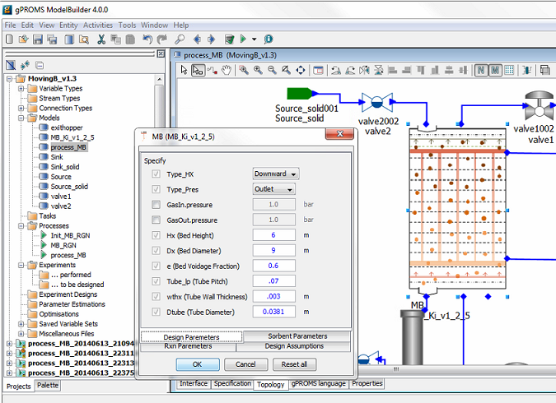

Figure : Specification box for MB model.  
The process flowsheet model “process_MB” is highlight in the “project tree” menu on the left.

**Note:** Specifying the required variables is done by double-clicking each piece of process equipment under the “Topology” tab of the “process_MB” window (Figure 20). These values are set to default values. Like the ACM model, if these variables are changed, it may require an initialization procedure. This can be turned on or off in the next step by selecting “Execute” or “Ignore” (Figure 21).

1. Run the model by clicking “Play” (the green button on the top of the toolbar). The “Simulate” option menu displays. Be sure the check box for “Ignore schedule and intrinsic tasks” is cleared (see Figure 21) to run a dynamic simulation. This runs the schedule already set up (it introduces a disturbance) which can be viewed by opening the “process_MB” under the “Processes” folder in the “project tree” and then navigating to the “Schedule” tab. Select the check box to run a   
   steady-state simulation. Additionally, change the reporting interval to “1.0.”

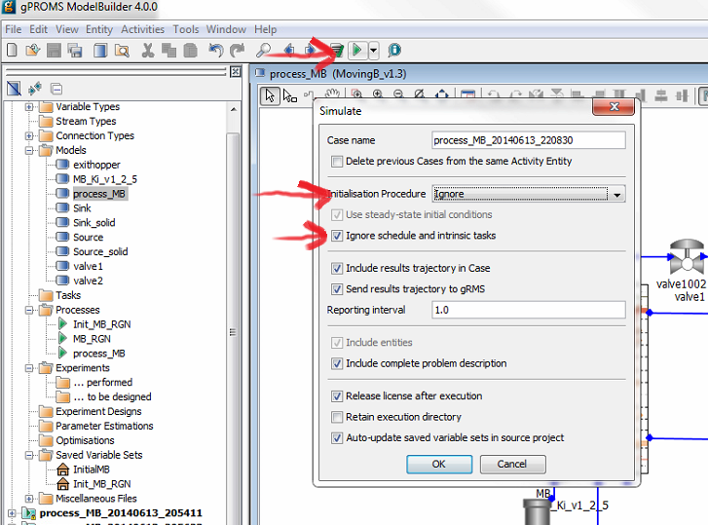

Figure : Click “Play” (the green button on the top of the toolbar)  
while the “process_MB Model” window is open to open the “Simulate” window.  
The “Initialisation Procedure” drop-down menu enables the user  
the option to run the initialization procedure.  
Select the “Ignore schedule and intrinsic tasks” check box to run a steady-state model.

1. Click “OK” on the “Simulate” options window to begin the simulation.
2. A new results window displays (listed at the bottom of the “project tree”).
3. A simulated ramped increase in inlet solid’s temperature occurs at 10s and the simulation time is 180s.
4. To view the results navigate to the “Trajectories” → “Flowsheet” → “MB” → “Variables” folder in the results file that is generated at the bottom of the “project tree” (see Figure 22). Find the variable “SolidCompflow,” double-click the variable, and then click the “Graph” tab at the bottom of the window to generate a plot.
5. Select the time to be fixed at “0,” the axial to be the x-axis and the “ionslist” to be a “series.” The resulting graph is given in Figure 23.
6. Select the time to be the y-axis, and the “ionslist” to be “H2O.” This will plot a 3-D plot of the bed profile through time. It can be seen in Figure 24.

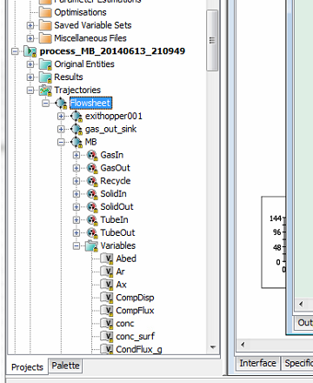

Figure : After a simulation begins, the “Results” folder displays at the end of the “project tree.”  
Navigate to the “Trajectories” → “Flowsheet” → “MB” → “Variables” folder  
to examine the results of a successful simulation.

**Note:** Plots can also be made using the gRMS program in a similar fashion with more options with the ability to save a template for the plots, allowing plots to be generated quickly for new simulation results.

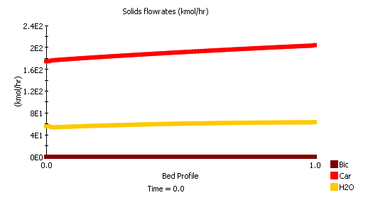

Figure : Steady-state profile of component solid flow through the reactor.

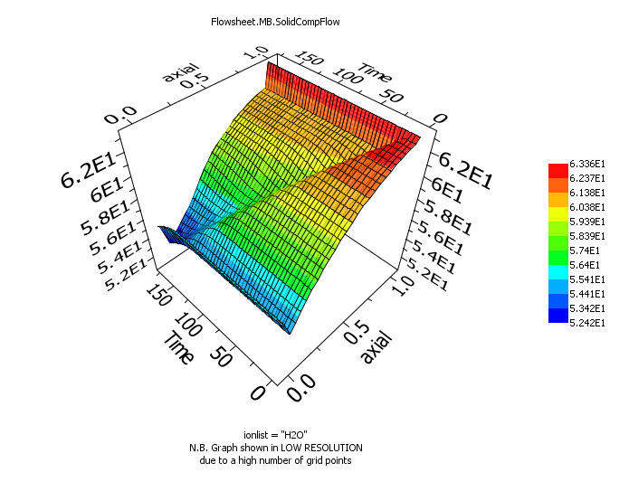

Figure : Dynamic profile of physiorbed H2O solid flow through the reactor  
from a simulated ramp in the inlet solid temperature.

1. Installation Requirements

The minimum suggested hardware requirement is a desktop/laptop running Windows® 7 on an Intel Core i-5 family 2.8 GHz or faster and 8 GB of RAM. With lower configuration, the simulation speed can be slower. The ACM and gPROMS models have been tested on Aspen® V8.4 and gPROMS ModelBuilder 4.0.0, respectively.

1. Reference

[1] Lee, A., Mebane, D.S., Fauth, D.J., and Miller, D.C., “A Model for the Adsorption Kinetics of CO2 on Amine-Impregnated Mesoporous Sorbents in the Presence of Water,ˮ Pittsburgh Coal Conference, 2011.

Integrated Solid Sorbent CO2 Capture System Model

**Intellectual Property Management Plan**

**February 28, 2011**

1. Introduction

This documentation introduces the dynamic integrated solid sorbent CO2 capture and compression process model that utilizes the Moving Bed (MB), Bubbling Fluidized Bed (BFB), and CO2 compression models that have been released as standalone models. This model can be used to predict the power requirements for the CO2 compression while taking into account the transport delay and pressure flow characteristics of the CO2 capture process. This document will give a brief overview of each sub-model that is used in the overall process model. More details of individual model’s assumptions and properties can be found in their corresponding sections in this manual.

1. Integrated Model Structure

There are two versions of the integrated model, one implemented in ACM, and the other is implemented in gPROMS® (Process Systems Enterprise Limited). The ACM integrated model is based on a Framework for Optimization and Quantification of Uncertainty and Sensitivity (FOQUS) optimized   
solid-sorbent steady-state process that is cable of 90% CO2 capture from a 650 MW coal fired plant. The process is assumed to require six trains of a 3-stage absorber, nine trains of 2-stage regenerators, and two trains of CO2 compressors. The model equations for the CO2 compressor are written in the Custom Modeling library. To find the various models that have been developed:

1. In the “All Items” pane of the “Simulation Explorer,” confirm the “Custom Modeling library” is expanded, and then expand the “Models” folder. A list of all models in the current simulation displays.
2. In the list of all developed models, click the desired model.
3. In the “Contents” pane, double-click the “equals” icon for the model.

The gPROMS version of the integrated model uses a two-stage BFB absorber, a 14-stage MB regenerator, and a single CO2 compressor train. **Note:** This model is not based on an optimized steady-state design, however demonstrates the predictive ability of all developed process models in gPROMS.

* 1. IO Structure

The integrated models contains several input and output ports. Each port has associated variables that correspond to the material connection stream variables. In the ACM version, the BFB and MB share the same port types, however those ports are converted when the CO2 stream enters the CO2 compressor train, as many auxiliary models are from the Aspen dynamics library that utilize a different port type. Additionally, the component N2 in the CO2 compressor inlet is removed as the amount of N2 should be negligible and the zero value would cause numerical problems with dynamic integration.

The gPROMS version of the model was developed with different ports for the MB and BFB models, so the project file contains a port convertor “model” that is used each time a stream connects one type of bed to another. Additionally, the CO2 compressor model in gPROMS was developed with the default PML port type (gPROMS model libraries), as many of the auxiliary equipment was modeled with the default PML library models, so the ports change across the beds and CO2 compressor train.

* 1. Component List and Physical Properties

There are three main parts of the integrated simulation, solid sorbent CO2 capture, compression, and drying. The compression section requires accurate properties for CO2 to predict compressor power. The drying section requires accurate vapor-liquid equilibrium calculations for the CO2-TEG-Water system. The MB/BFB needs accurate physical properties for hydrodynamics.

For the BFB and MB sections, two phase flow are modeled, gas and solid. Three components, carbon dioxide (CO2), water (H2O), and nitrogen (N2) are used in gas phase; and three ionic species, bicarbonate (Bic), carbamate (Car), and physisorbed water (H2O) are assumed for the solid phase which exists as the adsorbed state on sorbent. The mechanism of the adsorbate, CO2 and H2O, onto an amine-impregnated mesoporous sorbent is shown in reference (Lee, et al., 2012).

Physical properties of the fluids can be calculated using commercial property packages (Aspen Properties® in ACM and Multiflash® in gPROMS) using cubic equations of state. The sorbent properties should be specified by user, particle diameter, density, heat capacity, and heat conductivity. If the diffusion limited options to calculate the reaction rate is selected, the extra information for average pore diameter, intraparticle void fraction, and tortuosity is necessary.

The CO2 compressor section uses three components, carbon dioxide (CO2), water (H2O), and TEG. The nitrogen component from the solid sorbent section of the model is removed due to numerical issues stemming from the amount of nitrogen in the CO2 compressor train being near zero. The ACM version of the model uses LK-PLOCK for the compression train and the water knock-out drums, while HYSGLYCO is used for the drying section. However, the gPROMS version uses LK-PLOCK for the entire CO2 compression section as HYSGLYCO is not available in Multiflash.

1. ACM Integrated Model Tutorial

Example: Two ramp changes in the inlet flue gas flowrate and shutdown of one solid sorbent train.

1. Open the “ACM/Dynamic/Example_Flowrate/Int.BFB_CO2.acmf” file.
2. Load snapshot “int” results.
3. Run the model.
4. The flue gas ramps occur at 3hrs and 15hrs, and the shutdown of a train occurs at 40hrs. The total simulation time is 65hrs.
5. Observe the custom plot “Power,” “Flowrate,” and “CO2_removed” as shown below (Figure 25 under “Flowsheet Explorer.”



Figure : Gas flowrate to compressors.



Figure : Percent CO2 removed from the flue gas during step changes.



Figure : Power requirement of CO2 compressors during step changes.

1. Implementation of Integrated Model in gPROMS

The gPROMS model is set-up and simulated using the following steps:

1. Open the “gPROMS/Example/Integrated_process v1.0.gpj” file.
2. The integrated model utilizes the built in PML libraries in gPROMS. Navigate to “File” → “Open/Close Libraries.” A window opens with a list of available models. Select the “PML libraries” check box and then click “OK.”
3. In the “project tree” on the left, navigate to “Models” and then double-click “Integrated_process” (see Figure 28).

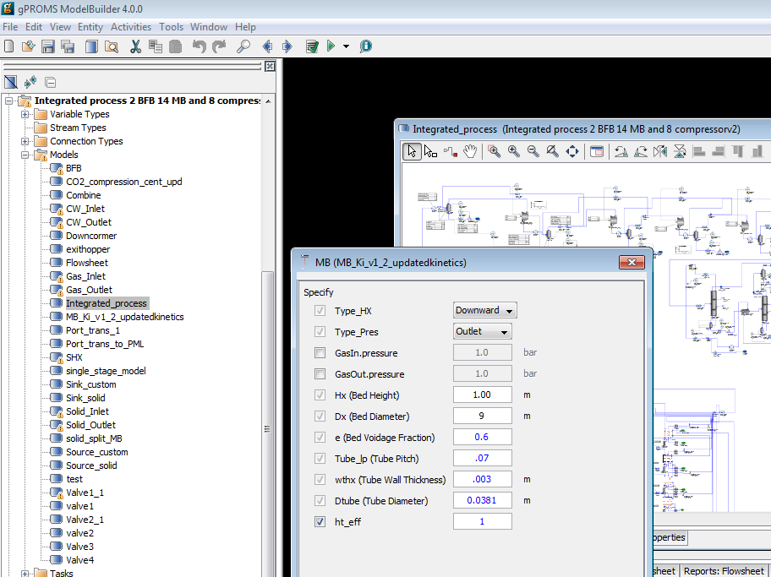

Figure : Specification box for MB model. The process flowsheet model  
“Integrated_process” is highlighted in the “project tree” menu on the left.

**Note:** Specifying the required variables is done by double-clicking each piece of process equipment under the “Topology” tab of the “process_MB” window. These values are set to default values. Like the ACM model, if these variables are changed, it may require an initialization procedure. This can be turned on or off in the next step by selecting “Execute” or “Ignore.”

1. Run the model by clicking “Play” (the green button on the top of the toolbar). The “Simulate” option menu displays. Be sure the check box for “Use steady-state initial conditions” is clear (see Figure 29). The model is setup to automatically select initial conditions. Additionally, be sure to select the “Send results trajectory to gRMS” check box. This sends the results of the simulation to gPROMS data management software, where templates for plotting the results have already been provided. Lastly, ensure that the “Ignore schedule and intrinsic tasks” is left cleared. This runs the schedule already set up (it introduces a disturbance) which can be viewed by opening the “Integrated_process” under the “Processes” folder in the “project tree” and then navigating to the “Schedule” tab. Select the check box to run a steady-state simulation. The disturbance configured is a decrease of inlet flue gas by closing the valve opening.

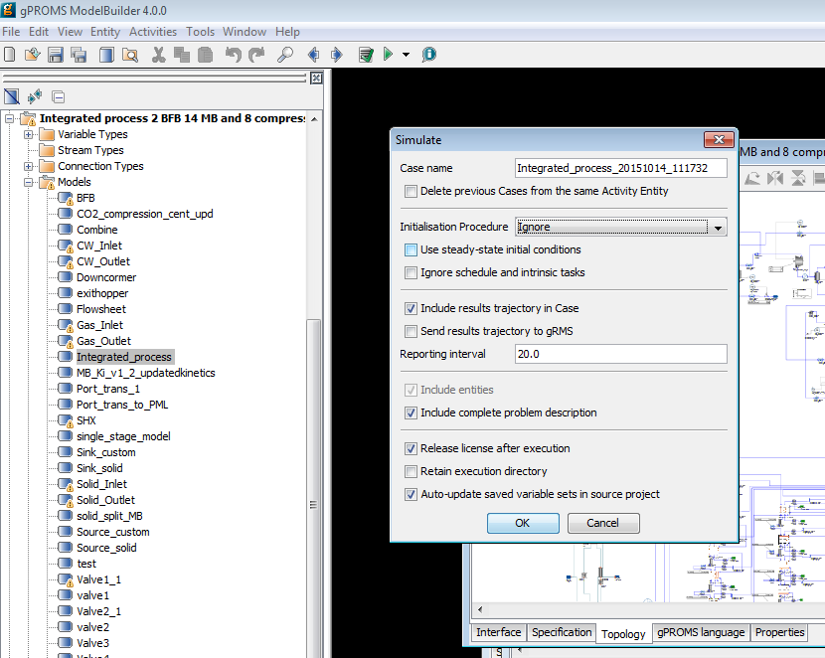

Figure : Click “Play” (the green arrow on the top toolbar) while the “process_MB Model” window is open to open the “Simulate” window. The “Initialisation Procedure” drop-down menu enables the user the option to run the initialization procedure. Select the “Ignore” option.

1. Click “OK” on the “Simulate” options window to begin the simulation.
2. A new results window displays (listed at the bottom of the “project tree”).
3. A ramp change occurs at 1,000s and the simulation time is 20,000s.
4. To view the results, navigate to the “gRMS” window that displayed once the simulation is run. gRMS is a data management program with numerous options and the ability to save a template for the plots, allowing plots to be generated quickly for new simulation results. Six of these templets’ have been provided as “.gpt” files. In the “gRMS” window, navigate to “Graph” → “Open Template” and then select the desired template that has been provided. A window displays asking to specify what results the user would like to plot (see Figure 30). Select the “Integrated_process_xxxxxx_xxxxx” data that is currently being generated. The results will be plotted. Assuming the simulation has not completed running yet, the plots will automatically update as the simulation is solved in gPROMS. Figure 31 shows the resulting plot that results from loading “stage12.gpt.”

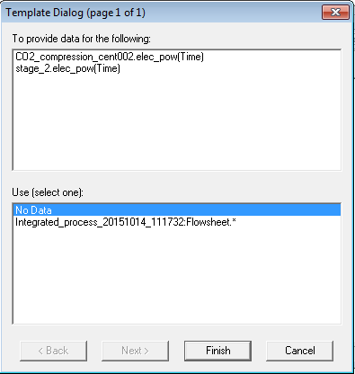

Figure : Data selection window for gRMS template.

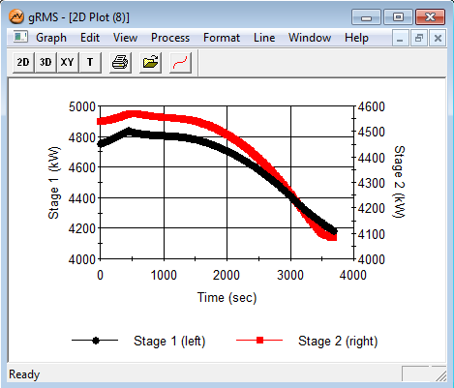

Figure : A plot that results from loading template “stage12.gpt.”  
This plot shows the dynamic power requirements of the stage 1 and stage 2 compressor.  
Note: The data will be added as the simulation to continue,  
therefore the generated plot may contain more or less time series data than is shown here.

**Note:** Results can also be viewed by navigating to the “Trajectories” → “Flowsheet” folder in the results file that is generated at the bottom of the “project tree.” Simply navigate to the desired variable within the flowsheet.

1. The simulation of 20,000 sec will require several hours to complete. When the simulation completes, the results of each template provided are given in Figures 32 and 33.



Figure : gPROMS simulation power requirement for CO2 compressors  
during ramped decrease in flue gas.



Figure : gPROMS simulation inlet flue gas flowrate and percent CO2 removed.

1. Installation Requirements

The minimum suggested hardware requirement is desktop/laptop running Windows® 7 on Intel Core i-5 family 2.8 GHz or faster and 8 GB of RAM. With lower configuration, the simulation speed can be slower. The ACM and gPROMS models have been tested on Aspen V8.4 and gPROMS ModelBuilder 4.0.0, respectively.

1. Reference

A. Lee and D.C. Miller. (2013), “A One-Dimensional (1-D) Three-Region Model for a Bubbling Fluidized-Bed Adsorber”, Industrial & Engineering Chemistry Research, 52 (1), 469-484.

S. Modekurti, D. Bhattacharyya, and S. Zitney (2013), “Dynamic Modeling and Control Studies of a Two-Stage Bubbling Bed Adsorber-Reactor for Solid-Sorbent CO2Capture”, Industrial & Engineering Chemistry Research, 52, 10250-10260.

Aungier, R.H. (2000), “Centrifugal Compressors: A Theory for Aerodynamic Design and Analysis,” ASME Press, NY.

Ilchman, A. (1993), “Non-Identifier-Based High-Gain Adaptive Control,” Springer, NY.

Ilchman, A., and Ryan, E.P. (1994), “Universal -Tracking for Nonlinearly Perturbed Systems in the Presence of Noise,” Automatica, 30, 337-346.

Kohl, A.L., and Nielson, R. (1997), “Gas Purification,” 5th Ed., Gulf Publishing Company, Houston, TX.

Lüdtke, K.H. (2004), “Process Centrifugal Compressors: Basics, Function, Operation, Design, Application,” Springer, Berlin.

Lüdtke, K.H., “Twenty Years of Experience with a Modular Design System for Centrifugal Process Compressors,” Proceeding of the Twenty-First Turbomachinery Syposium.

Mallen, M., and Saville, G. (1977), “Polytropic Processes in the Performance of Prediction of Centrifugal Compressors,” Institute of Mechanical Engineers, Paper No. C183/77.

Span, R., and Wagner, W. (1996), “A New Equation of State for Carbon Dioxide Covering the Fluid Region from the Triple-Point Temperature to 1100 K at Pressures up to 800 MPa,” *Journal of Physical Chemistry Reference Data*, v25, 1509-1596.

Turton, R., Bailie, R.C., Whiting, W.B., Shaeiwitz, J.S., Bhattacharyya, D. (2012), “Analysis, Synthesis and Design of Chemical Processes,” 4th Edition, Prentice Hall, 2012.

U.S. Department of Energy (2010), “Cost and Performance Baseline for Fossil Energy Plants Volume 1: Bituminous Coal and Natural Gas to Electricity,” DOE/NETL-2010/1397.

Weibe, R., and Gaddy, V.L. (1941), “Vapor-Phase Composition of Carbon Dioxide Water Mixtures at Various Temperatures and Pressures to 700 Atmospheres,” *Journal of the American Chemical Society*, v63, 475-477.

Lee, A., Mebane, D.S., Fauth, D.J., and Miller (2011), D.C., “A Model for the Adsorption Kinetics of CO2 on Amine-Impregnated Mesoporous Sorbents in the Presence of Water,ˮ Pittsburgh Coal Conference.

Solvent Process Models

MEA Steady State Model

1. Model Development

**Intellectual Property Management Plan**

**February 28, 2011**

* 1. Model Background

This document describes a solvent-based CO2 capture system using aqueous monoethanolamine (MEA). The model consists of the “CCSI_MEAModel.bkp” file with supporting files “gold.opt” and “gold.dll,” which contain FORTRAN user models associated with the simulation. This model was developed with Aspen Plus® V8.4 and is compatible with V8.4 and higher.

This model represents the first version of the “gold standard” model for the MEA capture system. It is composed of individually developed submodels for physical properties of CO2-loaded aqueous MEA solutions and hydraulic and mass transfer models for the system of interest. Each submodel is developed and calibrated with relevant data over the full range of process conditions of interest (e.g., temperature, composition). For each submodel, existing models are considered as candidates and are modified to better fit experimental data over the conditions of interest.

* 1. Physical Property Models

Physical property models developed in this work include standalone models and an integrated thermodynamic framework. Standalone models for viscosity, density, and surface tension of the system have been developed, with uncertainty quantification, as described in Morgan et al.,1 and are implemented as FORTRAN user models. The thermodynamic framework of this system is developed using UT Austin’s Phoenix model2 thermodynamic framework as a precursor. Here, the solution thermodynamics are represented by the ELECNRTL method in Aspen Plus, which uses the Redlich-Kwong equation of state to calculate the vapor phase fugacity coefficients and the electrolyte non-random two liquid   
(e-NRTL) model to calculate the activity coefficients in the liquid phase. Model parameters are calibrated by fitting data for VLE, heat capacity, and heat of absorption for the ternary MEA-H2O-CO2 system and VLE data for the binary MEA-H2O system. The kinetic model used in this work is taken from the Phoenix model, in which the overall ionic speciation of the system is simplified into two equilibrium reactions:

|  |  |  |
| --- | --- | --- |
|  | $$2MEA+{CO}_{2}↔{MEA}^{+}+{MEACOO}^{-}$$ | (1) |
|  | $$MEA+{CO}_{2}+H_{2}O↔{MEA}^{+}+{HCO}_{3}^{-}$$ | (2) |

The forward reaction rate constants are taken from the Phoenix model, and the overall reaction rate is written in terms of the equilibrium constants which are also calculated as part of the thermodynamic framework of the system. This follows the methodology presented in Mathias and Gilmartin3, and is implemented to ensure that the reaction kinetics are consistent with the thermodynamic framework.

* 1. Mass Transfer and Hydraulic Models

The hydrodynamic models developed in this work include models for pressure drop and hold-up. The Billet and Schultes4 correlation is regressed with data from Tsai5 for MellapakPlus™ 250Y packing, which is similar to MellapakPlus 252Y packing, which is considered in this work. In this work, a novel and integrated methodology to obtain the mass transfer model is proposed. In this integrated mass transfer model, parameters of the interfacial area, mass transfer coefficients, and diffusivity models are regressed using wetted wall column data from Dugas6 and pilot plant data from Tobiesen et al.7 This required simultaneous regression of process model and property parameters, which was accomplished using the CCSI software Framework for Optimization and Quantification of Uncertainty and Sensitivity (FOQUS).

* 1. Development of Process Model

The aforementioned submodels are integrated into this steady state process model, which is representative of the configuration of the National Carbon Capture Center (NCCC) in Wilsonville, Alabama, for which data have been obtained for validation of this model. No parameters are tuned to improve the fit to the fit to the pilot plant data. The model includes both the absorber and stripper columns, although the recycle of the lean solvent from the regenerator outlet to the absorber inlet is not modeled. The columns are modeled as rate based columns using RateSep™.

The various submodels are implemented in Aspen Plus either as built-in models (e.g., ELECNRTL thermodynamic framework) or FORTRAN user models, in cases where built-in models with the appropriate model form are not available. The user models are combined into a dynamic library (“gold.dll” for this model) and a dynamic linking options (DLOPT) file (“gold.opt”) is also provided, which has already been specified in the Aspen Plus file for this model. The various user models contained in the linked library include physical property models for viscosity, density, surface tension, and diffusivity, the hydraulics model, the interfacial area model, and the reaction kinetics model.

* 1. Model Features

The “CCSI_MEAModel.bkp” file included is representative of a typical operating case at NCCC and some adjustment of operating variables is possible. Table 14 includes some of these variables and suggested ranges for which the model is expected to work, based on the ranges considered in the testing at NCCC.

Table : Suggested Ranges for Variables in Simulation

| Variable | Range |
| --- | --- |
| Lean Solvent Amine Concentration (g MEA/g MEA+H2O) | 0.25 – 0.35 |
| Lean Solvent CO2 Loading (mol CO2/mol MEA) | 0.05 – 0.50 |
| Lean Solvent Flowrate (kg/hr) | 3000 – 12000 |
| Flue Gas Flowrate (kg/hr) | 1250 – 3000 |
| Regenerator Reboiler Duty (kW) | 150 – 700 |

Table 14 includes the major variables that dictate the performance of the process, although the list is not exhaustive. Other variables, including operating temperature and pressure of the equipment, are set at typical values for the MEA-based CO2 capture process, and slight variation of these variables is allowable. As the lean solvent flowrate is decreased, the intercooler flow rates should be adjusted accordingly. **Note:** The apparent mole fractions of molecular species may be calculated from the amine concentration (γ) and CO2 loading (α) using the equations:

|  |  |  |
| --- | --- | --- |
|  | $$X_{MEA}={\left(1+α+\left(\frac{{MW}_{MEA}}{{MW}_{H_{2}O}}\right)\left(\frac{1}{γ}-1\right)\right)}^{-1}$$ | (3) |
|  | $$X_{{CO}_{2}}=αX_{MEA}$$ | (4) |
|  | $$X_{H_{2}O}=1-X_{MEA}-X_{{CO}_{2}}$$ | (5) |

1. Tutorial
   1. Predicting System VLE
2. Place the “CCSI_MEAModel.bkp” file and the supporting files “gold.opt” and “gold.dll” in the same directory. Open the “CCSI_MEAModel.bkp” file. If the Model Palette is not visible, it may be selected from the “View” tab at the top of the window. In the Model Palette, navigate to the “Manipulators” tab and then select “Mult” to create a multiplier block, which will be referred to by its default name “B1.” Double-click “B1” and then set the multiplication factor to “1.” Add an inlet stream to the block by clicking “Material” in the Model Palette, the red arrow on the inlet of B1, and then elsewhere in the flowsheet. Repeat the procedure for the outlet stream of B1. Name the inlet and outlet streams as “IN” and “OUT,” respectively. **Note:** The streams may be renamed by double clicking the default name and typing the new name.
3. Double-click “IN” and configure it as follows:
   1. Select “Temperature” and “Vapor Fraction” as the “Flash Type” specifications.
   2. Temperature: 40°C.
   3. Vapor Fraction: 0.0001.
   4. Select “Mass-flow” in “gm/hr” as the composition basis. Set the values for “H2O” and “MEA” as “7” and “3,” respectively.
4. In the left navigation pane, navigate to “Model Analysis Tools” → “Sensitivity,” and then click “New.” The new sensitivity block may be named “PCO2.” Under “Manipulated variable” in the “Vary” tab, select “New,” select “Mole Flow” as “type,” “IN” as “stream,” “CO2” as “component,” and “mol/hr” as the “units.” Under “Manipulated variable limits,” specify “0.0005” and “0.03” as the “lower” and “upper limits,” respectively, and “10” as the “number of points.” Navigate to the “Define” tab and then create a new measured variable named “PCO2.” Under “Edit selected variable,” select “Streams” as the “category,” “Stream-Prop” as the “type,” “IN” as the “stream,” and “PPCO2” as the “prop set.” Navigate to the “Tabulate” tab and then click “Fill Variables.” Navigate to the “Options” tab and select the “Do not execute base case,” option under “Execution options.”
5. Run the simulation by clicking the “Run” arrow or pressing “F5.” The results of the “PCO2” sensitivity block should be consistent with what is shown in Table 15. **Note:** All of the warnings that appear in the “Control Panel” while running the simulation may be ignored.

Table : Results of PCO2 Sensitivity Block

|  |  |  |  |
| --- | --- | --- | --- |
| Row/ Case | Status | CO2 MOLEFLOW (MOL/HR) | PCO2 (KPA) |
| 1 | OK | 0.0005 | 1.50E-05 |
| 2 | OK | 0.003778 | 0.000778 |
| 3 | OK | 0.007056 | 0.003344 |
| 4 | OK | 0.010333 | 0.009855 |
| 5 | OK | 0.013611 | 0.026325 |
| 6 | OK | 0.016889 | 0.07395 |
| 7 | OK | 0.020167 | 0.261753 |
| 8 | OK | 0.023444 | 1.626653 |
| 9 | OK | 0.026722 | 15.53083 |
| 10 | OK | 0.03 | 81.84875 |

1. From this example, the vapor-liquid equilibrium (VLE) of the ternary MEA-H2O-CO2 system as a function of temperature and CO2 loading may be determined for 30 wt% MEA. The CO2 loading (mol CO2/mol MEA) may be calculated by multiplying the CO2 molar flow by the molecular weight of MEA and dividing by the mass flow of MEA. For example,

|  |  |  |
| --- | --- | --- |
|  | $$\frac{0.0005 mol {CO}_{2}}{hr}×\frac{61.08308 g MEA}{mol MEA}×\frac{hr}{3 g MEA}≈0.0102 mol {CO}_{2}/mol MEA$$ | (6) |

Following this procedure and evaluating the sensitivity block for temperatures of 80 and 120°C, by changing the temperature of the stream “IN” and re-running the simulation, a plot similar to Figure 34 may be generated.

Figure : CO2 partial pressure as a function of loading and temperature (30 wt% MEA).

* 1. CO2 Capture Process Simulation Base Case Setup

The base case model that is set up in the file “CCSI_MEAModel.bkp” has operating variables and equipment configurations as specified in Table 16.

Table : Variables for Base Case Simulation

| Variable | Value |
| --- | --- |
| **ABSLEAN Stream (Absorber Solvent Inlet)** | |
| Temperature (°C) | 40.97 |
| Pressure (kPa) | 245.94 |
| Mass Flow (kg/hr) | 6803.7 |
| **Component Mole Fractions** | |
| H2O | 0.87457 |
| CO2 | 0.01585 |
| MEA | 0.10958 |
| **GASIN Stream (Absorber Gas Inlet)** | |
| Temperature (°C) | 42.48 |
| Pressure (kPa) | 108.82 |
| Mass Flow (kg/hr) | 2266.1 |
| **Component Mass Fractions** | |
| H2O | 0.04623 |
| CO2 | 0.17314 |
| N2 | 0.71165 |
| O2 | 0.06898 |
| **Absorber** | |
| Intercooler #1 Flowrate (kg/hr) | 7364.83 |
| Intercooler #1 Return Temperature (°C) | 40.13 |
| Intercooler #2 Flowrate (kg/hr) | 7421.57 |
| Intercooler #2 Flowrate (°C) | 43.32 |
| Absorber Top Pressure (kPa) | 108.82 |
| Absorber Packing Diameter (m) | 0.64135 |
| Absorber Packing Height (ft) | 60.7184 |
| **Regenerator** | |
| Inlet Temperature (°C) | 104.81 |
| Inlet Pressure (kPa) | 183.87 |
| Top Pressure (kPa) | 183.7 |
| Reboiler Duty (kW) | 430.61 |
| Packing Diameter (in) | 23.25 |
| Packing Height (ft) | 39.6837 |

The variables described in Table 16 may be varied within reason, although abrupt changes in certain variables may results in failure of the simulation to converge. In the simulation provided in the example file, the variables for the “ABSLEAN” and “GASIN” streams can be located by double-clicking the respective streams. The variables for the absorber intercoolers can be located from the navigation pane by selecting “Blocks” → “ABSORBER” → “Configuration” → “Pumparounds,” and the first and second intercoolers are referred to as “P-1” and “P-2,” respectively. The top pressure of the absorber and regenerator can be located by double-clicking the “ABSORBER” and “REGEN” blocks and selecting the “Pressure” tab. Moreover, the reboiler duty for “REGEN” is located under the “Configuration” tab. The column packing diameters and height can be located by selecting “Blocks” → “ABOSRBER” or “REGEN” → “Sizing and Rating” → “Packing Rating” → “1” → “Setup.” The values of the regenerator inlet pressure and temperature are specified in the “PUMP” and “EXCHANGE” blocks, respectively. **Note:** A sensitivity block, referred to as “FLOW” in the simulation, is used to set the flowrate of the inlet solvent stream, as the simulation will not automatically converge for such a low flow rate.

* 1. CO2 Capture Process Simulation Example

In this example, the CO2 capture process, which includes the absorber and regenerator columns, is evaluated for two sets of operating conditions.

1. Open the “CCSI_MEAModel.bkp” file. In the navigation pane, right-click “Blocks,” select “Activate,” right-click “Streams,” and then select “Activate.” Run the simulation. **Note:** All streams and blocks have been deactivated to reduce the time required to obtain the results for the test in Section 2.1 Predicting System VLE. If block “B1” and streams “IN” and “OUT” have already been created in the same file, they need to be deactivated by right-clicking them and selecting “Deactivate” before activating all streams with the aforementioned procedure.
2. In the flowsheet, right-click stream “ABSRICH,” select “Results,” and then select “STRIPOUT” from the drop-down arrow at the top of the right column. Ensure that the results obtained match those given in Table 17, noting that only selected rows are included in the table.

Table : Selected Stream Table Results

|  |  |  |
| --- | --- | --- |
| Mole Flow mol/hr | ABSRICH | STRIPOUT |
| H2O | 257894 | 246184 |
| CO2 | 0.903922 | 9.918261 |
| MEA | 5802.829 | 21569.32 |
| MEA+ | 13570.85 | 5500.753 |
| MEACOO- | 12831.36 | 5118.272 |
| HCO3- | 739.4945 | 382.4814 |
| N2 | 35.44019 | 1.53E-16 |
| O2 | 5.791765 | 5.50E-20 |
| Temperature C | 51.06899 | 120.2257 |
| Pressure kPa | 108.82 | 183.7 |
| Enthalpy J/kmol | -304340000 | -285550000 |

1. Reinitialize the simulation by clicking “Reset” or pressing “Shift+F5,” and then selecting “OK.” In the navigation pane, navigate to “Blocks” → “Absorber” → “Configuration” → “Pumparounds” → “P-1,” and then change the “flow rate” to “3000 kg/hr.” Navigate to “P-2” and then change the “flow rate” to the same value.
2. Navigate to “Model Analysis Tools” → “Sensitivity” → “FLOW” → “Input.” This sensitivity block is used to report the CO2 capture percentage in the absorber and the lean solvent loading in the regenerator exit as a function of the flow rate of the lean solvent into the absorber. Modify the “Cases” by adding additional rows as shown in Figure 35. **Note:** The CO2 capture percentage and lean solvent loading are calculated in calculator blocks “CAPP” and “LLDG,” respectively, which can be located by navigating to “Flowsheeting Options” → “Calculator.”

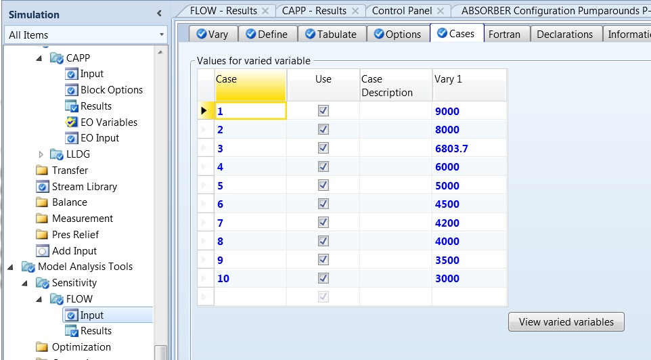

Figure : Setup of the “FLOW” sensitivity block for the case study.

1. Run the simulation. Navigate to “Results” under the Sensitivity block “FLOW” and then verify that the results are similar to those shown in Figure 36.

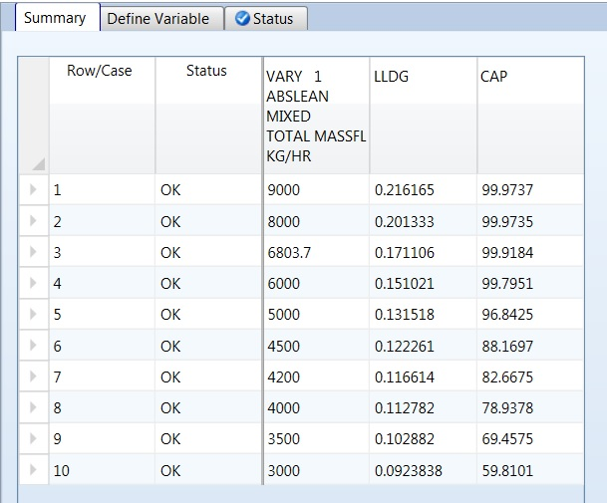

Figure : Results of the “FLOW” sensitivity block for the case study.

1. Navigate to “Blocks” → “Absorber” → “Profiles” and then highlight the columns labeled “Vapor Temperature” and “Liquid Temperature.” Under “Plot” on the “Home” tab, select “Custom,” and then verify that the resulting plot resembles Figure 37. **Note:** These temperature profiles correspond to the last simulation executed (Case 10 as defined in Figures 35–36).

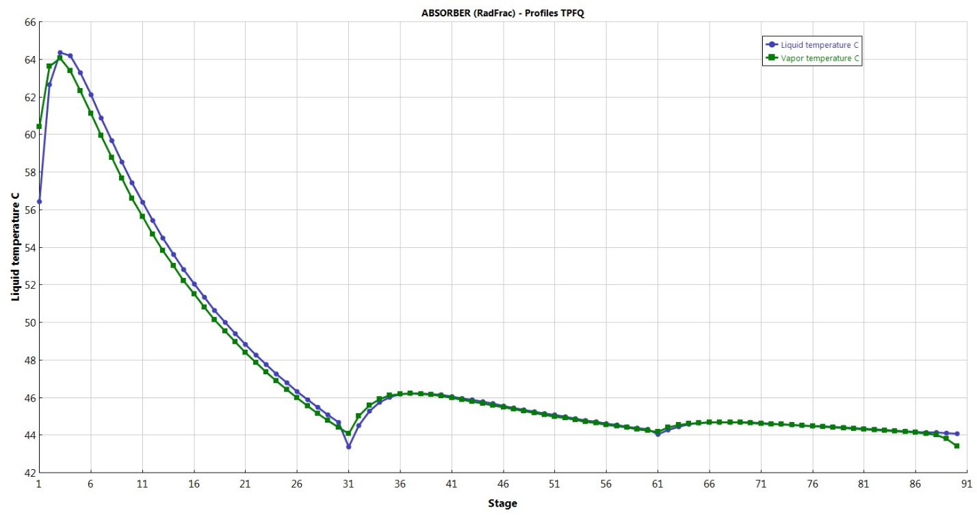

Figure : Absorber temperature profile for the case study.

1. Navigate to “Blocks” → “Regen” → “Profiles” and then repeat the procedure described in Step 6. Verify that the temperature profile resembles what is shown in Figure 38.

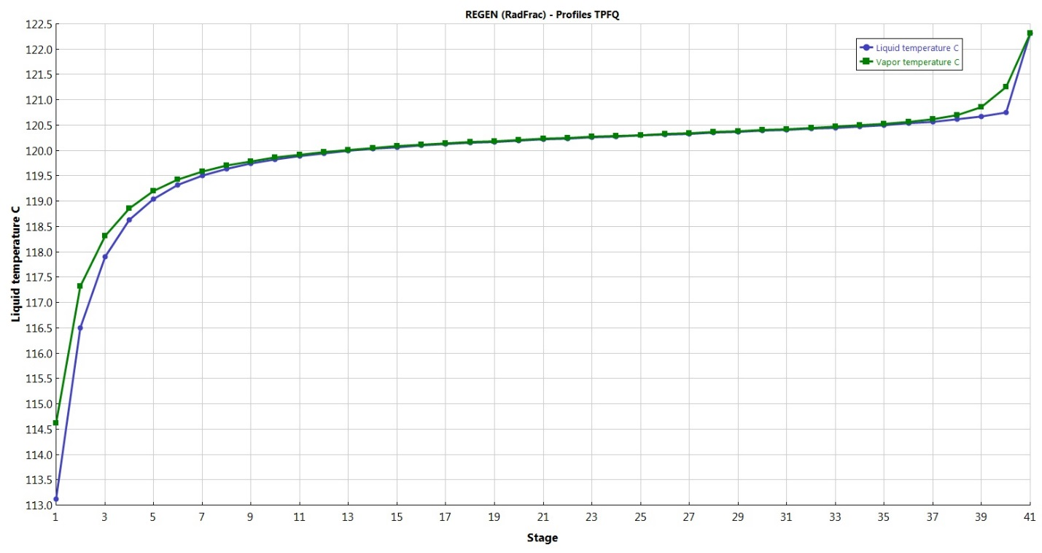

Figure : Regenerator temperature profile for the case study.

1. Usage Information
   1. Environment/Prerequisites

This product requires Aspen Plus V8.4 or newer with an Aspen Rate-Based Distillation license. As such, the supported environments are limited to:

* Windows® XP SP3
* Windows Vista® Business SP2
* Windows Vista Ultimate SP2
* Windows 7 Ultimate (32- and 64-Bit)
* Windows 7 Professional (32- and 64-Bit)
  1. Support

Support can be obtained from [ccsi-support@acceleratecarboncapture.org](mailto:ccsi-support@acceleratecarboncapture.org) or by filling out the “Submit Feedback/Request Support” form available on the product distribution page.

1. References

1. Morgan, J.C.; Bhattacharyya, D.; Tong, C.; Miller, D.C., Uncertainty Quantification of Property Models: Methodology and its Application to CO2-Loaded Aqueous MEA Solutions. *AIChE Journal* 2015, 61, (6), 1822-1839.

2. Plaza, J.M. Modeling of Carbon Dioxide Absorption Using Aqueous Monoethanolamine, Piperazine, and Promoted Potassium Carbonate. The University of Texas at Austin, 2012.

3. Mathias, P.M.; Gilmartin, J.P., Quantitative Evaluation of the Effect of Uncertainty in Property Models on the Simulated Performance of Solvent-Based CO2 Capture. *Energy Procedia* 2014, 63, 1171-1185.

4. Billet, R., Schultes, M., Prediction of mass transfer columns with dumped and arranged packings: updated summary of the calculation method of Billet and Schultes. *Chem Eng Res Des* 1999, 77, 498-504.

5. Tsai, R.E. Mass transfer area of structured packing. The University of Texas at Austin, 2010.

6. Dugas, R.E. Carbon Dioxide Absorption, Desorption, and Diffusion in Aqueous Piperazine and Monoethanolamine. The University of Texas at Austin, 2009.

7. Tobiesen, F.A.; Svendsen, H. F.; Juliussen, O., Experimental validation of a rigorous absorber model for CO2 postcombustion capture. *AIChE Journal* 2007, 53, 846-865.

MEA Dynamic Model

1. Model Background

This document describes the dynamic model of a solvent-based CO2 capture system using aqueous monoethanolamine (MEA). In addition to this user manual, the download folder consists of the main Aspen Plus® Dynamics® file “CCSI_MEAModel_dynamic.dynf” along with following supporting files:

* EQ_rxnmodified_abs3dyn.appdf
* EQ_rxnmodified_abs3dyn.opt
* EQ_rxnmodified_works.f
* jcm.dll
* jcm.opt

The first supporting file is the properties package obtained from the MEA steady-state process model. The remaining files are related to the FORTRAN user models. This model has been developed with Aspen Plus V8.4. For running the model successfully, all the files should be placed in the same folder.

1. General Information

Currently, there are very few dynamic models of chemical solvent-based CO2 capture systems. The existing few dynamic models available in the open literature are validated with a narrow range of operating conditions and for a single step change. As part of the Carbon Capture Simulation Initiative (CCSI), a dynamic model has been developed that has been validated using a wide range of experimental data from the National Carbon Capture Center (NCCC) in Wilsonville, Alabama.

* 1. Overview

This high fidelity “gold standard” steady-state model of the MEA system that has been developed in Aspen Plus as part of CCSI is a rate-based model. However, only equilibrium models are supported in Aspen Plus Dynamics. To get around with this issue, the rate-based model is approximated by using Murphree efficiencies similar to what has been described by Zhang et al.1 In this work the approach developed by Zhang et al.1 is further extended and the following correlation is regressed over a wide range of gas and liquid flows and compositions to obtain the Murphree efficiencies:

|  |  |
| --- | --- |
| $$ε=A{\left(\frac{F_{L}}{F_{Lo}}\right)}^{B}{\left(\frac{F_{V}}{F_{Vo}}\right)}^{C}{\left(\frac{{CO}_{2 load}}{{CO}_{2 load,o}}\right)}^{D}{\left(\frac{MEA}{{MEA}_{o}}\right)}^{E}$$ | (1) |

where, *F* is the flowrate, *CO2 load* is the ratio of mols of CO2 per mols of MEA in the liquid phase, and *MEA* is the MEA mass fraction in the liquid phase. The subscript *o* indicates a reference state of these variables, and the subscripts *L* and *V* indicate liquid and vapor phases, respectively. *A*, *B*, *C*, *D*, and *E* are parameters regressed to fit the conditions of the column profile using the method of least squares. The equation is then implemented in the equilibrium model in Aspen Plus Dynamics to approximate the   
rate-based results. Figure 39 shows the comparison between the rate based model and the equilibrium model enhanced with the Murphree efficiency model for CO2 flowrate from the top of the absorber. In the Aspen Plus Dynamics model, the Murphree efficiency model is implemented as a flowsheet constraint.

Figure : Equilibrium model and rate-based model comparison.

The flowsheet of the dynamic simulation is developed similar to the NCCC pilot plant configuration. Each equipment item is sized using the information from the NCCC pilot plant. This process model includes one flue gas condenser, one buffer tank between the absorber exit and the regenerator inlet, one heat exchanger between rich amine and hot lean amine followed by one cooler for the lean amine, and a lean amine storage tank. The absorber wash tower, the regenerator condenser, and the regenerator reboiler are also included in the flowsheet.

* 1. Thermodynamic Properties Package

This dynamic model is obtained by exporting the steady-state Aspen Plus model developed by CCSI (also part of this release), after converting it to an equilibrium model. Both the Aspen Plus and Aspen Plus Dynamics use Electrolyte-NRTL model in Aspen Properties® as the thermodynamic model.

Additional properties models as described in the User Manual of the Steady State MEA Model and in Morgan et al.,2 are implemented as FORTRAN user models. The thermodynamic framework of these systems is developed using UT Austin’s Phoenix model3 thermodynamic framework as a precursor. However, the model parameters of the Electrolyte-NRTL models are modified by using heat of absorption data of the ternary MEA-H2O-CO2 and binary MEA-H2O systems and additional VLE data, and heat capacity data. The kinetic model considers the following equilibrium reactions:

|  |  |  |
| --- | --- | --- |
|  | $$2MEA+{CO}_{2}↔{MEA}^{+}+{MEACOO}^{-}$$ | (2) |
|  | $$MEA+{CO}_{2}+H_{2}O↔{MEA}^{+}+{HCO}_{3}^{-}$$ | (3) |

The forward reaction rate constants are taken from the Phoenix model, but the overall reaction rate is written in terms of species activities and the equilibrium constants are calculated by using the thermodynamic framework of the system. This follows the methodology presented in Mathias and Gilmartin4, and is implemented to ensure that the chemical equilibrium is calculated consistently using the thermodynamic model.

* 1. Controllers Configuration

Table 18 provides a list of the controllers in the process flowsheet. The controller’s set-points correspond to a typical operating condition in NCCC. Each of these controllers are manually tuned to match the dynamic behavior observed for the collected data.

Table : List of Flowsheet Controllers

|  |  |  |
| --- | --- | --- |
| TAG | Description | Set-Point |
| LeanSolvent_FC | Lean solvent to absorber flow controller | 5674.60 kg/h |
| FlueGas_FC | Flue gas to absorber flow controller | 2248.37 kg/h |
| COND_LC | Flue gas condenser level controller | 5.33 m |
| ABS_DrumLC | Absorber sump level controller | 1.00 m |
| WASHTOW_PC | Absorber wash tower pressure controller | 1.05 bar |
| WASHTOW_LC | Absorber wash tower level controller | 1.83 m |
| BUFFER_LC | Buffer tank level controller | 2.25 m |
| REGEN_CondPC | Regenerator condenser level controller | 1.80 bar |
| REGEN_DrumLC | Regenerator top level controller | 0.64 m |
| REGEN_SumpLC | Regenerator sump level controller | 1.70 m |
| LeanTC | Lean solvent from heat exchanger temperature control | 50.50°C |
| SteamFC | Steam to regenerator reboiler flow controller | 500 kg/h |
| LeanColdTC | Lean solvent from cooler temperature control | 41.80°C |
| Tank_PC | Storage tank pressure controller | 1.00 bar |

1. Tutorial
   1. Reaching an Initial Steady-State

This example shows how to drive the process model from one steady-state to another. The lean solvent flowrate to the absorber is used as an example. Similar approach can be taken for perturbing other controlled variables.

1. Open the “CCSI_MEAModel_dynamic.dynf” file.
2. In the “Process Flowsheet Window,” double-click the controller “LeanSolvent_FC” to open the controller configuration window.

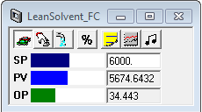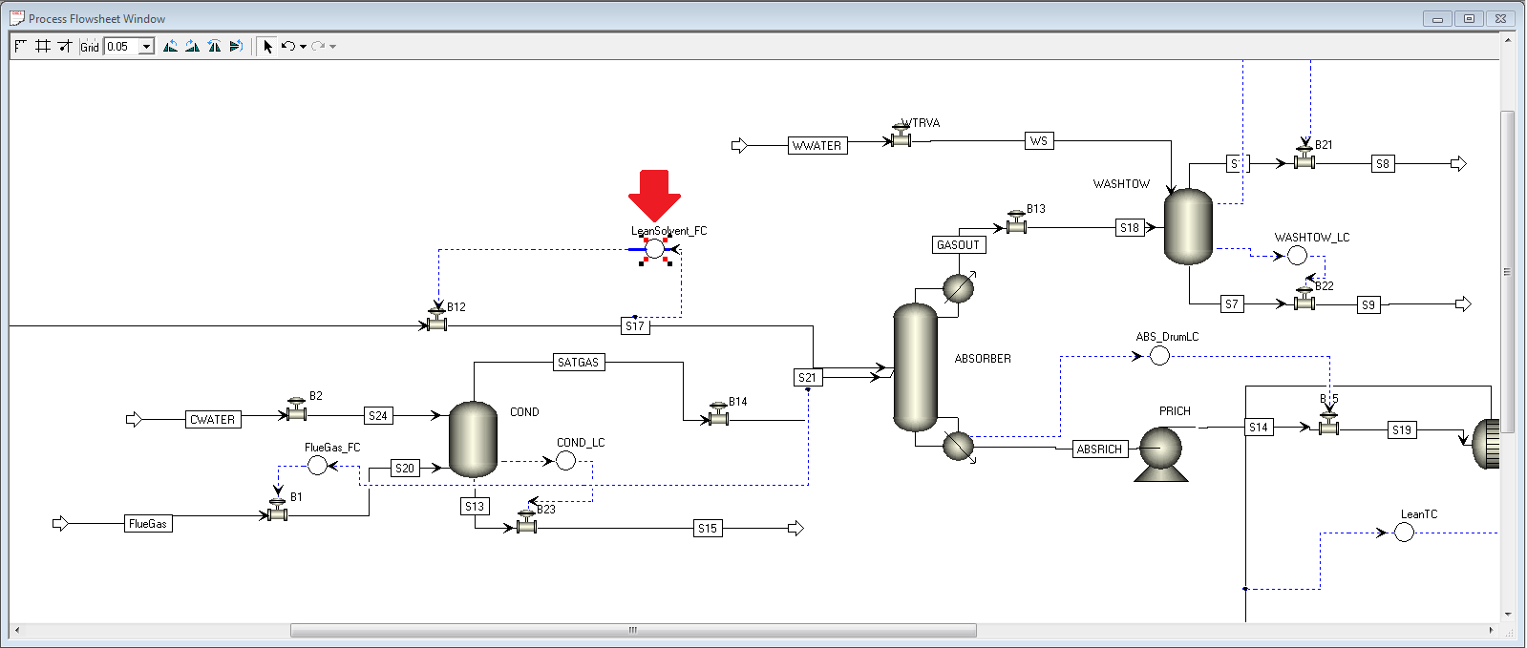

Figure : “LeanSolvent_FC” configuration window.

1. On the configuration window:
   1. Make sure the controller is in “auto-mode” as illustrated in Figure 40.
   2. Set “SP” to be “6000 kg/h.”
2. In the “Contents of Simulation” pane, located in the left side of the window, double-click “Flowsheet,” a new list of local files and options displays. Double-click the “Lean_Solvent” Form. Figure 41 illustrates this step.

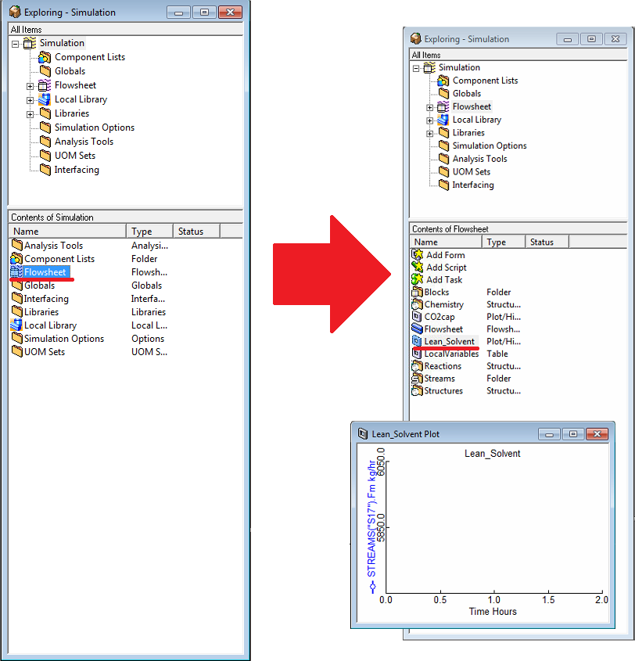

Figure : Opening a form.

1. Double-click the “x-axis” of the plot to open a configuration window that shows the axis properties. The default value for the time window is 2 hours, change it to “8.”
2. On the toolbar, click “Run Options,” as highlighted in red in Figure 42. Under “Simulation control,” change the “Pause at” value to “8” hours, which should be adequate to reach a new steady-state. This feature is very useful to introduce new step changes in the model, or to simply end the simulation at a given time.

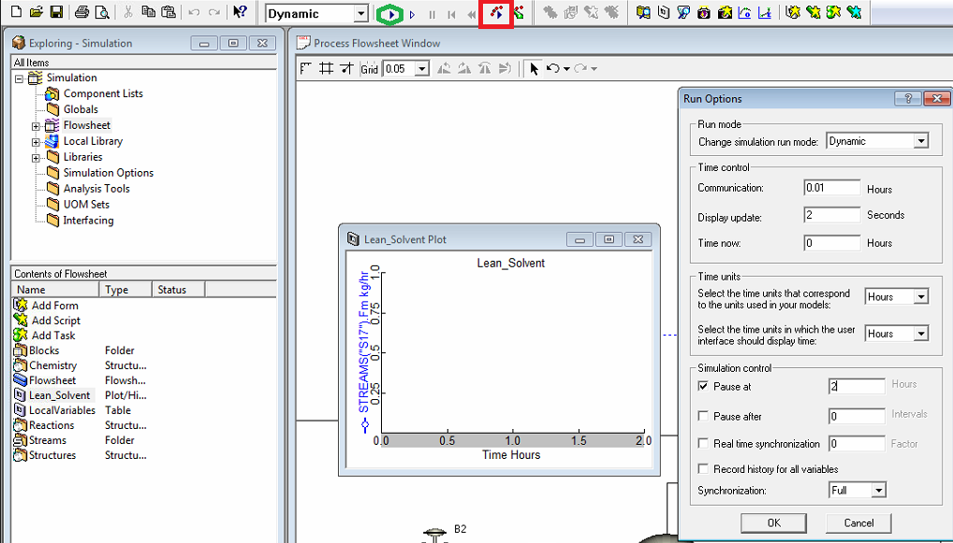

Figure : Run options.

1. Run the simulation by clicking “Play” as highlighted in green in Figure 43. The “Lean_Solvent” window records the behavior of the variable during the simulation. A plot similar to Figure 44 is expected. Figure 45 is a magnified version of the plot in Figure 44 showing the initial dynamics of the process.



Figure : Lean solvent flowrate behavior during step change to a new steady-state.



Figure : Lean solvent flowrate behavior during step change to a new steady-state (0.5 h).

* 1. CO2 Capture Dynamic Response Simulation

After a desired steady-state is reached, a number of step changes can be introduced to the system. In the beginning of this simulation, the lean solvent flowrate is at 5674 kg/h, which is the default lean amine flowrate when the file is opened.

1. Open the “CCSI_MEAModel_dynamic.dynf” file.
2. In the “Contents of Simulation” pane, located in the left side of the window, double-click “Flowsheet,” a new list of local files and options displays. Double-click “Lean_Solvent” Form and change the x-axis time window to “2” hours.
3. Repeat Step 2 for the “CO2 capture” Form.
4. On the toolbar, click “Run Options,” as highlighted in red in Figure 42. Under “Simulation control,” change the “Pause at” value to “0.50” hours.
5. Run the simulation until it is paused.
6. In the “Process Flowsheet Window,” double-click the controller “LeanSolvent_FC” to open the controller configuration window and then set “SP” to “6000.”
7. On the toolbar, click “Run Options,” as highlighted in red in Figure 42. Under “Simulation control,” change the “Pause at” value to “1.0” hours.
8. Run the simulation until it is paused.
9. In the “Process Flowsheet Window,” double-click the controller “LeanSolvent_FC” to open the controller configuration window and then set “SP” to “5674.”
10. On the toolbar, click “Run Options,” as highlighted in red in Figure 42. Under “Simulation control,” change the “Pause at” value to “1.5” hours.
11. Run the simulation until it is paused. Results similar to Figures 45 and 46 are expected.



Figure : Lean solvent flowrate into absorber.



Figure : CO2 capture percentage.

1. Reference

1. Zhang, Qiang; Turton, Richard; Bhattacharyya, Debangsu. Modeling and model predictive control of a MEA-based post-combustion CO2 capture process. Review Submitted, *Industrial & Engineering Chemistry* Research, 2015.

2. Morgan, J.C.; Bhattacharyya, D.; Tong, C.; Miller, D.C., Uncertainty Quantification of Property Models: Methodology and its Application to CO2-Loaded Aqueous MEA Solutions. *AIChE Journal* 2015, 61, 1822-1839.

3. Plaza, J.M. Modeling of Carbon Dioxide Absorption Using Aqueous Monoethanolamine, Piperazine, and Promoted Potassium Carbonate. PhD Thesis, The University of Texas at Austin, 2012.

4. Mathias, P.M.; Gilmartin, J.P., Quantitative Evaluation of the Effect of Uncertainty in Property Models on the Simulated Performance of Solvent-Based CO2 Capture. *Energy Procedia* 2014, 63, 1171-1185.

2-MPZ Model

**Intellectual Property Management Plan**

**February 28, 2011**

1. Introduction

This document describes a 2-methylpiperazine (2MPZ) CO2 capture system process simulation. The amine scrubbing system is divided into separate absorber and stripper simulations. The model consists of the “ThunderMoon.bkp” file with supporting subroutines “full.dll” and “2mpzloc.opt.” This manual was written using Aspen Plus® V7.3.

* 1. Predicting CO2 Solubility

Knowing the solubility of CO2 enables the user to select a loading range, as well as a stripper temperature and pressure. In this five minute example, a property analysis block is used to generate a series of isotherms for a fixed amine concentration and variable loading.

1. Open the “ThunderMoon.bkp” file, press “F8” to open the Data Browser, and then under “Setup” change the “Run type” to “Property Analysis.”
2. In the left pane, navigate to “Properties” → “Analysis.” Click “New” to create a new analysis block. Enter its “ID” as “82MPZVLE” and then select the “type” as “generic.” Change the “system basis” to “Mass” and then set “H2O” to “1000 kg/sec.”
3. On the “Variable” tab, change “Temperature” to “Vapor Fraction” and then set “Vapor Fraction” to “1e-05.” Create three variables: (1) Temperature, (2) Mole Flow 2MPZ, and (3) Mole Flow CO2. Select these variables and then click “Range/List” at the bottom of the window to define them.
   1. Temperature is a list: 293.15, 313.15, 333.15, 353.15, 373.15
   2. Mole Flow 2MPZ is a list: 8
   3. Mole Flow CO2 is a range: Lower=0, Upper=8, Points=20
4. On the “Tabulate” tab, select “PPCO2-KP” for the partial pressure of CO2 in kilopascals.
5. Run the simulation. A pop-up window displays, “Table generation completed with warnings. Results are present. Display Run-Status results form?” Click “Cancel.”
6. To view the results, navigate to “Properties” → “Analysis” → “82MPZVLE” → “Results.” Some of the results are shown in Table 19. Using additional graphing software, the user can plot results as shown in Figure 47.

Table : Excerpt of 2MPZ VLE Results

| Temp  K | Mole Flow 2MPZ kmol/sec | Mole Flow CO2 kmol/sec | Vapor PPMX CO2 kPa |
| --- | --- | --- | --- |
| 293.15 | 8 | 0 | 0 |
| 293.15 | 8 | 0.4 | 0.000101 |
| 293.15 | 8 | 0.8 | 0.000312 |
| 293.15 | 8 | 1.2 | 0.000629 |
| 293.15 | 8 | 1.6 | 0.001112 |
| 293.15 | 8 | 2 | 0.001886 |
| 293.15 | 8 | 2.4 | 0.003193 |
| 293.15 | 8 | 2.8 | 0.005527 |
| 293.15 | 8 | 3.2 | 0.009976 |
| 293.15 | 8 | 3.6 | 0.019235 |
| 293.15 | 8 | 4 | 0.040809 |
| 293.15 | 8 | 4.4 | 0.097194 |
| 293.15 | 8 | 4.8 | 0.249722 |
| 293.15 | 8 | 5.2 | 0.607471 |
| 293.15 | 8 | 5.6 | 1.256137 |
| 293.15 | 8 | 6 | 2.213122 |
| 293.15 | 8 | 6.4 | 3.523392 |
| 293.15 | 8 | 6.8 | 5.433286 |
| 293.15 | 8 | 7.2 | 8.835594 |
| 293.15 | 8 | 7.6 | 18.2461 |
| 293.15 | 8 | 8 | 188.3118 |

Figure : CO2 solubility in 8 m 2MPZ.

Using Property Analysis blocks, the user can explore many other properties of the solvent, such as vapor pressure or viscosity.

* 1. Features List

This product is a thermodynamic and kinetic model of 2MPZ for amine scrubbing; therefore, it represents the CO2 solubility, speciation, amine vapor pressure, heat capacity, pKa, heat of absorption, density, and viscosity for 2MPZ. While the model can extrapolate over a range of amine concentration, loading, and temperature, it is based on data collected primarily at 8 m 2MPZ with loadings ranging from 0 to 0.4 mol CO2/mol alkalinity.

1. Tutorial

This tutorial assumes basic knowledge of Aspen Plus software. Consult the Aspen Plus documentation, “Getting Started Building and Running a Process Model,” for additional information.

* 1. Absorber Simulation

Description

This example describes how to simulate a rate-based absorber. It includes tips on converging simulations, using design specifications to meet process criteria, and determining the proper discretization to be used for rate-based calculations.

Examples

*Setup*

1. Build the flowsheet of Figure 48, using an ABSBR1 RadFrac column. In the “Model Library” pane at the bottom of the window, navigate to “Columns” → “RadFrac” → “ABSBR1.” (If the model library is not visible, press “F10.”) Place the block on the flowsheet and name it “ABSORBER.” If a prompt to name the flowsheet does not display, right-click the block and then select “Rename Block.”

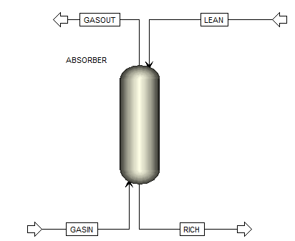

Figure : A simple absorber.

1. Select “Material STREAMS” in the model library. Create GASIN by clicking the arrow on the left of the block (the feed) and then clicking elsewhere. Create RICH by clicking the arrow at the bottom (the bottoms). Create GASOUT by clicking the arrow at the top (the vapor distillate). Lastly, create LEAN by clicking the now blue arrow on the left (the feed).
2. Double-click “GASIN” to configure it as follows:
   1. Temperature: 40 C
   2. Pressure: 1 atm
   3. Total flow: 5 kmol/sec
   4. Composition: Mole-Frac
      1. H2O: 7.3
      2. CO2: 12
      3. N2: 80.7

**Note:** Aspen normalizes the mole fractions to one.

1. Select “LEAN” from the left pane and configure it as follows:
   1. Temperature: 40 C
   2. Pressure: 1 atm
   3. Total flow: 20 kmol/sec
   4. Composition: Mole-Frac
      1. H2O: 55.556
      2. CO2: 4.32
      3. 2MPZ: 8
2. In the left pane, navigate to “Blocks” → “ABSORBER” and then configure its “Setup” as follows:
   1. On the “Configuration” tab:
      1. Calculation type: Rate-Based
      2. Number of stages: 30
      3. Condenser: none
      4. Reboiler: none
   2. On the “Streams” tab:
      1. GASIN On-Stage 30
      2. LEAN On-Stage 1
   3. On the “Pressure” tab, set the “Top stage pressure” to “1 atm.”
3. Configure the absorber Reactions with two sections:
   1. One starts on stage 1 and ends on stage 3 with Reaction ID ZERO.
   2. The other starts on stage 4 and ends on stage 30 with Reaction ID ZERO.

**Note:** This reaction set is used to ease convergence of the simulation. It is the 2MPZ reaction set with all activation energies and reaction pre-exponentials set to “0.”

1. Create a new pack rating section 1. Configure its “Specifications” as follows:
   1. Starting stage: 1
   2. Ending stage: 30
   3. Type: MELLAPAK
   4. Vendor: SULZER
   5. Material: STANDARD
   6. Dimension: 250X
   7. Section diameter: 8 meter
   8. Section packed height: 15 meter

**Note:** As the column is packed, the number of stages does not represent trays. It is purely a computational construct. The more stages, the more finely discretized the column. However, this results in more computation time. As a very rough approximation, one stage for every half meter of packing is recommended. Use more stages for greater temperature and mass transfer gradients.

* 1. Navigate to “Rate-based” from the left pane (“Pack Rating” → “1” → “Rate-based”). Configure it as follows:
     1. Select the “Rate-based calculations” check box.
     2. Flow model: Countercurrent
     3. Film resistance:
        1. Liquid phase: Discrxn
        2. Vapor phase: Film
  2. On the “Holdups” tab, set the “Holdup Method Correlation” to “Percent-Data” and then set the “Liquid Phase” to “Correlation with % of free volume set to 5.”
  3. On the “Design” tab, select the “Design mode” check box to calculate column diameter with Base Stage as 30.
  4. On the “Optional” tab, set the “Additional discretization points” to the “32” shown in Table 20.

Table : Boundary Layer Discretization

| Point | Liquid Film |  |  | Point | Liquid Film |
| --- | --- | --- | --- | --- | --- |
| 1 | 6.40E-05 |  |  | 17 | 0.0106 |
| 2 | 7.68E-05 |  |  | 18 | 0.0127 |
| 3 | 0.000159 |  |  | 19 | 0.0152 |
| 4 | 0.000229 |  |  | 20 | 0.0182 |
| 5 | 0.00033 |  |  | 21 | 0.0219 |
| 6 | 0.000476 |  |  | 22 | 0.0263 |
| 7 | 0.000571 |  |  | 23 | 0.0315 |
| 8 | 0.0007 |  |  | 24 | 0.0378 |
| 9 | 0.000986 |  |  | 25 | 0.0454 |
| 10 | 0.00118 |  |  | 26 | 0.059 |
| 11 | 0.00142 |  |  | 27 | 0.0826 |
| 12 | 0.00187 |  |  | 28 | 0.124 |
| 13 | 0.0027 |  |  | 29 | 0.198 |
| 14 | 0.00389 |  |  | 30 | 0.317 |
| 15 | 0.0056 |  |  | 31 | 0.507 |
| 16 | 0.00806 |  |  | 32 | 0.862 |

1. Under “Flowsheeting,” navigate to “Options” → “Calculator” and then create a new Calculator named “C-RM.” This block calculates the fraction of CO2 captured.
   1. On the “Define” tab, create three variables:

|  |  |  |
| --- | --- | --- |
| Variable Name | Information Flow | Definition |
| REMOVE | Export | Parameter Parameter no. = 2 |
| CO2IN | Import | Mole-Flow Stream = GASIN; Substream = MIXED; Component = CO2 Units=kmol/sec |
| CO2OUT | Import | Mole-Flow Stream = GASOUT; Substream = MIXED; Component = CO2 Units=kmol/sec |

* 1. On the “Calculate” tab, type “F REMOVE=(CO2IN-CO2OUT)/CO2IN.”

**Note:** Between “F” and “REMOVE” there are five spaces.

1. Create a Design Spec named “REMOVAL.”
   1. On the “Define” tab, create a variable “REMOVE” and assign it to parameter 2.
   2. On the “Spec” tab:
      1. Spec: REMOVE
      2. Target: 0.90
      3. Tolerance: 0.000001
   3. On the “Vary” tab:
      1. Type: Stream-Var
      2. Stream: LEAN
      3. Variable: MOLE-FLOW
      4. Lower: 5
      5. Upper: 300

*Running the Simulation*

1. Deactivate the design spec by right-clicking the design spec and then selecting “Deactivate.”
2. Run the simulation, which provides Aspen a good initial guess.
3. Change the absorber “Reactions” to “R-1” from ZERO for stages one to three. Run the simulation.
4. Change the absorber “Reactions” to “R-1” from ZERO for the remaining stages. Run the simulation.
5. Increase the “section packed height” under the pack rating to “12 m,” and then run the simulation.
6. Review the C-RM calculator block results (“Flowsheeting Options” → “Calculator” →   
   “C-RM” → “Results” on the “Define Variable” tab) to determine if the fractional CO2 removal is approximately 0.51.
   1. Increase the LEAN stream total flow in 10 kmol/sec increments until the percent removal is within 0.10 of 0.90. Be sure to run the simulation after each increment.
7. Once approximately 90% removal has been achieved, activate the Design Spec REMOVAL by right-clicking “Design Spec” → “Removal” and then selecting “Activate.” Run the simulation.
8. The converged absorber should now be removing 90% of the incoming CO2. Results should be similar to those shown in Figures 49–51 below. View the results by selecting   
   “Results Summary” → “Streams, Flowsheeting Options” → “Design Spec” → “Removal” → “Results, and Blocks” → “ABSORBER” → “Pack Rating” → “1” → “Results.”

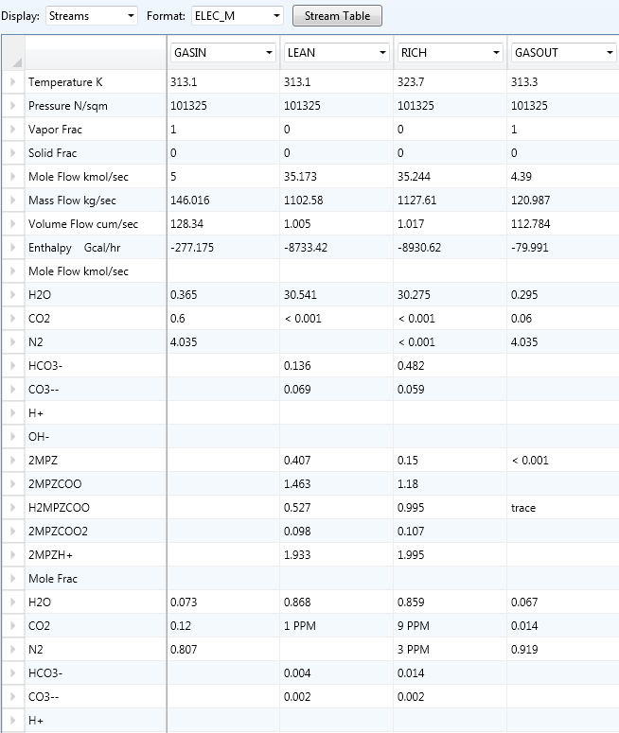

Figure : Excerpt of stream results.

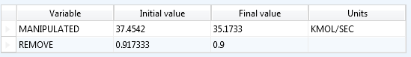

Figure : Design specification REMOVAL results.

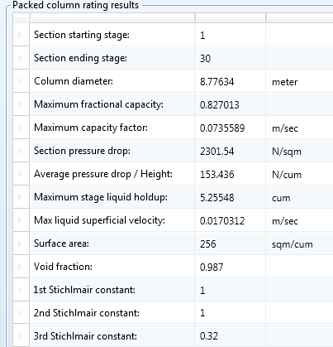

Figure : Packed column rating results.

* 1. Stripper Simulation

Description

This example is a guide to simulating a simple stripper and a heat exchanger.

Examples

*Setup*

1. Open the “ThunderMoon.bkp” file.
2. Construct the flowsheet shown in Figure 52. From “Columns” in the “Model Library,” select “RadFrac” → “STRIP1” for the stripper. From “Heat Exchangers,” select “Heater” for   
   “CX-COLD,” “CX-HOT,” and “HX-TRIM.” From “Pressure Changers,” select “pump” for “LEANPUMP.” Create the streams using “Material STREAMS.”

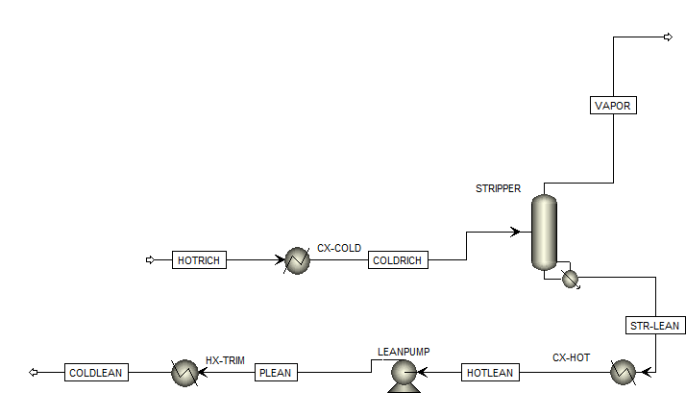

Figure : Stripper simulation flowsheet.

1. Set “HOTRICH” to the values from the absorber example.
   1. Temperature: 323.7 K
   2. Pressure: 11 bar
   3. Total flow: 35.244 kmol/sec
   4. Composition: Mole-Frac
      1. H2O 55.556
      2. CO2 5.29
      3. 2MPZ 8

**Note:** The pressure is set as if coming from a pump. This pump is neglected for simplicity.

1. Set “CX-COLD”:
   1. Pressure: 0 N/sqm
   2. Temperature: 85 C
   3. Valid phases: Liquid-Only

**Note:** Pressure drop is neglected.

1. Configure the “STRIPPER Setup” as follows:
   1. On the “Configuration” tab:
      1. Calculation type: Rate-Based
      2. Number of stages: 15
      3. Condenser: None
      4. Reboiler: Kettle
      5. Reboiler duty: 225 MW
   2. On the “Streams” tab, set “COLDRICH” to “stage 1 as liquid.”
   3. On the “Pressure” tab, set the “top stage pressure” to “3 bar.”
2. Set reactions in the stripper to stages 1–15 using “Chemistry ID REDUCED.”
3. Create a new Pack Rating for the stripper and configure it as follows:
   1. Under “Setup,” stages 1–14 use “MELLAPAK,” “SULZER,” “STANDARD,” “250X” with a “diameter” of “5 m,” and a “section packed height” of “2 m.”
   2. Under “Rate-Based,” select the “Rate-based calculations” check box with “Film Resistance” set to “Film for liquid and vapor phases.” On the “Design” tab, select the “Design mode” check box to calculate column diameter and then set the “base stage” to “14.”
4. Configure “CX-HOT”:
   1. Temperature: 50 C
   2. Pressure: 0 N/sqm
5. Configure “LEANPUMP”:
   1. Discharge pressure: 250 kPa
6. Configure “HX-TRIM”:
   1. Temperature: 40 C
   2. Pressure: 0 N/sqm

**Note:** This flowsheet takes the rich stream from the previous absorber tutorial, passes it through a cross-exchanger, and then to the stripper. CX-COLD and CX-HOT are used to simulate the cross exchanger. HX-TRIM is the trim cooler to lower the lean solvent down to 40°C prior to entering the absorber.

1. Create a LOADINGS calculator.
   1. Define the variables as shown in Table 21.
   2. The Fortran code is

F LLDG=(LCO2+LCO3+LHCO3+L2MPZCOO+2*L2MPZC2+LH2MPZC)/

F (2*(L2MPZ+L2MPZH+L2MPZCOO+L2MPZC2+LH2MPZC))

F RLDG=(RCO2+RCO3+RHCO3+R2MPZCOO+2*R2MPZC2+RH2MPZC)/

F (2*(R2MPZ+R2MPZH+R2MPZCOO+R2MPZC2+RH2MPZC))

Table : Variables for the LOADINGS Calculator

| Variable Name | Information Flow | Definition |
| --- | --- | --- |
| RLDG | Export | Parameter Parameter no. = 3 |
| LLDG | Export | Parameter Parameter no. = 4 |
| LCO2 | Import | Mole-Frac Stream = STR-LEAN; Substream = MIXED; Component = CO2 |
| L2MPZ | Import | Mole-Frac Stream = STR-LEAN; Substream = MIXED; Component = 2MPZ |
| L2MPZH | Import | Mole-Frac Stream = STR-LEAN Substream = MIXED; Component = 2MPZH+ |
| L2MPZCOO | Import | Mole-Frac Stream = STR-LEAN; Substream = MIXED; Component = 2MPZCOO |
| L2MPZC2 | Import | Mole-Frac Stream = STR-LEAN; Substream = MIXED; Component = 2MPZCOO2 |
| LH2MPZC | Import | Mole-Frac Stream = STR-LEAN; Substream = MIXED;  Component = H2MPZCOO |
| LHCO3 | Import | Mole-Frac Stream = STR-LEAN; Substream = MIXED; Component = HCO3- |
| LCO3 | Import | Mole-Frac Stream = STR-LEAN; Substream = MIXED; Component = CO3-- |
| R2MPZ | Import | Mole-Frac Stream = HOTRICH; Substream = MIXED; Component = 2MPZ |
| R2MPZH | Import | Mole-Frac Stream = HOTRICH; Substream = MIXED; Component = 2MPZH+ |
| R2MPZCOO | Import | Mole-Frac Stream = HOTRICH; Substream = MIXED; Component = 2MPZCOO |
| R2MPZC2 | Import | Mole-Frac Stream = HOTRICH; Substream = MIXED; Component = 2MPZCOO2 |
| RH2MPZC | Import | Mole-Frac Stream = HOTRICH; Substream = MIXED; Component = H2MPZCOO |
| RHCO3 | Import | Mole-Frac Stream = HOTRICH; Substream = MIXED; Component = HCO3- |
| RCO3 | Import | Mole-Frac Stream = HOTRICH; Substream = MIXED; Component = CO3-- |

1. Create a Design Spec named “SETLEAN.”
   1. Define “LLDG” as “Parameter 4.”
   2. “Spec LLDG” to “0.27 with a tolerance of 0.001.”
   3. On the “Vary” tab under “Manipulated variable limits,” Lower: 0 and Upper: 5.5E8 Watts. Under “Manipulated variable” set the following:
      1. Type: Block-Var
      2. Block: STRIPPER
      3. Variable: QN
2. Create a Design Spec named “SETTEMP.”
   1. Define “TEMP” as “Stream-Var Stream=STR-LEAN Substream=MIXED Variable=TEMP Units=K.”
   2. “Spec TEMP” to “423.15 K with a tolerance of 0.01.”
   3. On the “Vary” tab, set the “Manipulated variable limits” to “300000 to 1500000N/sqm.” Under “Manipulated variable” set the following:
      1. Type: Block-Var
      2. Block: STRIPPER
      3. Variable: STAGE-PRES
      4. ID1: 1

*Running the Simulation*

1. Deactivate both design specs.
2. Run the simulation.
3. Review the lean loading (LLDG) in the LOADINGS calculator block by navigating to the “Define Variable” tab of “Results.” Decrease the stripper reboiler duty in 25 MW increments until the lean loading is close to the desired value of 0.27. Run the simulation after each decrement.
4. Activate the SETLEAN design spec and then run the simulation.
5. Activate the SETTEMP design spec and then run the simulation.
6. Create a heat stream from CX-HOT to CX-COLD named “Q-XC.” To clear the temperature specification of CX-COLD, double-click the block, right-click “temperature” under “flash specifications,” and then select “Clear.”
7. Run the simulation. Results similar to those in Figures 53–55 should be displayed. To view these results, navigate to “Results Summary” → “Streams, Flowsheeting Options” →   
   “Design Spec” → “SETLEAN” → “Results, Flowsheeting Options” → “Design Spec” → “SETTEMP” → “Results, and Blocks” → “STRIPPER” → “Pack Rating” → “1” → “Results.”

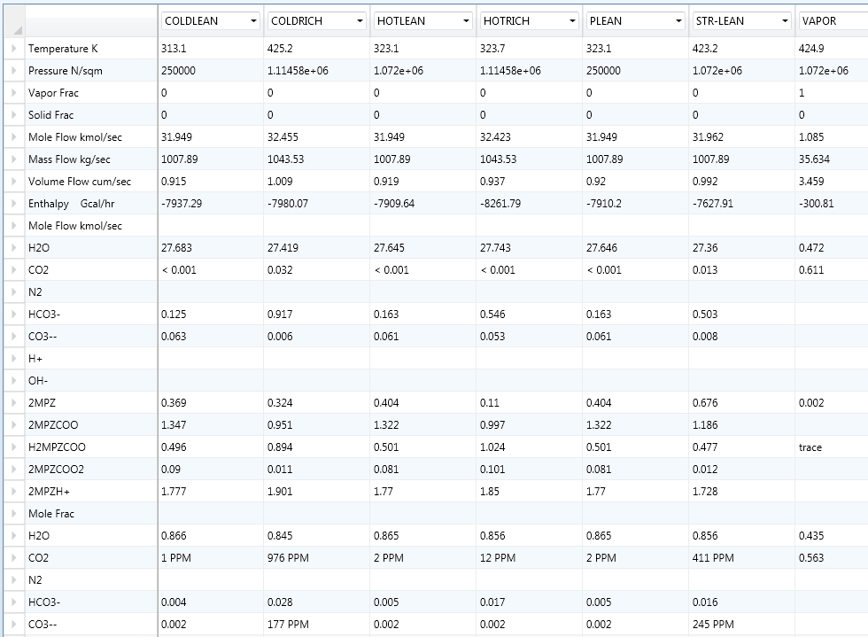

Figure : Excerpt of stream results.

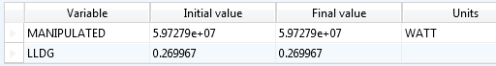

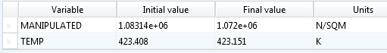

Figure : The design specification results.

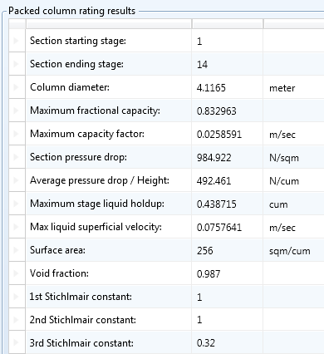

Figure : Excerpt from packed column rating results.

1. Usage Information
   1. Environment/Prerequisites

This product requires Aspen Plus V7.3 or newer with an Aspen Rate-Based Distillation license. As such, the supported environments are limited to:

* Windows® XP SP3
* Windows Vista® Business SP2
* Windows Vista Ultimate SP2
* Windows 7 Ultimate (32- and 64-Bit)
* Windows 7 Professional (32- and 64-Bit)
  1. Support

Support can be obtained from [ccsi-support@acceleratecarboncapture.org](mailto:ccsi-support@acceleratecarboncapture.org) or by filling out the “Submit Feedback/Request Support” form available on the product distribution page.

* 1. Restrictions

The model is centered at an amine concentration of 8 m. Extrapolating far from this concentration should be done with care.

* 1. Next Steps

The next release will include a heat exchanger model that predicts area as a function of pressure drop and solvent viscosity and a model for kla in the absorber and stripper as a function of viscosity.

1. Debugging

The model is running correctly if it is converging for the above tutorials with similar results. If it is not, see the next section, “How to Debug.”

* 1. How to Debug

Always run the simulation with the control panel visible. It is the only output available during computation, and it notifies the user whether or not the simulation will converge. This enables the user to avoid wasting time on fruitless computation. Furthermore, it alerts the user to any problems encountered during computation.

*Subroutine Errors*

If the following error message displays:

*** SEVERE ERROR

COULD NOT RESOLVE USER OR IN-LINE FORTRAN SUBROUTINE(S):

the simulation will not run. The possible causes and solutions are:

1. The “.bkp” file and the “.dll” and “.opt” files are not located in the same directory. Move all the files into the same directory to resolve this.
2. The linker is not specified in the run settings. Set the linker to “2mpzloc.opt.”

*Simulation Problems*

* If warnings are displayed regarding unusual liquid molefrac profile or unusual component production profile, follow the suggested instructions in the error message.
* If a warning is displayed stating that the water liquid viscosity model MULH2O is violated due to the temperature being lower than the minimum temperature limit, something is not specified correctly. Review the inputs and re-run.
* Ignore flooding errors (TPSAR MESSAGE: XXX.XX% FLOOD IN COLUMN EXCEEDS 80%) unless it displays in the final step.

*Aiding Convergence*

* Only reinitialize when absolutely necessary.
* Make small changes in a converged model.
* Converge an initial, simple case before enabling reactions and design specifications. It is recommended that only small changes are made; therefore, only turn on one of these at a time.
* Before enabling the design specification, the variable should be close to the desired value.
  1. Known Issues
* Flash errors can occur if the solvent goes above 0.5 mol CO2/mol alk.
* Multiple warnings display regarding property data while processing input specifications that follow this pattern, “PARAMETER XXX DATA SET 1 FOR COMPONENT 2MPZ HAS BEEN ENTERED MORE THAN ONCE. THE LAST ENTRY WILL BE USED.”, where XXX is the parameter name.
* In running the tutorials, warnings display that the mole fractions are normalized to unity.
* Warnings display that IONRDL is missing for 2MPZCOO, 2MPZCOO2, and 2MPZH+.
* Using design mode to calculate column diameter for the absorber can lead to inconsistent results. With the absorber tutorial, the model may converge with a diameter of 4.58 m.
  1. Reporting Issues

To report an issue, please send an e-mail to [ccsi-support@acceleratecarboncapture.org](mailto:ccsi-support@acceleratecarboncapture.org).

1. Model History

This section details the creation of Thunder Moon, including the data used in the regressions.

* 1. Thermodynamic Model

Thunder Moon is based on previous work using the electrolyte NRTL model (Chen, 2011). The model is focused on the operating conditions for capture from a coal-fired power plant, meaning a loading range from 0.27 to 0.37 mol CO2/mol alkalinity. The thermodynamic framework was modified slightly in that the default chemistry used had proton and hydroxide ions removed to enhance convergence. The equilibrium chemistry is shown in Table 22.

Table : The Thunder Moon Chemistry Block

|  |
| --- |
| Model Chemistry |
| 2 2MPZ + CO2 ↔ 2MPZCOO‒ + 2MPZH+ |
| 2 2MPZCOO‒ + CO2 ↔ 2MPZCOO2 + H2MPZCOO |
| 2MPZCOO‒ + CO2 + H2O ↔ HCO3‒ + H2MPZCOO |
| 2MPZ + H2MPZCOO ↔ 2MPZH+ + 2MPZCOO‒ |
| 2MPZCOO‒ + HCO3‒ ↔ CO3‒‒ + H2MPZCOO‒ |

Changing the chemistry reaction set did not significantly affect the thermodynamic model; therefore, all fits are the same as in (Chen, 2011). In the process of verifying all fits, a discrepancy between the calorimetric and thermodynamic methods for calculating heat of absorption was uncovered.

|  |  |  |
| --- | --- | --- |
|  |  | (1) |
|  |  | (2) |

where *Q* is the net-duty of the flash block, and  is the molar flow rate of gaseous CO2. The heat of absorption is calculated by sending a loaded solvent stream and a gaseous CO2 stream to a flash block for a bubble point calculation.

The latter method using Equation 1 is shown in Figure 56; while the former using Equation 2 is shown in Figure 57. (The process model uses the calorimetric heat of absorption.) The disagreement between the two methods occurs above a loading of 0.25, as shown in Figure 58. It is suspected that the deviation above a loading of 0.25 mol CO2/mol alkalinity is due to the zwitterion becoming a significant species.

Figure : Thermodynamic heat of absorption of 8 m 2MPZ calculated from Equation 1.

Figure : Calorimetric heat of absorption of 8 m 2MPZ calculated from Equation 2.

Figure : The absolute differences between the two heat of absorption calculations, which agree well until a loading of 0.25 mol CO2/mol alkalinity, where the zwitterion becomes significant.

In conclusion, the thermodynamic model represents amine volatility, CO2 solubility, pKa, speciation, density, and viscosity data (Chen, 2011).

* 1. Kinetic Model

The kinetics were regressed using a wetted wall column (WWC) Aspen Plus simulation to adjust reaction rate constants, activation energies, and diffusion parameters to match experimental flux values within 20% (Plaza, 2011; Rochelle et al., 2012). Activity-based kinetics are used as in (Chen, 2011). The process flow diagram is shown in Figure 59.

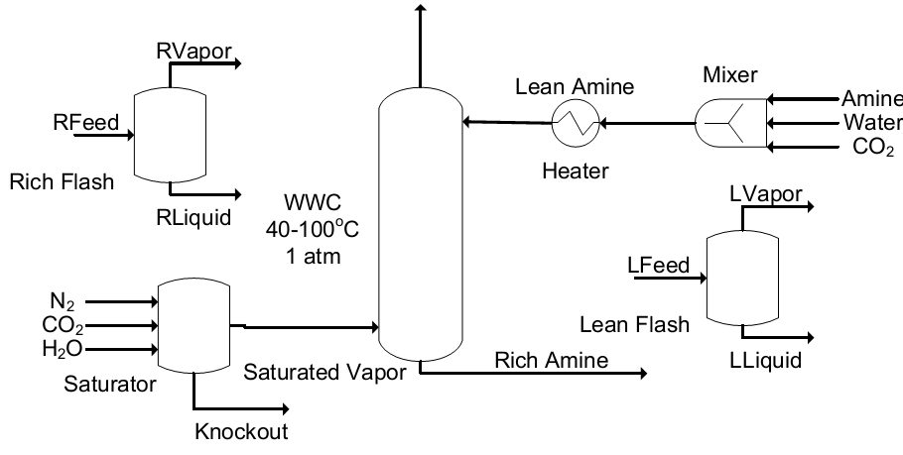

Figure 59: WWC process flow diagram for Aspen Plus.

The solvent is fed as three separate streams of amine, water, and CO2. When mixed, the solvent heats up due to heat of mixing and speciation; therefore, a heater is used to return it to the desired temperature for isothermal operation. The entire WWC is operated isothermally to mimic laboratory conditions. The gas is fed to a flash vessel, which saturates it with water. The gas and solvent are contacted in the WWC, which has the same height as the real life apparatus (9.1 cm) but a diameter that is 100x larger (0.44 cm x100). The rich and lean flash vessels flash the rich and lean amine streams after the heater to calculate the equilibrium partial pressure of CO2.

Aspen Plus discretizes the boundary layer to perform its mass transfer calculation for the reactions. The previous discretization used 50—the maximum number of points possible—which means it requires the most computation time (Chen, 2011). Based on prior studies (Kucka et al., 2003) and looking at previous modeling work (Plaza, 2011), the number of discretization points was reduced without any loss of accuracy. The old and new discretizations are compared in Figure 60.

Figure 60: Boundary layer discretization. The x-axis is fraction through the boundary layer with the gas-liquid interface at left and the bulk liquid at right.

The complete reaction set used is shown in Table 23. The forward and reverse kinetic reactions are represented separately in Aspen Plususing a powerlaw form shown in Equation 3.

|  |  |  |
| --- | --- | --- |
|  |  | (3) |

The forward reaction rates are calculated, and then the reverse rates are back-calculated using the reaction equilibrium constant. The bicarbonate-forming reaction was fixed using values from literature (Ko & Li, 2000), while the dicarbamate-forming reaction was ratioed to the carbamate-forming reaction by assuming the Brønsted plot of PZ holds (kcarbamate = 0.88kdicarbamate). This plot is shown in Figure 61. Thus, only the carbamate-forming reaction was regressed.

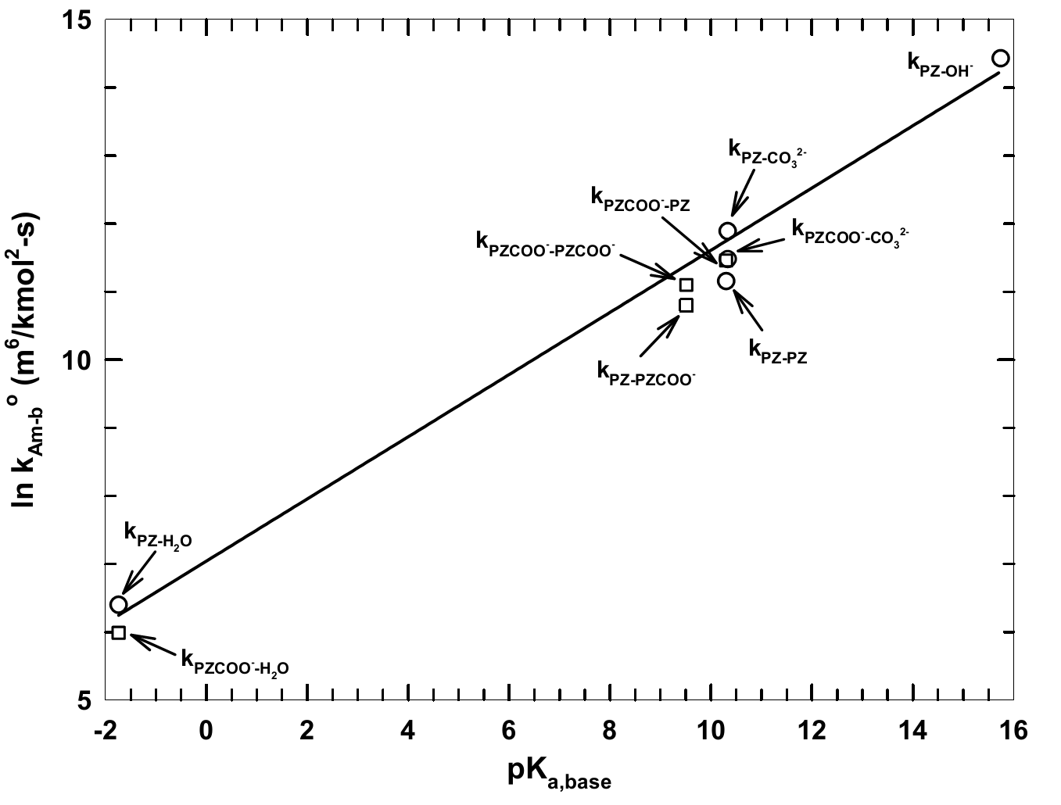

Figure : Brønsted plot showing the reaction rate constant (kAm-b) versus the pKa of a  
base for an amine catalyzed by a base, kAm-base.

To calculate ko and EA, two points were chosen at different loadings: one where the bicarbonate reaction is insignificant and a second, higher one where the bicarbonate is significant. At each of these points, the 40°C and 60°C fluxes were examined. Using a fixed set of kinetic parameters, the loading was adjusted to ensure that at zero driving force there is zero flux. This adjustment was made until the ratio of predicted flux to actual flux for the absorption and desorption points were within 1% of each other, or until the loading had been adjusted up to 10% of the operational loading range. Therefore, the maximum loading adjustment was ±0.01 mol CO2/mol alk.

Once this loading adjustment was completed, a design specification was used to match the flux exactly by varying the ko of one reaction. This is tested at two different temperatures to produce a coherent set of ko and EA ­for all reactions. The diffusivity parameters of Equation 4 were also adjusted. The diffusivity adjustments were made to fit the higher temperature data points primarily.

|  |  |  |
| --- | --- | --- |
|  |  | (4) |

With all parameters fixed, the WWC flux cases were all simulated. The power-law parameters, the loading, and the diffusivity parameters were adjusted. The flux cases were again simulated and this process was repeated until a satisfactory fit emerged.

Using a very small reaction set, most of the data were matched within 20%. There were nine predicted fluxes not within 20% of the experimental fluxes. The kinetic fit is displayed in Figures 62 and 63. As seen in Figure 62, the predictions worsen at higher temperatures as experimental error is expected to increase and as the mechanism shifts to diffusion-dominated. In addition to increasing scatter with increasing temperature, there is a linear systematic bias. Efforts to correct for this bias by changing the reference temperature for diffusivity were unsuccessful. Figure 63 shows no systematic trend with loading and the scatter with temperature remains approximately constant.

Table 23 shows the power-law parameters, and Table 24 shows diffusivity parameters. While the dependence of diffusivity on viscosity is reasonable, its dependence on temperature is probably indicative not of a physical effect, but of the diffusivity being distorted to fit temperature dependence effects.

Table 23: Reaction Set for 2MPZ with Forward Reactions above the Rule

|  |  |  |
| --- | --- | --- |
| Reaction | ko (kmol/s-m3) | EA (kJ/mol) |
| 2MPZCOO- + H2O + CO2 🡪 H2MPZCOO + HCO3- | 2.62E6 | 98.0 |
| 2 2MPZ + CO2 🡪 2MPZH+ + 2MPZCOO- | 1.45E10 | 21.9 |
| 2 2MPZCOO- + CO2 🡪 2MPZ(COO-)2 + H2MPZCOO | 1.28E10 | 21.9 |
| H2MPZCOO + HCO3- 🡪 2MPZCOO- + H2O + CO2 | 3.67E5 | 174 |
| 2MPZH+ + 2MPZCOO 🡪 2 2MPZ + CO2 | 3.96E4 | 97.8 |
| 2MPZ(COO-)2 + H2MPZCOO 🡪 2 2MPZCOO- + CO2 | 2.71E8 | 129 |

Table : Diffusivity Parameter Values

|  |  |
| --- | --- |
| Diffusivity Parameter | 8 m 2MPZ value |
| Do | 4.4E-11 m2/s |
| α | -1.50 |
| β | -11.5 |
| Tref | 373.15 K |

**Figure 62: 8 m 2MPZ kinetic fit. There is a linear bias with temperature. Filled points represent absorption, open points desorption. Dashed lines delineate the target range ±20%.**

Figure : 8 m 2MPZ kinetic **fit. Model flux ratioed to experimental flux shows no clear trend with loading. Filled points represent absorption, open points desorption.  
The dashed lines delineate the target range ±20%.**

1. References

Chen, X., “Carbon Dioxide Thermodynamics, Kinetics, and Mass Transfer in Aqueous Piperazine Derivatives and Other Amines,” The University of Texas at Austin, PhD Dissertation, 2011.

Frailie, P., Plaza, J., Van Wagener, D., and Rochelle, G.T., “Modeling Piperazine Thermodynamics,” *Energy Procedia*, 4, 35–42, 2011.

Freeman, S.A., “Thermal Degradation and Oxidation of Aqueous Piperazine for Carbon Dioxide Capture,” The University of Texas at Austin, PhD Dissertation, 2011.

Hilliard, M.D., “A Predictive Thermodynamic Model for an Aqueous Blend of Potassium Carbonate, Piperazine, and Monoethanolamine for Carbon Dioxide,” The University of Texas at Austin, PhD Dissertation, 2008.

Ko, J., and Li, M., “Kinetics of Absorption of Carbon Dioxide into Solutions of   
N-Methyldiethanolamine + Water,” *Chem Eng Sci*., 55:4139–4147, 2008.

Plaza, J.M., “Modeling of Carbon Dioxide Absorption using Aqueous Monoethanolamine, Piperazine and Promoted Potassium Carbonate,” The University of Texas at Austin, PhD Dissertation, 2011.

Rochelle, G.T., Xi, C., Li, L., Namjoshi, O., Xu, Q., Nguyen, T., Frailie, P., Van Wagener, D.,   
Plaza, J.M., Wang, C., Chen, E., Ziaii, S., Dunia, R., Cohen, S., Closmann, F., Freeman, S., Voice, A., Ashouripashaki, M., Fulk, S., and Rafique, H.A., “CO2 Capture by Aqueous Absorption, First Quarterly Progress Report 2011.” Luminant Carbon Management Program, The University of Texas at Austin, 2011.

Rochelle, G.T., Li, L., Nguyen, T., Li, H., Du, Y., Frailie, P., Chen, E., Sachde, D., Wang, C.,   
Madan, T., Sherman, B., Walters, M., Ziaii, S., Cohen, S., Namjoshi, O., Voice, A., Fulk, S., Nielsen, P., Fine, N., and Ashouripashaki, M., “CO2 Capture by Aqueous Absorption, Second Quarterly Progress Report 2012,” Luminant Carbon Management Program, The University of Texas at Austin, 2012.

Rochelle, G.T., Li, L., Du, Y., Frailie, P., Chen, E., Sachde, D., Lin, Y., Wang, C., Madan, T., Sherman, B., Walters, M., Namjoshi, O., Voice, A., Fulk, S., Nielsen, P., and Fine, N., “CO2 Capture by Aqueous Absorption, Fourth Quarterly Progress Report 2012,” Luminant Carbon Management Program, The University of Texas at Austin, 2013.

Weiland, R.H., Dingman, J.C., Cronin, D.B., Browning, G.J., “Density and Viscosity of Some Partially Carbonated Aqueous Alkanolamine Solutions and Their Blends,” *J. Chem. Eng. Data*, *9568*(1985), 378–382, 1998.

Xu, Q., “Thermodynamics of CO2 Loaded Aqueous Amines,” University of Texas at Austin, PhD Dissertation, 2011.

Solvent Crossflow Heat Exchanger

1. Installation Requirements

This product requires Aspen Plus® V8.4 or newer. As such, the supported environments are limited to:

* Windows® XP SP3
* Windows Vista® Business SP2
* Windows Vista Ultimate SP2
* Windows 7 Ultimate (32- and 64-Bit)
* Windows 7 Professional (32- and 64-Bit)
* Windows 8

1. Introduction

The heat exchanger model can be used to optimize the size of the heat exchangers and their log-mean temperature difference (LMTD) to minimize capital and operating expenses. The model consists of the “HeatCalc.bkp” file. This manual was written using Aspen Plus V8.4.

* 1. Features List

This product sizes a non-flashing plate and frame heat exchanger for amine scrubbing. As this product consists of a calculator block and an optimization block, it does not interfere with convergence of the flowsheet. In addition to exchanger size, many other quantities of interest are reported, such as pressure drop, flow length, and velocity.

1. Tutorial

This tutorial assumes basic knowledge of the Aspen Plus software. Consult the Aspen Plus documentation “[Getting Started Building and Running a Process Model](http://support.aspentech.com/webteamcgi/ValidateDownload.cgi?instructions=5767421_Ghekjys3BBVcxW_MM7744AAAAQQ88521&attachid=4231219&docid=138579&location=T)” for additional information.

The provided file is a template. This tutorial will explain how to cut and paste the necessary components into an existing process simulation, herein referred to as “the destination file.”

* 1. Setup: Property Sets

The heat exchanger calculator block depends on property sets. These need to be verified as present with the correct units.

1. Open the “HeatCalc.bkp” file.
2. In the navigation pane, navigate to “Analysis” → “EXPROP” → “Results.” The results should be like Table 25.
3. Confirm that the units match for the property sets by navigating to “Property Sets,” clicking each “Property Set” listed in Table 26, and then checking the value in the “Units” column.
4. In the “HeatCalc.bkp” file, navigate to “Property Sets,” and then select all.
5. Click “Copy.”
6. In the destination file, navigate to “Property Sets” and then click “Paste.”

Table : EXPROP Results

| TEMP  K | MOLEFLOW MEA kmol/sec | MOLEFLOW CO2 kmol/sec | LIQUID KMX Watt/m-K | LIQUID CPMX J/kg-K | LIQUID MUMX Pa-sec | LIQUID RHOMX kg/cum | VAPOR RHOMX kg/cum | LIQUID SIGMAMX N/m |
| --- | --- | --- | --- | --- | --- | --- | --- | --- |
| 313 | 7 | 3.15 | 5.54E-01 | 3.11E+03 | 1.57E-03 | 1.10E+03 | 4.96E-02 | 7.07E-02 |
| 313 | 7 | 3.85 | 6.02E-01 | 3.01E+03 | 1.62E-03 | 1.13E+03 | 2.98E-01 | 7.43E-02 |
| 323 | 7 | 3.15 | 5.61E-01 | 3.12E+03 | 1.29E-03 | 1.10E+03 | 8.30E-02 | 6.90E-02 |
| 323 | 7 | 3.85 | 6.07E-01 | 3.03E+03 | 1.33E-03 | 1.12E+03 | 5.45E-01 | 7.24E-02 |
| 333 | 7 | 3.15 | 5.66E-01 | 3.13E+03 | 1.09E-03 | 1.09E+03 | 1.36E-01 | 6.73E-02 |
| 333 | 7 | 3.85 | 6.09E-01 | 3.04E+03 | 1.12E-03 | 1.12E+03 | 9.70E-01 | 7.06E-02 |
| 343 | 7 | 3.15 | 5.69E-01 | 3.14E+03 | 9.27E-04 | 1.08E+03 | 2.23E-01 | 6.56E-02 |
| 343 | 7 | 3.85 | 6.07E-01 | 3.05E+03 | 9.59E-04 | 1.11E+03 | 1.69E+00 | 6.87E-02 |
| 353 | 7 | 3.15 | 5.71E-01 | 3.16E+03 | 8.02E-04 | 1.07E+03 | 3.64E-01 | 6.39E-02 |
| 353 | 7 | 3.85 | 5.99E-01 | 3.07E+03 | 8.30E-04 | 1.10E+03 | 2.85E+00 | 6.68E-02 |
| 363 | 7 | 3.15 | 5.71E-01 | 3.18E+03 | 7.04E-04 | 1.06E+03 | 6.02E-01 | 6.22E-02 |
| 363 | 7 | 3.85 | 5.84E-01 | 3.09E+03 | 7.27E-04 | 1.09E+03 | 4.67E+00 | 6.50E-02 |
| 373 | 7 | 3.15 | 5.68E-01 | 3.20E+03 | 6.24E-04 | 1.06E+03 | 1.01E+00 | 6.05E-02 |
| 373 | 7 | 3.85 | 5.63E-01 | 3.11E+03 | 6.43E-04 | 1.08E+03 | 7.41E+00 | 6.30E-02 |
| 383 | 7 | 3.15 | 5.62E-01 | 3.22E+03 | 5.60E-04 | 1.05E+03 | 1.72E+00 | 5.87E-02 |
| 383 | 7 | 3.85 | 5.36E-01 | 3.14E+03 | 5.73E-04 | 1.07E+03 | 1.13E+01 | 6.11E-02 |
| 393 | 7 | 3.15 | 5.50E-01 | 3.24E+03 | 5.06E-04 | 1.04E+03 | 2.95E+00 | 5.70E-02 |
| 393 | 7 | 3.85 | 5.04E-01 | 3.17E+03 | 5.14E-04 | 1.05E+03 | 1.67E+01 | 5.91E-02 |
| 403 | 7 | 3.15 | 5.33E-01 | 3.28E+03 | 4.60E-04 | 1.03E+03 | 5.04E+00 | 5.52E-02 |
| 403 | 7 | 3.85 | 4.69E-01 | 3.20E+03 | 4.63E-04 | 1.04E+03 | 2.37E+01 | 5.70E-02 |
| 413 | 7 | 3.15 | 5.08E-01 | 3.31E+03 | 4.20E-04 | 1.02E+03 | 8.41E+00 | 5.33E-02 |
| 413 | 7 | 3.85 | 4.34E-01 | 3.24E+03 | 4.18E-04 | 1.03E+03 | 3.23E+01 | 5.49E-02 |
| 423 | 7 | 3.15 | 4.75E-01 | 3.36E+03 | 3.85E-04 | 1.00E+03 | 1.35E+01 | 5.14E-02 |
| 423 | 7 | 3.85 | 3.99E-01 | 3.29E+03 | 3.79E-04 | 1.01E+03 | 4.27E+01 | 5.28E-02 |

Table : Property Sets

|  |  |  |  |
| --- | --- | --- | --- |
| Name | Physical Properties | Units | Qualifiers |
| CONDUC-L | KMX | Watt/m-K | Phase=Liquid |
| CPMX | CPMX | J/kg-K | Phase=Liquid |
| MDOT-V | MASSFLMX | kg/sec | Phase=Vapor |
| MU-L | MUMX | Pa-sec | Phase=Liquid |
| MU-V | MUMX | Pa-sec | Phase=Vapor |
| RHO-L | RHOMX | kg/cum | Phase=Liquid |
| RHO-V | RHOMX | kg/cum | Phase=Vapor |
| SURFT | SIGMAMX | N/m | Phase=Liquid |

* 1. Setup: Flowsheet

Before moving the calculator blocks, the template streams must be renamed to the destination stream names.

1. Click the “Main Flowsheet” tab at the top to view the flowsheet of Figure 64.

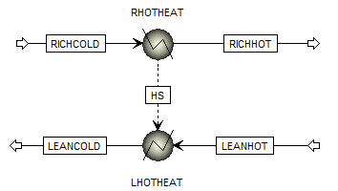

Figure : Linked heater blocks.

1. Rename the heat and material streams by right-clicking and selecting “Rename” to match the corresponding stream names of the destination flowsheet.
2. Navigate to “Flowsheeting Options” → “Calculator” → “C-HX” → “Results,” and then select the “Define Variable” tab. Verify that the results are similar to those of Table 27. If not, check the Property Set Units.

Table : C-HX Results

|  |  |  |  |
| --- | --- | --- | --- |
| Variable | Value Written | Description | Units |
| EXCAP | 4.38E-01 | exchanger CAPEX | $/tonne CO2 |
| RPUMPOP | 6.83E-02 | rich pump CAPEX | $/tonne CO2 |
| RPUMPCAP | 3.58E-02 | rich pump OPEX | $/tonne CO2 |
| TAC | 5.42E-01 | total annualized capital | $/tonne CO2 |
| AREA | 4.25E+03 | exchanger area | m2 |
| LMTD | 1.52E+01 | log mean temperature difference | K |
| U | 5.17E+03 | overall heat transfer coefficient | W/K‒m2 |
| DPRICH | 9.43E+04 | rich-side pressure drop | Pa |
| DPLEAN | 9.17E+04 | lean-side pressure drop | Pa |
| LPLATE | 2.80E+00 | plate length | m |
| VRICH | 4.43E-01 | rich-side fluid velocity | m/sec |
| VLEAN | 4.72E-01 | lean-side fluid velocity | m/sec |

* 1. Setup: Calculator Blocks

Now that the property sets exist and the stream names agree, the calculator blocks can be imported.

1. In the “HeatCalc.bkp” file, navigate to “Flowsheeting Options” → “Calculator,” and then select “C-HX.” Click “Copy.”
2. In the destination file, navigate to “Flowsheeting Options” → “Calculator.”
3. Click “Paste.”
   1. Setup: Optimization Block

This block functions similarly to Solver in Excel®. The provided optimization block minimizes the total annualized capital of the exchanger and the rich pump by varying the total width (NW) of the exchanger.

1. Return to the “HeatCalc.bkp” file, navigate to “Model Analysis Tools” → “Optimization,” and then select “O-TAC.” Click “Copy.”
2. Navigate to “Model Analysis Tools” → “Optimization” in the destination file.
3. Click “Paste.”
   1. Running the Simulation

Aspen Plus will sequence the calculator and optimization blocks after the flowsheet calculations, meaning the heat exchanger model has no impact on flowsheet convergence. Running the simulation is no different from running the simulation before adding in the heat exchanger model.

1. Usage Information
   1. Support

Support can be obtained from [ccsi-support@acceleratecarboncapture.org](mailto:ccsi-support@acceleratecarboncapture.org) or by filling out the “Submit Feedback/Request Support” form available on the product distribution page.

* 1. Restrictions

This model works with any non-flashing solvent in a plate and frame heat exchanger. Note that the heat transfer coefficient assumes turbulence and 45° herringbone plates. Additional restricting assumptions include:

* a plate spacing of 2 mm
* a plate thickness of 6 mm
* plate material of 304 stainless steel
* assumptions on capital and electricity cost
  1. Known Issues
* The exchanger and pump sizing is continuous, while in reality it is discrete.

1. Debugging

* If the provided file does not yield similar results to those described here, then:
* check the Property Set Units
* check that the Streams are properly named
* use the four provided debugging outputs to troubleshoot
  1. How to Debug

Always run the simulation with the control panel visible. The output will notify the user about potential problems and errors. For problems specific to C-HX, the four debugging output parameters (OUT1, OUT2, OUT3, and OUT4) can be used to check intermediate values.

* 1. Reporting Issues

To report an issue, please send an email to [ccsi-support@acceleratecarboncapture.org](mailto:ccsi-support@acceleratecarboncapture.org).

1. Model History
   1. Block Descriptions

C-HX

This block sizes and costs a non-flashing plate and frame heat exchanger.

Variables

The variables defined are listed in Table 28. As variable names are limited to seven characters, the following shorthand is used:

* CR = cold, rich
* HR = hot, rich
* HL = hot, lean
* CL = cold, lean

Table : C-HX Variable Definitions

| Variable | Information Flow | Definition |
| --- | --- | --- |
| EXCAP | Export variable | Parameter Parameter no. = 311 |
| RPUMPOP | Export variable | Parameter Parameter no. = 312 |
| RPUMPCAP | Export variable | Parameter Parameter no. = 313 |
| TAC | Export variable | Parameter Parameter no. = 315 |
| AREA | Export variable | Parameter Parameter no. = 310 |
| LMTD | Export variable | Parameter Parameter no. = 314 |
| U | Export variable | Parameter Parameter no. = 319 |
| DPRICH | Export variable | Parameter Parameter no. = 316 |
| DPLEAN | Export variable | Parameter Parameter no. = 317 |
| LPLATE | Export variable | Parameter Parameter no. = 318 |
| VRICH | Export variable | Parameter Parameter no. = 320 |
| VLEAN | Export variable | Parameter Parameter no. = 321 |
| OUT1 | Export variable | Parameter Parameter no. = 300 |
| OUT2 | Export variable | Parameter Parameter no. = 301 |
| OUT3 | Export variable | Parameter Parameter no. = 303 |
| OUT4 | Export variable | Parameter Parameter no. = 304 |
| TCR | Import variable | Stream-Var Stream = RICHCOLD; Substream = MIXED; Variable = TEMP; Units = K |
| THL | Import variable | Stream-Var Stream = LEANWRM; Substream = MIXED; Variable = TEMP; Units = K |
| THR | Import variable | Stream-Var Stream = RICHWRM1; Substream = MIXED; Variable = TEMP; Units = K |
| TCL | Import variable | Stream-Var Stream = LEANCOLD; Substream = MIXED; Variable = TEMP; Units = K |
| MCR | Import variable | Stream-Var Stream = RICHCOLD; Substream = MIXED;  Variable = MASS-FLOW; Units = kg/sec |
| MHL | Import variable | Stream-Var Stream = LEANWRM; Substream = MIXED;  Variable = MASS-FLOW; Units = kg/sec |
| MHR | Import variable | Stream-Var Stream = RICHWRM1; Substream = MIXED;  Variable = MASS-FLOW; Units = kg/sec |
| MCL | Import variable | Stream-Var Stream = LEANCOLD; Substream = MIXED;  Variable = MASS-FLOW; Units = kg/sec |
| MUCR | Import variable | Stream-Prop Stream = RICHCOLD; Prop-Set = MU-L; Units = Pa-sec |
| MUHL | Import variable | Stream-Prop Stream = LEANWRM; Prop-Set = MU-L; Units = Pa-sec |
| MUHR | Import variable | Stream-Prop Stream = RICHWRM1; Prop-Set = MU-L; Units = Pa-sec |
| MUCL | Import variable | Stream-Prop Stream = LEANCOLD; Prop-Set = MU-L; Units = Pa-sec |
| RHOCR | Import variable | Stream-Prop Stream = RICHCOLD; Prop-Set = RHO-L; Units = kg/cum |
| RHOHL | Import variable | Stream-Prop Stream = LEANWRM; Prop-Set = RHO-L; Units = kg/cum |
| RHOHR | Import variable | Stream-Prop Stream = RICHWRM1; Prop-Set = RHO-L; Units = kg/cum |
| RHOCL | Import variable | Stream-Prop Stream = LEANCOLD; Prop-Set = RHO-L; Units = kg/cum |
| CPCR | Import variable | Stream-Prop Stream = RICHCOLD; Prop-Set = CPMX; Units = J/kg-K |
| CPHL | Import variable | Stream-Prop Stream = LEANWRM; Prop-Set = CPMX; Units = J/kg-K |
| CPHR | Import variable | Stream-Prop Stream = RICHWRM1; Prop-Set = CPMX; Units = J/kg-K |
| CPCL | Import variable | Stream-Prop Stream = LEANCOLD; Prop-Set = CPMX; Units = J/kg-K |
| KCR | Import variable | Stream-Prop Stream = RICHCOLD; Prop-Set = CONDUC-L;  Units = Watt/m-K |
| KHL | Import variable | Stream-Prop Stream = LEANWRM; Prop-Set = CONDUC-L; Units = Watt/m-K |
| KHR | Import variable | Stream-Prop Stream = RICHWRM1; Prop-Set = CONDUC-L;  Units = Watt/m-K |
| KCL | Import variable | Stream-Prop Stream = LEANCOLD; Prop-Set = CONDUC-L;  Units = Watt/m-K |
| DUTY | Import variable | Heat-Duty Stream = WRMHS; Units = Watt |
| CO2RM | Import variable | Mole-Flow Stream = PRODUCT1; Substream = MIXED; Component = CO2; Units = kmol/sec |
| NW | Import variable | Parameter Parameter no. = 366; Initial value = 1962.13 |

All of the variables defined in the “Define” tab of the calculator block input are included in Table 29 in addition to all the variables defined in the “Calculate” tab.

Table : C-HX Variable Description

| Variable | I/O | Description | Units |
| --- | --- | --- | --- |
| EXCAP | O | Annualized exchanger CAPEX | $/tonne CO2 |
| AREA | O | Exchanger area | m2 |
| RPUMPOP | O | Annualized rich pump OPEX | $/tonne CO2 |
| RPUMPCAP | O | Annualized rich pump CAPEX | $/tonne CO2 |
| TAC | O | Total annualized capital cost of exchanger and rich pump | $/tonne CO2 |
| LMTD | O | LMTD of warm exchanger | K |
| U | O | Overall heat transfer coefficient | W/K-m2 |
| DPRICH | O | Pressure drop of rich stream | Pa |
| DPLEAN | O | Pressure drop of lean stream | Pa |
| LPLATE | O | Plate length | m |
| VRICH | O | Velocity of rich stream | m/sec |
| VLEAN | O | Velocity of lean stream | m/sec |
| OUT1 | O | Debugging output | arbitrary |
| OUT2 | O | Debugging output | arbitrary |
| OUT3 | O | Debugging output | arbitrary |
| OUT4 | O | Debugging output | arbitrary |
| TCR | I | Temperature of CR | K |
| THL | I | Temperature of HL | K |
| THR | I | Temperature of HR | K |
| TCL | I | Temperature of CL | K |
| MCR | I | Mass flow of CR | kg/sec |
| MHL | I | Mass flow of HL | kg/sec |
| MHR | I | Mass flow of HR | kg/sec |
| MCL | I | Mass flow of CL | kg/sec |
| MUCR | I | Liquid viscosity of CR | Pa‒sec |
| MUHL | I | Liquid viscosity of HL | Pa‒sec |
| MUHR | I | Liquid viscosity of HR | Pa-sec |
| MUCL | I | Liquid viscosity of CL | Pa-sec |
| RHOCR | I | Liquid density of CR | kg/m3 |
| RHOHL | I | Liquid density of HL | kg/m3 |
| RHOHR | I | Liquid density of HR | kg/m3 |
| RHOCL | I | Liquid density of CL | kg/m3 |
| CPCR | I | Liquid heat capacity of CR | J/kg‒K |
| CPHL | I | Liquid heat capacity of HL | J/kg‒K |
| CPHR | I | Liquid heat capacity of HR | J/kg‒K |
| CPCL | I | Liquid heat capacity of CL | J/kg‒K |
| KCR | I | Liquid thermal conductivity of CR | W/m‒K |
| KHL | I | Liquid thermal conductivity of HL | W/m‒K |
| KHR | I | Liquid thermal conductivity of HR | W/m‒K |
| KCL | I | Liquid thermal conductivity of CL | W/m‒K |
| DUTY | I | Heat duty | W |
| CO2RM | I | Mole flow of CO2 in stripper overhead | kmol/sec |
| VCLW | O | Volumetric flowrate of CL | m3/sec |
| NW | I | Total exchanger width | m |
| PLATESPACE | I | Plate spacing | m |
| GRICH | O | Mass flux of rich stream | kg/m2‒sec |
| GLEAN | O | Mass flux of lean stream | kg/m2‒sec |
| VELCR | O | Velocity of CR | m/sec |
| VELCL | O | Velocity of CL | m/sec |
| VELHR | O | Velocity of HR | m/sec |
| VELHL | O | Velocity of HL | m/sec |
| DIAM | I | Equivalent diameter | m |
| RECR | O | Reynolds number of CR | — |
| RECL | O | Reynolds number of CL | — |
| REHR | O | Reynolds number of HR | — |
| REHL | O | Reynolds number of HL | — |
| PRCR | O | Prandtl number of CR | — |
| PRCL | O | Prandtl number of CL | — |
| PRHR | O | Prandtl number of HR | — |
| PRHL | O | Prandtl number of HL | — |
| HCR | O | Heat transfer coefficient of CR | W/m2‒K |
| HCL | O | Heat transfer coefficient of CL | W/m2‒K |
| HHR | O | Heat transfer coefficient of HR | W/m2‒K |
| HHL | O | Heat transfer coefficient of HL | W/m2‒K |
| KPLATE | I | Plate thermal conductivity | W/m2‒K |
| PLATETHICK | I | Plate thickness | m |
| HPLATE | O | Plate heat transfer coefficient | W/m2‒K |
| UCOLD | O | Cold side overall heat transfer coefficient | W/m2‒K |
| UHOT | O | Hot side overall heat transfer coefficient | W/m2‒K |
| DELTC | O | Cold side temperature approach | K |
| DELTH | O | Cold side temperature approach | K |
| FCR | O | Fanning friction factor of CR | — |
| FCL | O | Fanning friction factor of CL | — |
| FHR | O | Fanning friction factor of HR | — |
| FHL | O | Fanning friction factor of HL | — |
| DPCR | O | Pressure drop per length of CR | Pa/m |
| DPCL | O | Pressure drop per length of CL | Pa/m |
| DPHR | O | Pressure drop per length of HR | Pa/m |
| DPHL | O | Pressure drop per length of HL | Pa/m |
| ACOST | I | CAPEX of exchanger area | $/m2 |
| ECOST | I | Cost of electricity | $/MWh |
| ALPHA | I | Converts PEC to total capital requirement | — |
| BETA | I | Lang factor (annualizes cost) | — |
| CFACTOR | I | Capacity factor | — |
| PETA | I | Pump efficiency | — |
| PCOST | I | Pump CAPEX | $/W |
| CO2RMA | O | CO2 removed per annum | tonne/annum |
| VCR | O | Volumetric flowrate of CR | m3/sec |

Fortran Code

The first part of the code calculates and maps all necessary properties for the model calculations. The next part calculates the exchanger size. The last part calculates the economics and formats miscellaneous outputs.

If a comment line ends with a number in parentheses, e.g., (1), then there is a comment in this documentation. The comment shows the equation in a more readable format, explains all variables, and elucidates the equation origin.

C Brent Sherman

C 2014-11-17

C PURPOSE: Size a non-flashing plate and frame heat exchanger

C and cost it and the rich pump.

C Numbers in parentheses refer to comments in documentation.

C --- Calculations begin ---

C Set plate spacing (m).

PSPACE=0.002

C Calculate mass flux (kg/sec-m2). (1)

GRICH=MCR/(PSPACE*NW)

GLEAN=MHL/(PSPACE*NW)

C Calculate stream velocity (m/sec). (2)

VELCR=GRICH/(RHOCR)

VELCL=GLEAN/(RHOCL)

VELHR=GRICH/(RHOHR)

VELHL=GLEAN/(RHOHL)

C Output velocities of rich and lean sides.

VRICH=VELCR

VLEAN=VELHR

C Calculate the Reynolds number. (3)

DIAM=2*PSPACE

RECR=GRICH*DIAM/MUCR

RECL=GLEAN*DIAM/MUCL

REHR=GRICH*DIAM/MUHR

REHL=GLEAN*DIAM/MUHL

C Calculate the Prandtl number. (4)

PRCR=(CPCR*MUCR)/KCR

PRCL=(CPCL*MUCL)/KCL

PRHR=(CPHR*MUHR)/KHR

PRHL=(CPHL*MUHL)/KHL

C Calculate the heat transfer coefficient (W/m2-K). (5)

C h=Nu*ki/D

HCR=(0.3*KCR/DIAM)*(PRCR**0.333)*(RECR**0.663)

HCL=(0.3*KCL/DIAM)*(PRCL**0.333)*(RECL**0.663)

HHR=(0.3*KHR/DIAM)*(PRHR**0.333)*(REHR**0.663)

HHL=(0.3*KHL/DIAM)*(PRHL**0.333)*(REHL**0.663)

C Set wall thermal conductivity (W/m-K)

KPLATE=16

C Set Plate thickness in m.

PTHK=0.0006

C Calculate the plate heat transfer coefficient (W/m2-K).

HPLATE=KPLATE/PTHK

C Calculate the overall heat transfer coefficients (W/m2-K). (6)

UCOLD=(1/HCR)+(1/HCL)+(1/HPLATE)

UCOLD=1/UCOLD

UHOT=(1/HHR)+(1/HHL)+(1/HPLATE)

UHOT=1/UHOT

C Calculate the temperature approaches (K).

DELTC=TCL-TCR

DELTH=THL-THR

C Calculate the area (m2). (7)

AREA=-DUTY/((UHOT*DELTC-UCOLD*DELTH)

. /DLOG((UHOT*DELTC)/(UCOLD*DELTH)))

C LMTD (K)

LMTD=(DELTC-DELTH)/DLOG(DELTC/DELTH)

C Overall heat transfer coefficient (W/K-m2) (8)

U=-DUTY/(AREA*LMTD)

C --- Economic Calculations Begin ---

C Calculate plate length (m).

LPLATE=AREA/NW

C Calculate Fanning friction factor for turbulent flow. (9)

FCR=1.441*RECR**-0.206

FCL=1.441*RECL**-0.206

FHR=1.441*REHR**-0.206

FHL=1.441*REHL**-0.206

C Calculate the pressure drop per length (Pa/m). (10)

DPCR=(2*FCR*GRICH**2)/(RHOCR*DIAM)

DPCL=(2*FCL*GLEAN**2)/(RHOCL*DIAM)

DPHR=(2*FHR*GRICH**2)/(RHOHR*DIAM)

DPHL=(2*FHL*GLEAN**2)/(RHOHL*DIAM)

C Calculate the rich-, and lean-side pressure drop (Pa). (11)

DPRICH=((DPCR+DPHR)/2)*LPLATE

DPLEAN=((DPCL+DPHL)/2)*LPLATE

C Economic parameters.

ACOST=231.61

ECOST=100

ALPHA=5

BETA=0.2

CFACTOR=0.90

PETA=0.65

PCOST=0.4135

C Exchanger CAPEX ($/tonne CO2)

C Convert CO2 removed from kmol/sec to tonne/sec. (12)

CO2RMA=CO2RM*44/1D3

EXCAP=(AREA*ACOST*ALPHA*BETA)

. /(CO2RMA*3600*24*365*CFACTOR)

C Calculate pump CAPEX ($/tonne CO2). (13)

VCR=MCR/RHOCR

RPUMPCAP=(DPRICH*VCR/PETA)

. *PCOST*ALPHA*BETA

. /(CO2RMA*3600*24*365*CFACTOR)

C Calculate pump OPEX ($/tonne CO2). (14)

RPUMPOP=(DPRICH*VCR/PETA)

. *ECOST/(3600*1D6)/CO2RMA

C Calculate Total annualized capital ($/tonne CO2). (15)

TAC=EXCAP+RPUMPOP+RPUMPCAP

C Debugging outputs (16)

OUT1= FCR

OUT2= DPCR

OUT3= DPHR

OUT4= LPLATE

Code Comments

1. The mass flux is calculated using Equation 1,

|  |  |  |
| --- | --- | --- |
|  | $$G=\frac{\dot{m}}{δ×nW}$$ | (1) |

where *G* is mass flux (kg/m2‒sec), *ṁ* is mass flow rate (kg/sec), *δ* is plate spacing (m), *n* is number of plates, and *W* is plate width (m).

1. The velocity is calculated from the mass flux using Equation 2,

|  |  |  |
| --- | --- | --- |
|  | $$v=\frac{G}{ρ}$$ | (2) |

where *v* is velocity (m/sec) and *ρ* is liquid density (kg/m3).

1. The Reynolds number *Re* is calculated using Equation 3,

|  |  |  |
| --- | --- | --- |
|  | $$Re=\frac{G}{μD}$$ | (3) |

where *μ* is the liquid viscosity (Pa‒sec), and *D* is the equivalent diameter (m), which is twice the plate spacing.

1. The Prandtl number *Pr* is calculated in Equation 4,

|  |  |  |
| --- | --- | --- |
|  | $$Pr=\frac{C_{p}μ}{k}$$ | (4) |

where *Cp* is the liquid heat capacity (J/kg‒K), and *k* is the liquid thermal conductivity (W/m‒K).

1. The heat transfer coefficient *h* (W/m2‒K) is calculated using Equation 5,

|  |  |  |
| --- | --- | --- |
|  | $$h=\frac{Nu*k}{D}=0.3\frac{k}{D}{Pr}^{0.333}{Re}^{0.663}$$ | (5) |

where *Nu* is the Nusselt number. This assumes herringbone plates with 45° corrugation angle (Ayub, 2003).

1. The overall heat transfer coefficient *Ui* of the hot or cold side (W/m2‒K) is calculated using Equation 6,

|  |  |  |
| --- | --- | --- |
|  | $$\frac{1}{U_{i}}=\frac{1}{h_{1}}+\frac{1}{h_{2}}+\frac{1}{h_{plate}}$$ | (6) |

where *h1* is the heat transfer coefficient of the rich stream (W/m2‒K), *h2* is the heat transfer coefficient of the lean stream (W/m2‒K), and *hplate* is the heat transfer coefficient of the plate (W/m2‒K) equal to the plate thermal conductivity divided by plate thickness.

1. The exchanger area *A* (m2) is calculated using Equation 7,

|  |  |  |
| --- | --- | --- |
|  | $$A=\frac{Q}{\frac{U_{hot}∆T_{cold}-U_{cold}∆T_{hot}}{\ln\left(\frac{U_{hot}∆T_{cold}}{U_{cold}∆T_{hot}}\right)}}$$ | (7) |

where *Q* is the duty (W), *Uhot* (*Ucold*) is the overall heat transfer coefficient of the hot (cold) side (W/m2‒K), and *ΔThot* (*ΔTcold*) is the hot- (cold-) side temperature approach (K).

1. The overall heat transfer coefficient *U* (W/m2‒K) is calculated using Equation 8.

|  |  |  |  |
| --- | --- | --- | --- |
|  | $$U=\frac{Q}{A{∆T}_{LMTD}}$$ |  | (8) |

1. The Fanning friction factor *ff* is calculated using Equation 9.

|  |  |  |
| --- | --- | --- |
|  | $$f_{f}=1.441{Re}^{-0.206}$$ | (9) |

1. The pressure drop per length ${∆P}/L$ (Pa/m) is calculated using Equation 10,

|  |  |  |
| --- | --- | --- |
|  | $$\frac{∆P}{L}=\frac{2f_{f}G^{2}}{ρD}$$ | (10) |

where *L* is the length (m). This is calculated for each stream.

1. The pressure drop of the rich and lean sides $∆P$ (Pa) is calculated using Equation 11.

|  |  |  |
| --- | --- | --- |
|  | $${∆P}_{rich}=\frac{{\left(\frac{∆P}{L}\right)}_{CR}+{\left(\frac{∆P}{L}\right)}_{HR}}{2}×L$$ | (11) |

The equivalent equation is used for the lean side pressure drop.

1. The exchanger CAPEX *EXCAP* ($/tonne CO2) is calculated using Equation 12,

|  |  |  |
| --- | --- | --- |
|  | $$EXCAP=\frac{A×\$A×αβ}{{\dot{m}}_{{CO}_{2}}×3600×24×365×C}$$ | (12) |

where *$A* is the cost per unit area ($/m2), *α* is the conversion of PEC to total capital requirement, *β* is the Lang factor, ${\dot{m}}_{{CO}_{2}}$ is the mass flowrate of CO2 leaving the stripper overhead (tonne/sec), and *C* is the capacity factor, which accounts for 10% plant downtime. The purchased equipment cost (PEC) came from vendor quotes. It is assumed to vary linearly with area.

1. The rich pump CAPEX *RPUMPCAP* ($/tonne CO2) is calculated using Equation 13,

|  |  |  |
| --- | --- | --- |
|  | $$RPUMPCAP=\frac{\left(\frac{{∆P}_{rich}×Q_{CR}}{η}\right)×\$P×αβ}{{\dot{m}}_{{CO}_{2}}×3600×24×365×C}$$ | (13) |

where *QCR* is the volumetric flowrate of the cold, rich stream (m3/sec), η is the pump efficiency, and *$P* is the cost of the pump ($/W).

1. The rich pump operating cost RPUMPOP ($/tonne CO2) is calculated using Equation 14,

|  |  |  |
| --- | --- | --- |
|  | $$RPUMPOP=\frac{\left(\frac{{∆P}_{rich}×Q_{CR}}{η}\right)×COE}{{\dot{m}}_{{CO}_{2}}×3600×{10}^{5}}$$ | (14) |

where *COE* is the cost of electricity ($/MWh).

1. The total annualized capital *TAC* ($/tonne CO2) is calculated using Equation 15.

|  |  |  |
| --- | --- | --- |
|  | $$TAC=EXCAP+RPUMPOP+RPUMPCAP$$ | (15) |

1. The following four outputs were used for debugging: OUT1, OUT2, OUT3, and OUT4. They are available for displaying intermediate values. Change the variable on the right side of the equal sign to the variable or expression to display.
2. References

Ayub, Z.H. Plate Heat Exchanger Literature Survey and New Heat Transfer and Pressure Drop Correlations for Refrigerant Evaporators. *Heat Transf Eng* **2003**, *24*, 3–16.

Other Process Models

Membrane Model

1. Introduction

**Intellectual Property Management Plan**

**February 28, 2011**

This documentation introduces the Hollow Fiber Gas Permeation (HFGP) Membrane Steady-State Model that has been developed within the Carbon Capture Simulation Initiative (CCSI) to simulate the membrane stage units in carbon capture processes. This one-dimensional partial differential equation (PDE)-based process model is flexible, modular, and computationally efficient. This model is suitable for process synthesis and design tasks aimed to facilitate the rapid screening of new concepts and technologies for carbon capture.

1. General Information
   1. Overview

This multi-component, one-dimensional model is applicable for membrane materials that follow the solution-diffusion model and predicts the pressure drop in both the shell side and fiber bore side according to the Hagen-Poiseuille equation for a compressible fluid. The one-dimensional permeate and retentate gas plug-flows are assumed to be counter-current to each other. The model provides profiles for component fluxes and concentrations. The equation oriented structure enables the user to perform rating or design calculations depending on the variables being specified to satisfy the degrees of freedom.   
Figure 65 below shows a schematic for the model.

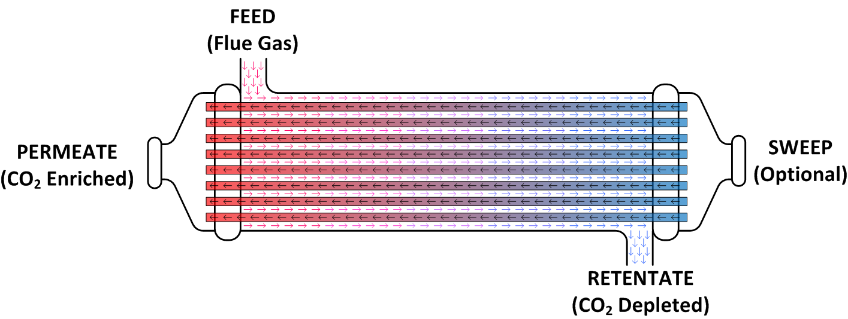

Figure : HFGP membrane device model schematic.

* 1. System/Installation Requirements

The minimum suggested hardware requirement is a desktop/laptop running Windows® 7 on Intel®   
Core i-5 family 2.8 GHz or faster and 8 GB of RAM. With a lower configuration, the simulation speed can be slower. The Aspen Custom Modeler® (ACM, Aspen Technology, Inc.) has been tested on Aspen V8.4.

* 1. Model Assumptions

The main assumptions of the HFGP Membrane Model are listed as follows.

* The feed gas enters the shell side of the hollow fiber membrane and permeates to the fiber’s bore. The sweep gas (optional) enters the fiber bore side at the opposite end from the feed. The gases in the retentate (shell) and permeate (fiber bore) sides flow from one discretized node to the next in the direction of flow accumulating to form the retentate and permeate outlet streams   
  (counter-current flow).
* The fibers that make up the bundle are identical, perfectly straight, and uniform diameter, cylindrical hollow tubes. The feed gas mixture is evenly distributed throughout a cross section of the fiber bundle. This is the starting point of the discretized length domain of integration. The end point is at the retentate outlet stream. Radial concentration and flow gradients in the fiber bundle are neglected (the problem is reduced to one dimension).
* Under the expected operation conditions, the gas mixtures in the module are assumed to behave ideally. The driving force for gas permeation is the difference of component partial pressure across the dense skin.
* The properties and state variables are constant at each node of the discretized axial domain.
* The dense skin layer of the asymmetrical hollow fiber membrane faces the shell side. The molar composition at the boundary of the dense skin layer and the porous support is equal to the bulk molar composition at the fiber bore. This assumption implies that there is no flux resistance imposed by the porous support.
* The pressure in the fiber bore varies due to constrained flow and can be described by the   
  Hagen-Poiseuille equation for a compressible fluid. Similarly, the pressure drop in the shell side is related to the velocity in the shell side by introducing hydraulic radius into the   
  Hagen-Poiseuille equation.
* The model is isothermal (no energy balance equation is considered).

1. Model Structure

The developed model was implemented in ACM and all PDEs are solved using method of lines. The spatial domain has been discretized using a 2nd order centered finite difference method and 20 elements are used as a default. The ACM file includes a newly-defined initialization parameter type, as well as the main device models. The model equations are written in the Custom Modeling library.

To find an HFGP Membrane Model in the Custom Modeling library:

1. In the “All Items” pane of the “Simulation Explorer,” confirm the Custom Modeling library is expanded and then expand the “Models” folder. A list of all the models in the current simulation displays.
2. Click either “HFGPnoS” or “HFGPw_S.”
3. In the “Contents” pane, double-click the icon that looks like an equal sign to view the model syntax.
   1. IO Structure and Reactor Dimensions

There are two versions of the model. One is defined with a sweep stream port and a second one without the port. Each port has associated variables that correspond to the material connection stream variables. The gas inlets and outlets are defined using the built-in ACM mole fraction port.

Given the equation oriented nature of this implementation, this model can be used to perform either rating or design calculations as long as the corresponding variables are specified as fixed to satisfy the degrees of freedom required for the solution.

* 1. Membrane Transport Model

The asymmetric membrane architecture found in modern gas permeation devices was developed to address conflicting requirements. Membrane thickness must be sufficiently thin to achieve high permeation rates but sufficiently thick to be mechanically stable and endure the imposed pressure gradient. By coating a thin (0.5-1 *μ*m) selective layer on a porous support two to three orders of magnitude thicker both requirements are fulfilled. Figure 66 below shows a simplified sketch of the asymmetric membrane architecture.

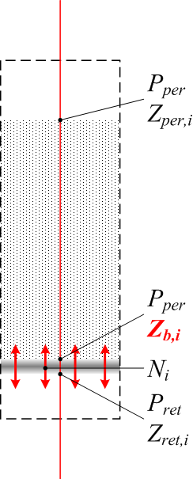

Figure : Asymmetric membrane.

The transport across the selective layer is assumed to follow the solution-diffusion model as described by Baker (2004). The permeance, *Q*, is the permeability divided by the layer thickness. Another important assumption of the solution-diffusion model is that the rates of adsorption and desorption are much higher than the permeation rate. Therefore, the compositions at the boundaries of the selective layer are at equilibrium with its immediate surroundings. Equations (1)–(3) describe the asymmetric membrane model.



The molar composition at the boundary of the porous support and the dense skin (*Zb,i*) is assumed to be equal to the bulk composition at the fiber bore. This may not be a valid assumption for a system with high fluxes (high partial pressure ratio and/or component permeances) or a Knudsen diffusion limited systems (porous support with relative large thickness and/or small mean pore radius).

* 1. Membrane Module Model

There are two types of industrial gas permeation modules suitable for this application: hollow fiber and spiral wound. Baker (2004) gives a complete description and comparison for these and other types of industrial membrane modules. From a modeling perspective, a hollow fiber module system is advantageous because the permeate pressure drop effects can be described from basic principles, and the flow patterns can be described in one dimension. For a spiral wound module, the permeate pressure drop is a function of the number and dimensions of the wound membrane envelopes and the spacer material. This information is typically proprietary and is therefore difficult to find. The permeate flows along the spiral on a plane perpendicular to the flow in the retentate side, which may require an additional dimension to be accurately described.

The equations that describe the hollow fiber module along the module length, *x*, under the assumptions above are:

|  |  |
| --- | --- |
| (4) | $$\frac{{dF}_{per}}{dx}={-J}_{t} Fiber Bore Overall Molar Balance$$ |
| (5) | $$P_{per}\frac{{dP}_{per}}{dx}=\frac{16RTμF_{per}}{πr_{FI}^{4}n_{F}} Fiber Bore Pressure Drop$$ |
| (6) | $\frac{{dFc}_{per,i}}{dx}={Fc}_{ret,i} -J_{i} Fiber Bore Component Molar Balanc$ e |
| (7) | $$\frac{{dF}_{ret}}{dx}={-J}_{t} Shell Overall Molar Balance$$ |
| (8) | $$\frac{{dP}_{ret}}{dx}=\frac{8μ}{r_{H}^{2}}V_{ret} Shell Pressure Drop$$ |
| (9) | $$\frac{{dFc}_{ret,i}}{dx}={Fc}_{ret,i} -J_{i} Shell Component Molar Balance$$ |

Where

$$J_{i}=2πr_{FO}n_{F}N_{i } , J_{t}=\sum_{j}^{n}{J_{j}}$$

$$r_{FO/I}=Fiber Outer/ Inner Radius$$

$$n_{F}=Number of Fibers, r_{H}=Hydraulic radius$$

Equations (4)–(9) are the basis for the model. Boundary conditions, physical properties procedure calls, and other equations are written in the model syntax using the same nomenclature as the equations in this document.

* 1. Hollow Fiber Module Properties

The permeation properties and dimensions of the hollow fiber membrane are treated as lumped parameters of the model.

Table 30 includes the values assigned to each of these model variables. Selectivity is defined as the ratio of the permeance for CO2 to the permeance for a given gas species.

Table : Hollow Fiber Module Properties

| Variable | Typical | Base Case |
| --- | --- | --- |
| Inner Fiber Diameter (μm) | 100-700* | 400 |
| Outer Fiber Diameter (μm) | 200-800* | 600 |
| Effective Fiber Length (m) | 0.15-1.50* | 1.00 |
| CO2 Permeance (GPU) | 10-10000† | 1000‡ |
| H2O Selectivity | <1 | 0.5 |
| N2 Selectivity | 4-150† | 50‡ |
| O2 Selectivity | N/A | 50 |
| * Chowdhury et al., 2005 † Brunetti et al., 2010 ‡ Merkel et al., 2010 | | |

1. Tutorial

This section provides a detailed tutorial to simulate the performance of a two-stage membrane system in series. This tutorial was developed using ACM V8.4 and Aspen Properties® V8.4, additional modifications could be required when using different versions.

1. Open a new “ACM” file from the “Windows Programs” folder.
2. Define the Component List and Property Method.

In the “All Items” pane of the “Simulation Explorer,” select the “Component Lists,” and then double-click “Configure Properties” in the “Components List” pane. The “Physical Properties Configuration” window displays. Select “Use Aspen property system” in the dialog box and then click “Edit using Aspen Properties.” A new Aspen Properties file displays. In the “All Items” pane under “Components,” click “Specifications.” In the window that displays, click the “Selection” tab, under the “Component ID” tab type “CO2,” and then press “Enter.” This populates the “Type,” “Component name,” and “alias” fields. In the subsequent rows under “Component ID,” type “H2O,” “N2,” and “O2” in the same manner. In the “All Items” pane, click “Methods.” In the window that displays, select the “Global” tab, under the field “Method Name” click the drop-down arrow, and then select “PENG-ROB.” Double-click “Method” in the “All Items” pane. Double-click “Parameters” in the drop-down menu and then double-click “Binary Interaction.” Click the “half-filled red circle” icon for PRKBV-1. This turns the   
half-filled red circle to a completely filled blue circle with a tick mark through the circle. This ensures that Aspen Properties has populated all the required binary interaction parameters from its database. Run the property calculation by clicking “Run” or pressing “F5.” Confirm at the bottom of the window beside the “Check Status” tab, that the following message “Results Available” displays. Click “Save.” In the window that displays, Aspen Properties asks if the user also wants to save the file in Aspen Properties Document format. Select “No” and then close the window. This closes Aspen Properties. The “Physical Properties Configuration” window displays with a green box under the “Properties” status that indicates that the properties have been successfully configured. Click “OK.”

Open the “Default component” list dialog box by double-clicking “Default” under “Component Lists” in the “Simulation Explorer,” and then move all of the available components into the list on the right side of the dialog box.

1. Change the Non Linear Solver from Standard to DMO.

For this, open the “Solver options” dialog box by pressing “F10” and then change the “Non linear solver” from “Standard” to “DMO” in the “Non Linear solver” tab. Click “OK.”

1. From the “File” menu, click “Import Types.” Browse and then select “HFGP.acmf” in the folder where it was saved. Click “Open.” Ignore any warnings that appear in the “Simulation Messages” window stating that content that is not relevant to the Custom Modeling library was ignored.
2. Place an HFGPnoS Block on the “Process Flowsheet Window.”

In the “All Items” pane of the “Simulation Explorer,” double-click “Custom Modeling,” and then from under “Models” drag and drop the “HFGPnoS” model onto the “Process Flowsheet” pane.

Rename the model “M1.” Renaming in ACM is achieved by right-clicking an “item” and then selecting the “Rename” option, or by pressing “Ctrl+M” once the item is selected. Exchange the icon by selecting the “block” and then pressing “Ctrl+K.”

1. Specify the M1 Device Variables.

Double-click “M1.” On the “Device Variables” window enter the values as listed in Table 31.

Table :M1 Device Variables

| Variables | Values |
| --- | --- |
| alpha(“CO2”) | 1.0 |
| alpha(“H2O”) | 0.5 |
| alpha(“N2”) | 50 |
| alpha(“O2”) | 50 |
| CCfct | 0.51 |
| Dfi | 0.0004 |
| Dfo | 0.0006 |
| L | 1 |
| Qcd | 0.12047 |

**Note:** The fiber diameters are defined in meters while the CO2 permeance is defined in ACM default units (1000 GPU = 0.12047 kmol/m2/hr/bar). CCfct is a custom variable defined as the fraction (mol basis) of CO2 that leaves in the permeate outlet stream with respect to the CO2 at the feed inlet.

1. Specify the M1 Stream Variables.

Connect the inlet and outlet streams to the device model by dragging the “Connection type streams” from the “Stream Types” folder of the “Custom Modeling library” onto the port of the device model in the “Process Flowsheet Window.” There is only one feed port. Connect one stream to the feed port and name the stream “FeedM1.” When connecting the stream to the outlet port, a window displays with two choices. Select “Permeate” and then rename the stream “PermeateM1.” Connect another stream to the outlet and name the stream “RetenateM1.” To rename a stream in ACM, select the “stream,” right-click, and then select “Rename Stream.”

Double-click the “feed inlet stream” and then enter the values as listed in Table 32. Once the values have been entered, change the variable “Spec” value from “Free” to “Fixed.”

Table : M1 Gas Feed Specification

| Variables | Value | Units |
| --- | --- | --- |
| FeedM1.F | 100,000 | kmol/hr |
| FeedM1.P | 2.0 | bar |
| FeedM1.T | 50 | °C |
| FeedM1.z(“CO2”) | 0.19 |  |
| FeedM1.z(“H2O”) | 0.04 |  |
| FeedM1.z(“N2”) | 0.72 |  |
| FeedM1.z(“O2”) | 0.05 |  |

Specify the Permeate outlet stream pressure. Double-click the “PermeateM1 stream” and then enter “0.2” for “P” in the “PermeateM1.AllVariables Table.” Change the “Spec” from “Free” to “Fixed.”

1. Run the Simulation.

The simulation is ready to be solved. This can be verified by the presence of a green square at the bottom of the “ACM” window. However, the ACM solver cannot reach a solution from this point due to the size and non-linear nature of the problem. Verify this by running the simulation (press “F5”).

Reset the simulation (press “Ctrl+F7”). This changes the value of the free variables to the default values.

A solution procedure with a custom initialization method is defined using a Visual Basic® script. The script solves the model in incremental steps of complexity by using initialization procedure selectors. The selectors are switched from an “Initial” state that selects a set of simplified model equations to “Rigorous” which selects a set of more accurate equations corresponding to the desired solution. In the HFGP Model this script has two steps. The first one applies to the equation for the permeate side molar balance, and the second one applies to the permeate side pressure drop.

1. Invoke the IPsolve Script.

Right-click the “M1 block,” select “Scripts,” and then click “IPsolve.” Once the script is completed, the desired solution has been achieved.

1. Place an HFGPw_S Block on the “Process Flowsheet Window.”

Drag the “HFGPw_S model” from the “Models” folder of the “Custom Modeling library” in the “Simulation Explorer” panel onto the “Process Flowsheet” pane.

Rename the model (“Ctrl+M”) “M2” and then exchange its icon (“Ctrl+K”).

1. Specify the M2 Device Variables.

Double-click “M2.” On the “Device Variables” window enter the values as listed in Table 33.

Table : M2 Device Variables

| Variables | Value |
| --- | --- |
| alpha(“CO2”) | 1.0 |
| alpha(“H2O”) | 0.5 |
| alpha(“N2”) | 50 |
| alpha(“O2”) | 50 |
| CCfct | 0.86 |
| Dfi | 0.0004 |
| Dfo | 0.0006 |
| L | 1 |
| Qcd | 0.12047 |

1. Specify the M2 Stream Variables.

Connect M1’s Retentate outlet stream to the Feed port of M2. Select the stream “RetenateM1,” right-click, select “Reconnect Destination,” and then try to connect to the feed port of M2. A window displays. Select “Feed” and then click “OK.”

Connect one more feed stream and two outlet streams to M1 similar to M2. Name the feed stream “SweepM2.” Name the outlet streams “RetenateM2” and “PermeateM2.”

Double-click the “sweep inlet stream” and then enter the values as listed in Table 34 (composition of air). Once the values have been entered, change the variable “Spec” value from “Free” to “Fixed.”

Table : Gas Sweep Specification

| Variables | Value | Units |
| --- | --- | --- |
| SweepM2.F | 65,000 | kmol/hr |
| SweepM2.P | 1.3 | bar |
| SweepM2.z(“CO2”) | 0.00030 |  |
| SweepM2.z(“H2O”) | 0.01009 |  |
| SweepM2.z(“N2”) | 0.78223 |  |
| SweepM2.z(“O2”) | 0.20738 |  |

1. Run the Simulation by invoking the “IPsolve” script. Right-click the “M2” block, select “Scripts,” and then click “IPsolve.” Once the script is completed, the desired solution has been achieved.

Double-click the streams “PermeateM2” and “RetenateM2” to ensure that the results shown in Figures 67 and 68 below are obtained.

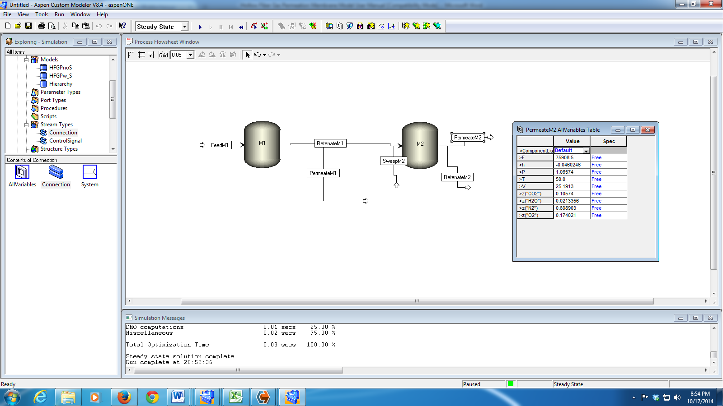

Figure : PermeateM2 stream results.

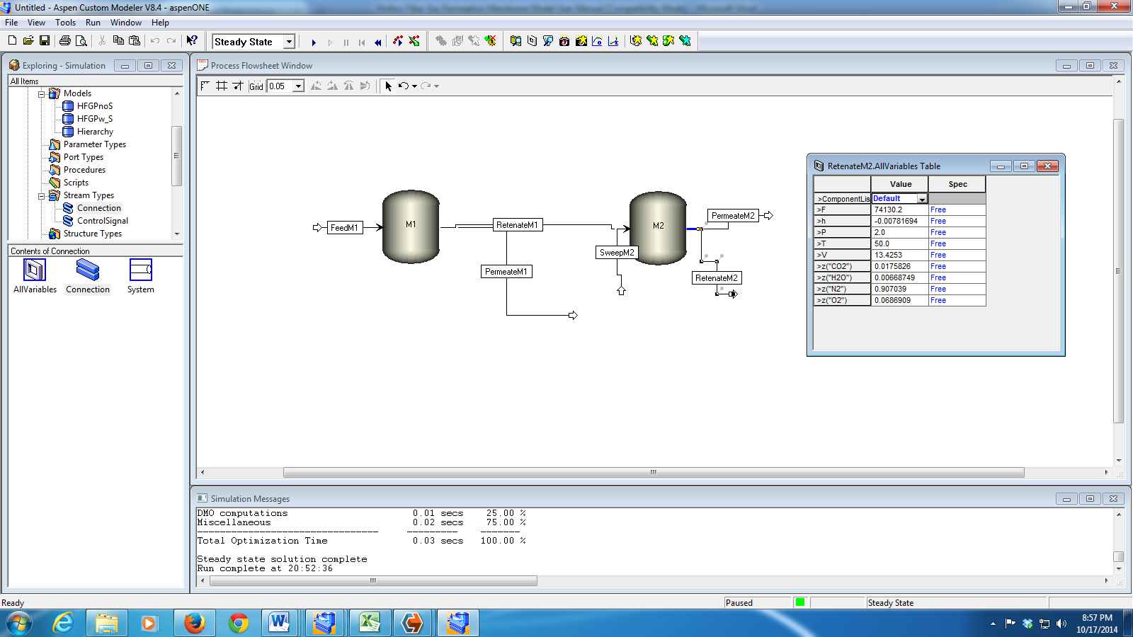

Figure : RetenateM2 stream results.

1. References

[1] Baker, R.W., *Membrane Technology and Applications*,2nd Ed., Wiley, Chichester, 2004.

[2] Brunetti, A., Scura, F., Barbieri, G., and Drioli, E., “Membrane Technologies for CO2 Separation,” *Journal of Membrane Science*, 2010, 359, p. 115–125.

[3] Chowdhury, M.H.M., Feng, X., Douglas, P., and Croiset, E., “A New Numerical Approach for a Detailed Multicomponent Gas Separation Membrane Model and Aspen Plus Simulation,” *Chemical Engineering and Technology*, 2005, 28, p. 773–782.

[4] Merkel, T.C., Lin, H., Wei, X., and Baker, R., “Power Plant Post-Combustion Carbon Dioxide Capture: An Opportunity for Membranes,” *Journal of Membrane Science*, 2010, 359, p. 126–139.

Compressor Model

**Intellectual Property Management Plan**

**February 28, 2011**

1. Introduction

This manual presents information on the CO2 compression system that uses a train of multistage integral gear compressors to compress the CO2-rich gas from the regenerator to the supercritical phase for pipeline transport. In this work, the design point size and performance of the integral gear compressors are validated with the design data provided by the commercial vendor. For simulating off-design performance of the compressor, the performance curves obtained from a commercial vendor are leveraged. Interstage coolers, flash vessels, recycle loops, glycol tower for water removal, and the inventory of the associated system significantly affect the performance and transient response of the compression system. To capture the effect of this associated system, a pressure-driven dynamic model of the entire system is developed using Aspen Custom Modeler® (ACM) and gPROMS®. Surge must be avoided during operation of the centrifugal compressors to avoid significant damage to the compressor and the associated equipment. To this end, a surge detection algorithm has been developed. For avoiding surge, the compressor system should be appropriately developed and control action must be taken. Gain-scheduling controllers are designed to move the compressor away from the surge conditions. The dynamic model is used to study the transients of the key variables in response to various disturbances such as change in the flow rate, temperature, and composition of the feed to the compression system.

1. Compressor Stage Calculations

This document describes a method for predicting the design point centrifugal compressor performance. An ACM implementation is provided. ACM Version 8.4 or higher is required. The compressor model and design constraints are taken mainly from Angier (2000) and Lüdtke (2004). The methods were validated as much as possible by comparison to typical industrial compressors. The purpose of the compressor modeling work is to provide simple compressor equations that can be used in the optimization of CO2 capture and compression systems. The compressor model uses preliminary design calculations and does not require any detail about the compressor geometry, making it relatively easy to use. Multi-stage compressor models are provided that include TEG drying systems. This section describes the basic design point calculations for centrifugal compressor stages.

* 1. Dimensionless Numbers

The calculations are based on dimensionless numbers that characterize a compressor stage. This section provides the definitions for important dimensionless numbers.

The mass flow coefficient ($φ$) is given by Equation 1 where $\dot{m}$ is the mass flow rate in kg/s, $ρ_{0}$ is the density at the stage inlet in kg/m3, is the impeller radius in m, and $U_{2}$ is the speed of the impeller tip in m/s.

|  |  |
| --- | --- |
| $$φ=\frac{\dot{m}}{{πρ}_{0}r_{2}^{2}U_{2}}$$ | (1) |

The polytrophic head coefficient ($μ_{p}$) is given by Equation 2, where ${∆h}_{p}$ is the polytropic enthalpy change through the compressor stage in J/kg. Head units of m2/s2 are equivalent to J/kg.

|  |  |
| --- | --- |
| $$μ_{p}=\frac{{∆h}_{p}}{U_{2}^{2}}$$ | (2) |

The work coefficient (*I*) is similar to the polytropic head coefficient, but it uses the actual enthalpy change instead of the polytropic enthalpy change. The work coefficient is given by Equation 3.

|  |  |
| --- | --- |
| $$I=\frac{{∆h}_{t}}{U_{2}^{2}}$$ | (3) |

The rotational Mach number (Ma) is the primary factor in determining the pressure ratio for a stage. Higher Ma numbers result in less stable operation, so stages with higher Ma can operate over a smaller range of inlet conditions. The Ma number is given by Equation 4, where $a_{0}$ is the speed of sound in the gas at the compressor inlet.

|  |  |
| --- | --- |
| $$\text{Ma}=\frac{U_{2}}{a_{0}}$$ | (4) |

The speed of sound in a gas is given by Equation 5, where $P$ is pressure, $ρ$ is mass density, and s is entropy. The equation can be converted into a slightly more useful form, where $κ_{T}$ is the isothermal compressibility, *cp* is the constant pressure heat capacity, and *cv* is the constant volume heat capacity. Some property packages may calculate speed of sound or isothermal compressibility directly.

|  |  |
| --- | --- |
|  | (5) |

* 1. Efficiency

With the above dimensionless numbers, efficiency can be estimated. Two types of efficiencies are commonly used, adiabatic and polytropic.

Adiabatic efficiency is calculated by first calculating the isentropic enthalpy change between the inlet conditions (P0, T0) and the outlet conditions (P2, S0) (the isentropic discharge temperature is not the actual discharge temperature). Dividing the isentropic enthalpy change by the actual change in enthalpy between the inlet conditions (P0, T0) and the outlet conditions (P2, T2) gives the adiabatic efficiency. The adiabatic efficiency is easy to calculate but has the disadvantage that it depends on the pressure ratio of the compressor, making it more difficult to interpret.

Polytropic efficiency is more convenient because it is independent on pressure ratio. The polytropic head is calculated over a reversible path of constant efficiency. Equation 6 provides a very good approximation for polytropic enthalpy change in a real gas (Mallen and Saville, 1977). In Equation 6, temperature is in K.

|  |  |
| --- | --- |
| $$∆h_{p}={∆h}_{t}-\frac{\left(∆s\right)\left(∆T\right)}{ln\left({T_{out}}/{T_{in}}\right)}$$ | (6) |

The polytropic efficiency is given by Equation 7.

|  |  |
| --- | --- |
| $$η_{p}=\frac{{∆h}_{p}}{{∆h}_{t}}=\frac{μ_{p}}{I}$$ | (7) |

Compressor stage efficiency can be related to the flow coefficient. Aungier (2000) gives correlations between the flow coefficient and the polytropic and work coefficients. These empirical correlations are for typical well designed centrifugal compressors. The correlations are given by Equations 8 and 9 for covered impellers with vaned diffusers, and Equations 10 and 11 for open impellers with vaned diffusers.

|  |  |
| --- | --- |
| $I=0.62-{\left(φ/{0.4}\right)}^{3}+{0.0014}/φ$ (covered) | (8) |
| $μ_{p}=0.51+φ-7.6φ^{2}-{0.00025}/φ$ (covered) | (9) |
| $I=0.68-{\left(φ/{0.37}\right)}^{3}+{0.002}/φ$ (open) | (10) |
| $μ_{p}=0.59+0.7φ-7.5φ^{2}-{0.00025}/φ$ (open) | (11) |

Covered impellers add weight, but do not require the tight tolerances of open impellers. In small stages, covered impellers may be used since relatively tight tolerances become more difficult to achieve.

* 1. Constraints

This section presents design constraints for centrifugal compressors. These constraints are approximate and vary depending on the manufacturer. The constraints presented here should provide a good approximation for generic compressor cases.

The mass flow coefficient for centrifugal compressors is usually between 0.01 and 0.15 (Lüdtke, 2004).

Limits on Ma for multistage compressors are given by Equation 12, where *n* is the stage number. Equation 12 is based on Lüdtke (2004). The limits on Ma are dependent on more detailed design considerations, so the limits given by Equation 12 are approximate. Since high Ma numbers reduce the allowable range of operating conditions, it makes sense that earlier stages can have higher Ma numbers since pressure variations will be magnified through each stage.

|  |  |
| --- | --- |
| $$\text{Ma}≤-0.202\ln\left(n\right)+1.25$$ | (12) |

Table 35 shows the Ma limits from Equation 12 for easy reference.

Table : Maximum Stage Mach Numbers

|  |  |  |  |  |  |
| --- | --- | --- | --- | --- | --- |
| Stage | Mamax |  |  | Stage | Mamax |
| 1 | 1.25 |  |  | 8 | 0.83 |
| 2 | 1.11 |  |  | 9 | 0.81 |
| 3 | 1.03 |  |  | 10 | 0.78 |
| 4 | 0.97 |  |  | 11 | 0.77 |
| 5 | 0.92 |  |  | 12 | 0.75 |
| 6 | 0.89 |  |  | 13 | 0.73 |
| 7 | 0.86 |  |  | 14 | 0.72 |

If Equation 12 is applied to the stages of an integral gear compressor, the Ma numbers calculated from a typical industrial integral gear compressor can be compared. Figure 69 shows the result. The low estimate and high estimate are from Lüdtke (2004). The average estimate curve is Equation 12, and the purple dots are compressor data. It can be seen from Figure 69 that it seems likely that Ma number limits, similar to those in Equation 12, were taken into account in the industrial compressor design. Other constraints, which will be discussed, may affect the first and last stages.

Figure : Maximum Mach number estimates.

The impeller tip speed is limited by maximum stress on the impeller. Equation 13 was adapted from Lüdtke (2004) for steel impellers, where $U_{2}$ is the impeller tip speed in m/s, and $R_{P0.2}$ is the yield stress of the material in MPa. For typical impellers, $R_{P0.2}≈830$ MPa, although there are higher strength steels (Lüdtke, 2004). The maximum tip speed allows stress in the impeller up to 70% of the yield stress.

|  |  |
| --- | --- |
| $$U_{2}≤\sqrt{0.7(1984.1φ^{2}-616.88φ+215.97)R_{P0.2}}$$ | (13) |

Comparing Equation 13 to the calculated tip speed from the first stage of the industrial compressor shows a tip speed of 312 m/s and a maximum tip speed given by Equation 13 of 314 m/s. It seems that this may be an active constraint in some compressor designs.

The rotational speed of a centrifugal compressor is limited to approximately 20,000 rpm or 25,000 rpm for very high speed compressors (Lüdtke, 2004). The last stage in the industrial compressor has a rotation speed of 24,743 rpm. From Figure 69 it can be seen that the Ma number for the last stage is significantly below the trend set by the other stages. This may be because it is constrained by maximum rotation speed instead of maximum Ma. In this work, the maximum rotation speed of 20,000 rpm will be applied to inline compressors. The 25,000 rpm limit will be applied to integral gear and single stage compressors.

The discharge temperature of a stage is generally limited to less than 250°C (482°F). Temperatures of 250°C or greater are possible but may require special construction (Lüdtke, 2004). Other temperature limits apply depending on the gas being compressed, but are probably not of concern in the CO2 application.

Stage diameters are generally between 150 mm and 1,500 mm, although it depends on the manufacturer. Some manufacturers may make stages with diameters up to 2,000 mm (Lüdtke, 2004).

For this work, impellers with a diameter of less than 400 mm were assumed to be covered impellers, and larger impellers were assumed to be open. This is still a matter for further study.

1. Multi-Stage Compressors

There are two basic compressor designs considered in this work, integral gear and inline.

* 1. Integral Gear

The integral gear compressor offers high efficiencies and relatively low power requirements. The integral gear design consists of pairs of stages arranged around a central gear. Both stages in a pair operate at the same speed but can have different diameters. Since the rotation speed changes after every other stage, stages can operate near their optimum efficiency. The arrangement of an integral gear compressor also allows intercooling after every stage, which significantly reduces the power requirements. At high pressure, intercooling is reduced or not used at all to avoid liquefaction of CO2. Due to the intercooling, temperatures do not generally get high enough to recover compression heat for use in other parts of the process.

* 1. Inline

The inline compressor contains sections of compressor stages in the same casing which run on a common shaft. Stages in a section have the same radius and run at the same speed. Since several stages operate at the same speed, some stages may operate far from the optimal mass flow coefficient, resulting in lower efficiencies than integral gear compressors. Intercooling also happens between sections, so there are fewer intercoolers than in an integral gear compressor; however, higher temperatures increase heat integration opportunities. Gear boxes can help different sections of an inline compressor to operate at different speeds.

1. TEG CO2 Drier

The bituminous baseline report specifies the maximum water content for CO2 as 150 ppm, so a drying system is required (U.S. Department of Energy, 2010). The triethylene glycol (TEG) drying system was modeled. Figure 70 shows the layout of the drying system in an integral gear compressor. The absorber and regenerator consist of packed columns. The columns are modeled using a series of flash blocks to simulate equilibrium stages.

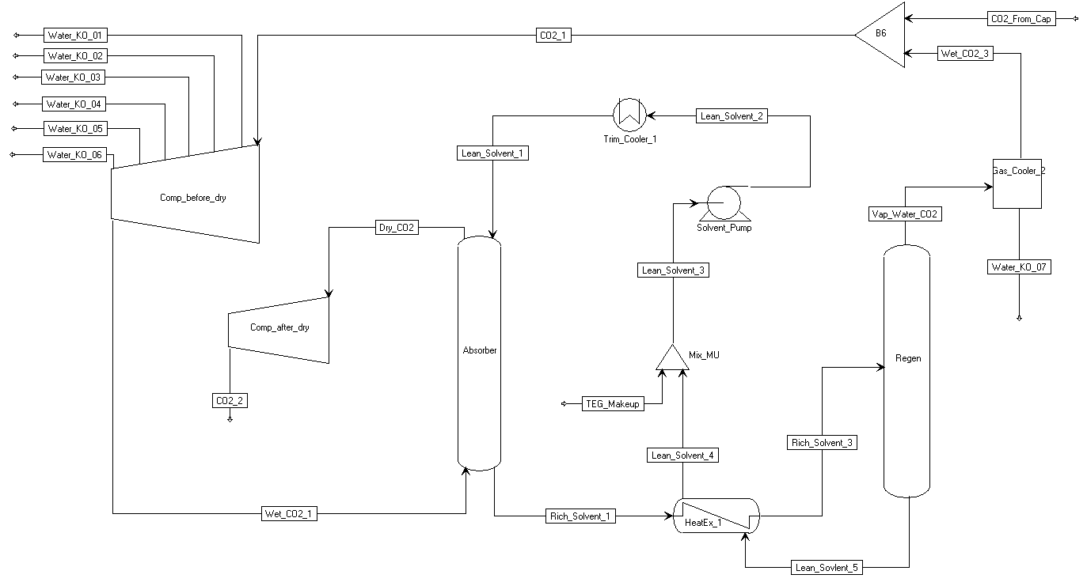

Figure : ACM integral gear with drying flowsheet.

Lean (low CO2 and water content) TEG solvent flows into the top of the absorber, and wet CO2 flows into the bottom. TEG absorbs both water and CO2 from the CO2 phase. The absorber operates at a pressure of about 45 to 60 bar. Approximately four times more CO2 is absorbed than water on a mole basis. The gas phase pressure drop in the TEG absorber column was assumed to be 5 psia, although this value was based on a concurrent contactor (Kohl and Nielson, 1997). The pressure drop depends on the packing used, so other systems may have lower pressure drops. This is still a matter for further study.

CO2 leaves the absorber with a water content of 150 ppm, and continues on to be compressed further. The rich solvent leaving the absorber goes to a heat exchanger where it gets heated by the lean solvent leaving the regenerator.

The rich solvent is fed to the regenerator, which operates at a pressure of about 1 to 2 bar. The regenerator also contains a reboiler. Due to the lower pressure in the regenerator, most of the water and CO2 are desorbed from the TEG solvent, and very little heat is required. The CO2 phase released from the solvent flows through a condenser where most of the TEG and water are removed. The low pressure CO2 saturated with water is recycled back to the compressor feed. About 2 to 3% of the CO2 feed is recycled for a typical configuration.

1. Property Methods

There are two main parts of the compressor simulation, compression and drying. The compression section requires accurate properties for CO2 to predict compressor power. The drying section requires accurate vapor-liquid equilibrium calculations for the CO2-TEG-Water system.

* 1. Compression

Most property methods provide a good approximation of the properties of CO2 over a wide range of temperatures and pressures, but have relatively large errors near the critical point. For the compressor, this potentially leads to power calculations that can have significant error. The Span-Wagner property method provides a highly accurate property method for CO2 (Span and Wagner, 1996); however, it cannot be used for mixtures in Aspen Properties (in Aspen it is available as REFPROP). To find the best method, other equations of state were compared to Span-Wagner. Table 36 shows the results for conditions similar to a compressor stage with the least accurate results.

Since Span-Wagner cannot be used because of water in the CO2 stream, the Lee-Kesler-Plöcker   
(LK-PLOCK) appears to provide the next best method.

The property method for the compressor sections of the flowsheet is also used to calculate water knockout in the intercoolers. Figure 71 compares the LK-PLOCK predictions to experimental data. The data in Figure 71 approximately covers the range that would be found in the intercoolers. The 25° and 31.04°C curves are shorter because the flash calculation failed at higher pressures for those temperatures. While the fit is probably acceptable, improvements may be made by adjusting the model parameters in future work.

Table : Comparison of Property Methods

| (T1 = 55 °C, P1 = 55 bar) and (T2 = 109 °C, P2 = 100 bar) Pure CO2 | | |
| --- | --- | --- |
|  | **Δ (kJ/kmol)** | **Relative Error (%)** |
| Aspen Ideal | 2154.4 | 38.7 |
| Aspen BRWS | 1582.0 | 1.8 |
| Aspen BWR-LS | 1558.1 | 0.3 |
| Aspen LK-PLOCK | 1556.5 | 0.2 |
| Aspen Refporp (Span-Wagner) | 1553.7 | 0.0 |
| NIST Refprop (Span Wagner) | 1553.7 | 0.0 |
| Handbook (Span-Wagner) | 1553.7 | 0.0 |
| Aspen/Hysis SRK | 1502.4 | -3.3 |
| Aspen RKS | 1498.3 | -3.6 |
| Aspen SRK | 1494.0 | -3.8 |
| Aspen RKS-BM | 1451.2 | -6.6 |
| Aspen RK-ASPEN | 1451.2 | -6.6 |
| Aspen SR-Polar | 1451.2 | -6.6 |
| Aspen/Hysis Peng-Robinson | 1447.2 | -6.9 |
| Aspen Peng-Robinson | 1442.8 | -7.1 |
| Aspen/Hysis Glycol | 1429.7 | -8.0 |
| Aspen Grayson2 | 1426.4 | -8.2 |
| Aspen PR-BM | 1395.1 | -10.2 |

*Data Source: Wiebe and Gaddy (1941)*

Figure : CO2 saturated water content, Aspen Properties LK-PLOCK.

* 1. Drying, Aspen Properties

The drying section of the flowsheet makes use of an Aspen Properties method named HYSGLYCO, which is specially designed to work for drying natural gas with TEG. CO2 is a component of natural gas, but in low concentrations.

This section provides some comparisons between Aspen Properties predictions and literature data. Figure 72 shows the predictions for saturated water content of CO2 in a CO2/water system. The HYSGLYCO method provides better agreement than LK-PLOCK, and appears to be reasonably accurate, although there is a discontinuity in the 25° and 31.04°C curves.

*Data Source: Wiebe and Gaddy (1941)*

Figure : CO2 saturated water content, Aspen Properties HYSGLYCO.

Figure 73 shows the solubility of CO2 in TEG calculated by Aspen compared to literature data.

*Data Source: Kohl and Nielson (1997)*

Figure : CO2 solubility in TEG, Aspen Properties HYSGLYCO.

The property methods chosen for the compressor simulation probably provide reasonable approximations; however, some refinement may be able to yield better results. The current property method selection provides the best results obtainable with standard Aspen provided parameters. The collection of additional data and refinement of parameters is a matter for future work. Additionally, since HYSGCLYCO is not available in Multiflash, the gPROMS process model uses the less accurate LK-PLOCK method.

1. ACM Model

This section describes ACM compressor model implementation. Two ACM files are provided. The file “CompIG.acmf” provides a simulation for an integral gear compressor and drier. The file “CompInline.acmf” provides a simulation of an inline compressor and drier.

* 1. Compressor Stage Calculations

There are two models for centrifugal compressor stages. The first is a simple stage calculation (CompStageSimple), which uses a specified efficiency to do the compressor stage calculation.

The second compressor model (CompStagePrelimDesign) uses the calculations detailed in this document to estimate the performance of compressor stages. Assuming the inlet stream for a stage is specified, this model has two degrees of freedom. The list below provides variables typically specified for a stage, two of which should be fixed. Some variables are mutually exclusive, e.g., discharge pressure and pressure ratio.

* Mass flow coefficient (phi)
* Polytropic head coefficient (mu_p)
* Work coefficient (I)
* Rotational Mach number (Ma)
* Pressure ratio (Pratio)
* Discharge pressure (i_port.P)
* Tip speed (U2)
* Rotation speed (rspeed)
* Impeller radius (r2)

There are also several parameters that define characteristics of the compressor stage.

* Diffuser type (diffuser_type)
* Impeller type (impeller_type)
* Driver efficiency (eff_drive)
* Mechanical efficiency (eff_mech)

The variables that should be fixed depend on the compressor configuration.

* 1. Intercoolers

The intercoolers are modeled as flash stages using the “Flash_Stage” model, which is provided in the ACM files. Assuming the inlet stream is known, the flash stage has two degrees of freedom. For intercoolers, temperature and pressure are usually fixed. A pressure drop at the flowsheet level can be used to set the discharge pressure of a flash stage. To set the temperature and pressure, fix the temperature and pressure of either the liquid or vapor outlet port. The liquid stream is the water knockout.

* 1. Multistage Compressor Models

There are two multistage compressor models (“CompInline” and “CompIntegralGear”) provided in the ACM files. Both models include an array of compressor stages. The integral gear compressor model contains a series of compressor stages, and each stage is followed by an intercooler. An intercooler may be disabled by setting the heat flow and pressure drop to zero. The inline compressor model contains only a series of compressor stages and no intercoolers.

Multiple multistage models can be combined to form a complete compressor model. For inline compressors, two or three inline sections may be separated by intercoolers. For integral gear compressors, there may be a compressor section before and after a drier.

The multistage compressor models calculate the maximum impeller tip Ma number for each stage. Both multistage models have a parameter that allows the first stage number to be set. If a compressor model is made of several multistage sections, this can be used so the models know the correct stage number.

Several special forms for the multistage compressor models make it easier to find variables.

* Dimensionless – mass flow coefficients for each stage
* Efficiency – polytropic, adiabatic, driver, and mechanical efficiencies for each stage
* Impeller_Diffuser – the impeller and diffuser type for each stage
* Power – fluid and electric power for each stage
* Speed – rotation speed, tip speed, and Ma for each stage, as well as limits for Ma and tip speed
* TPQ – temperature, pressure, and heat transfer into and out of each stage and intercooler, as well as pressure drop, for intercoolers in integral gear models

The integral gear model sets the rotation speed of the even numbered stages to be equal to the odd stage before them. This leaves the odd stages with two degrees of freedom and the even stages with one. The mass flow coefficient can be set in the odd stages to provide near optimal efficiency. The impeller tip speed or Ma numbers can get the desired discharge pressure. The constraints listed in Section 2.3 Constraints must be checked to ensure the result is feasible. Pressure ratio can be increased at the expense of efficiency by lowering mass flow coefficients. If the desired outlet pressure cannot be achieved without violating constraints, the number of stages must be increased. The intercoolers are specified by a pressure drop and temperature. If an intercooler is not needed at a particular location, the heat flow and pressure drop can be set to zero.

The inline model sets the radius and rotation speed of all stages equal to the first stage. Only the first stage has two degrees of freedom, and the rest are specified by that. An inline compressor can be constructed of multiple inline models with intercoolers between.

* 1. Multistage Flash Model

The multistage flash models are used to simulate equilibrium stages for separation columns. The number of stages is a parameter in the model. Inlets can be added to any stage, and there is a gas outlet at the first (top) stage and a liquid outlet at the last (bottom) stage. A stage can act as a reboiler or condenser by setting the temperature or heat flow for the stage. Most stages will be adiabatic so the heat flow can be set to zero. To get the flash stages to converge for the first time, it is better to fix the temperature. After the model converges with the fixed temperature, the temperature variable can be freed and the heat transfer can be fixed.

* 1. Integral Gear Compressor with Drier Simulation

Figure 74 shows the ACM flowsheet for the integral gear compressor with a TEG drier, which is contained in the “CompIG.acmf” file.

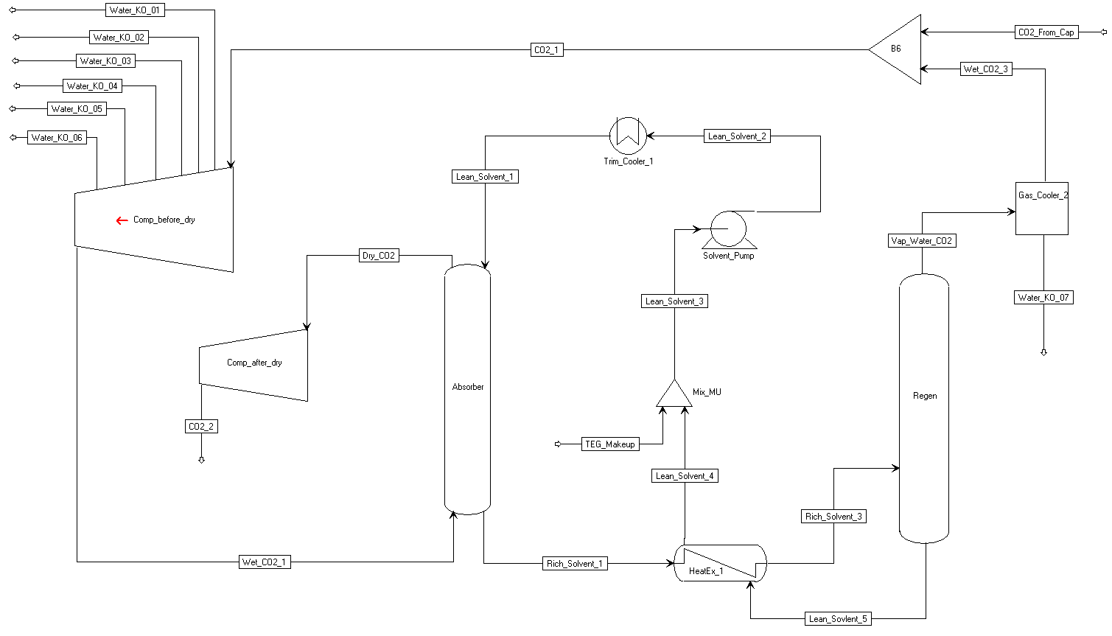

Figure : ACM flowsheet for an integral gear compressor with drier.

The flowsheet consists of two compressor sections with a TEG drying system between. The simulation is configured for a typical CO2 stream from a solid sorbent process. The flow rate is about half the CO2 captured from a 650 MW power plant at 90% capture; this size of compressor would be commercially available.

The first compressor section consists of six stages with intercooling after each stage. Water knockout streams are attached to each intercooler. The second compressor section after the drier has two stages and no intercooler. There is an after-cooler after the last stage, which should supply enough heat for the regenerator in the drying system.

The mass flow coefficients for the odd compressor stages were set to 0.09, providing good efficiency and allowing pressure ratios high enough to obtain the required discharge pressure of 2216 psia. The first compressor stage speed is limited by stress on the impeller. The remaining stage speeds are limited by the impeller tip Ma number. To determine the tip speed for the first stage and Ma for the remaining stages, equations at the flowsheet level were used that set the tip speed or Ma equal to some fraction of their maximum. The fraction was determined to produce the correct discharge pressure. In this case, the fraction for first-stage tip speed and Ma for the rest of the stages was 0.9965. If the fraction is greater than 1, there is a constraint violation. Either the mass flow coefficients can be lowered or more stages can be added if needed.

The flowsheet variables “teg_flow” and “water_content” are used to control the water content of the CO2 leaving the compressor. The TEG solvent flow rate is calculated to get the desired water content. The CO2 pressure into the absorber column is about 860 psia in this case. In the absorber, the CO2 and water are absorbed by the TEG solvent. The absorber consists of five equilibrium stages.

After leaving the absorber, the rich solvent gets heated by the lean solvent leaving the regenerator. The rich solvent is fed directly to the reboiler, which is operated at 250°F and 16 psia. The large pressure drop causes CO2 and water to be desorbed from the solvent. Only one equilibrium stage is required for the regenerator. The regenerator contains two stages, but the second stage does not do anything. The CO2 and water then go to a condenser where most of the water is removed, and the saturated CO2 is recycled to the compressor inlet. Some TEG is lost in the drying process, so there is a TEG make-up stream.

* 1. Inline Compressor with Drier Simulation

Figure 75 shows the ACM flowsheet for the inline compressor with TEG drier simulation, which is contained in the “CompInline.acmf” file.

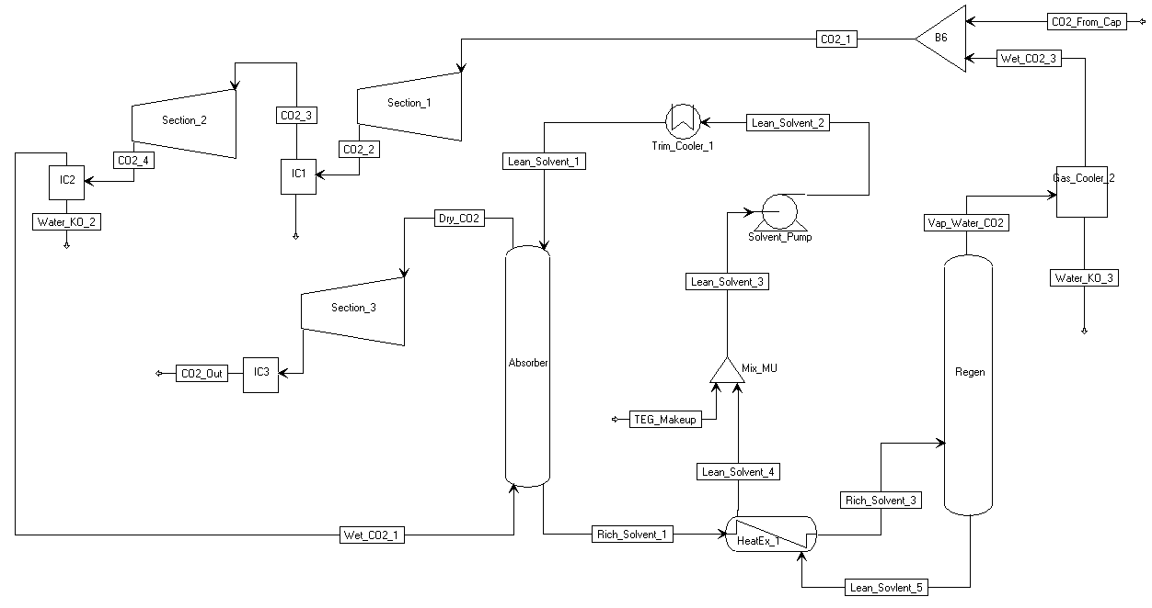

Figure : ACM flowsheet for an inline compressor with drier.

The inline compressor model has the same drying section as the integral gear compressor, but the absorber operates at 710 psia due to its placement in the compressor train. The feed is the same as the integral gear model.

The inline compressor consists of three inline sections. The first section has three stages, the second section has four stages, and the third section after the drier has three stages. There are no intercoolers in inline sections, but there are intercoolers between sections. A gear box between each section allows them to operate at different speeds. The mass flow coefficient for the first stage in each section was set to 0.11, 0.12, and 0.12. The higher mass flow coefficients provide a better efficiency over the whole section.

The compressor speed in the first section is limited by impeller stress. The speed of the second section is limited by the Ma number, and the last section is limited by the maximum rotation speed. The rotation speed of the last section is set to 20,000 rpm. The first and second sections are set to a fraction of the maximum impeller tip speed and Ma number respectively. The fraction of the maximum is calculated to produce the required discharge pressure. The fraction is 0.9964.

1. Results

This section provides some simulation results. First, the simulation results are validated by comparison to typical industrial compressors. Then results for the integral gear and inline compressor configurations are compared for a typical CO2 stream from a solid sorbent process.

* 1. Validation

The compressor model was validated by comparing results to typical industrial integral gear compressors. Four compressors were examined and are summarized in Table 37. The comparison was done in two ways. First (case a), the results were compared with the model compressor stages set to the same diameter and rotation speed as the compressor quotes; in this case, the discharge pressure from the simulation does not necessarily match the quote. In the second comparison (case b), a compressor was designed to produce the specified outlet pressure by setting the mass flow coefficient of every other stage and setting the Ma number of each stage to some fraction of the maximum, which was determined to produce the required discharge pressure; in this case, the rotation speed and diameter do not necessarily match the quotes. Information about intercooling in the last one or two stages was incomplete, which has some effect on the results, most significantly on the discharge temperatures.

Table : Compressor Specifications

| Compressor | Inlet Pressure (psia) | Number of Stages | Discharge P  (psia) |
| --- | --- | --- | --- |
| 1 | 16.7 | 8 | 2216 |
| 2 | 67.0 | 6 | 2216 |
| 3 | 300.1 | 4 | 2216 |
| 4 | 600.2 | 4 | 2216 |

Ninety seven (97)% mechanical efficiency was assumed in all simulations. The compressor quotes included an undisclosed mechanical efficiency. Covered impellers were assumed for stages less than 400 mm in diameter. An intercooler temperature was given in the compressor quotes and was used in the simulations; however, the intercooler temperature for the last stage or two was not provided. In the simulations for the first two compressors, no intercoolers were used before the last stage. In the simulations for the third compressor, no intercooler was used before the last two stages. In the fourth case, no intercooler was included before the last three stages. The overall efficiency was calculated using a stage power weighted average. Table 38 shows the results of the simulations compared to the compressor quotes.

Table : Comparison of Simulations to Compressor Quotes

|  | Power % Err (%) | Discharge P % Err (%) | Discharge T Diff (°F) | Efficiency  Diff (pp) |
| --- | --- | --- | --- | --- |
| 1a | 5.39 | -0.89 | 9.4 | 0.88 |
| 1b | 5.88 | 0.00 | 10.2 | 0.68 |
| 2a | 5.81 | 6.74 | 12.4 | -0.33 |
| 2b | 3.08 | 0.00 | -6.8 | -0.12 |
| 3a | -0.09 | -0.21 | 10.6 | 0.78 |
| 3b | -1.79 | 0.00 | -3.12 | 0.95 |
| 4a | 0.75 | 9.12 | 11.82 | 0.46 |
| 4c | -6.11 | 0.00 | 1.85 | 0.83 |

From Table 38 it appears that the simulation provides reasonable results for the integral gear case. All results are within 10% of the compressor quotes.

* 1. Results for Typical Feed

Two types of compressors, integral gear and inline, were compared for a typical CO2 stream from a solid sorbent capture process at a 650 MW coal-fired power plant. The compressors were assumed to have a combined mechanical/driver efficiency of 97%. Covered impellers were used for stages with diameters less than 400 mm, otherwise open impellers were used. The comparison includes a TEG drying system that reduces the water content of the CO2 to 150 ppm on a mole basis. All intercoolers were assumed to cool to 104°F with a pressure drop of 1.45 psi. The drying system was assumed to have a pressure drop of 5 psi.

Table 39 shows the inlet and outlet conditions of the compressors. The CO2 stream represents half of the total flow from the capture process.

Table : Solid Sorbent Capture, CO2 Stream Conditions

|  | Inlet | Outlet |
| --- | --- | --- |
| Flow Rate (lbmol/hr) | 12,530 | 11,780 |
| Temperature (F) | 104 | 104 |
| Pressure (psia) | 14.68 | 2216 |
| Mole Fraction CO2 | 0.94000 | 0.99985 |
| Mole Fraction Water | 0.06000 | 0.00015 |

Table 40 provides a summary of the simulation results for each type of compressor. Although the compressor designs are not optimized, there should be a reasonable comparison.

Table : Compressor Comparison Summary

|  | Integral Gear | Inline |
| --- | --- | --- |
| Total Power (kW) | 24,972 | 29,717 |
| Average Polytropic Efficiency (%) | 84.7 | 84.0 |
| Total Cooling (kW) | 44,897 | 48,708.2 |
| Dryer Reboiler Duty (kW reboiler at 250°F) | 786 | 1,341 |
| Recoverable Heat (kW above 250°F) | 902 | 23,547.4 |
| CO2 Recycle (%) | 2.25 | 3.0 |

The following two sections provide more detailed information for the two compressors.

Integral Gear

Table 41 summarizes the results of each stage in the integral gear compressor simulation. This simulation is saved as “CompIG.acmf,” which can be accessed for detailed results.

Table : Integral Gear Compressor Stage Summary

| Stage | ηp (%) | Power (kW) | Ts (F) | Td (F) | Ps (psia) | Pd (psia) |
| --- | --- | --- | --- | --- | --- | --- |
| Compress 1 | 85.7 | 4,984.1 | 104.0 | 239.8 | 14.7 | 35.7 |
| Cool 1 | -- | -- | 239.8 | 104.0 | 35.7 | 34.3 |
| Compress 2 | 82.7 | 4,736.2 | 104.0 | 240.2 | 34.3 | 80.0 |
| Cool 2 | -- | -- | 240.2 | 104.0 | 80.0 | 78.5 |
| Compress 3 | 85.7 | 3,739.7 | 104.0 | 215.9 | 78.5 | 162.4 |
| Cool 3 | -- | -- | 215.9 | 104.0 | 162.4 | 160.9 |
| Compress 4 | 84.1 | 3,344.9 | 104.0 | 208.3 | 160.9 | 312.2 |
| Cool 4 | -- | -- | 208.3 | 104.0 | 312.2 | 310.8 |
| Compress 5 | 85.8 | 2,510.1 | 104.0 | 188.7 | 310.8 | 536.0 |
| Cool 5 | -- | -- | 188.7 | 104.0 | 536.0 | 534.6 |
| Compress 6 | 84.3 | 2,162.9 | 104.0 | 184.7 | 534.6 | 888.3 |
| Cool 6 | -- | -- | 184.7 | 104.0 | 888.3 | 886.8 |
| Dry | -- | -- | 104.0 | 104.0 | 886.8 | 881.8 |
| Compress 7 | 85.8 | 1,678.3 | 104.0 | 186.0 | 881.8 | 1,429.6 |
| Compress 8 | 84.1 | 1,815.3 | 189.0 | 259.7 | 1,429.6 | 2,217.5 |
| Cool 8 | -- | -- | 259.7 | 104.0 | 2,217.5 | 2,216.0 |

Inline

Table 42 summarizes the results of each stage in the inline compressor simulation. This simulation is saved as “CompInline.acmf,” which can be accessed for detailed results.

Table : Inline Compressor Stage Summary

| Stage | ηp (%) | Power (kW) | Ts (°F) | Td (°F) | Ps (psia) | Pd (psia) |
| --- | --- | --- | --- | --- | --- | --- |
| Compress 1 | 85.9 | 4,273.5 | 104.0 | 222.2 | 14.7 | 31.6 |
| Compress 2 | 84.3 | 4,462.5 | 222.2 | 338.8 | 31.6 | 61.3 |
| Compress 3 | 80.7 | 4,586.6 | 338.8 | 453.6 | 61.3 | 107.8 |
| Cool 1 | -- | -- | 453.6 | 104.0 | 107.8 | 106.3 |
| Compress 4 | 85.7 | 2,774.0 | 104.0 | 189.3 | 106.3 | 185.3 |
| Compress 5 | 85.5 | 2,890.6 | 189.3 | 274.8 | 185.3 | 307.9 |
| Compress 6 | 83.4 | 2,953.5 | 274.8 | 359.5 | 307.9 | 484.2 |
| Compress 7 | 80.8 | 3,010.3 | 359.5 | 443.2 | 484.2 | 725.3 |
| Cool 2 | -- | -- | 443.2 | 104.0 | 725.3 | 723.8 |
| Dry | -- | -- | 104.0 | 104.0 | 723.8 | 718.8 |
| Compress 8 | 85.7 | 1,545.5 | 119.0 | 186.0 | 718.8 | 1,081.6 |
| Compress 9 | 85.8 | 1,596.6 | 186.0 | 251.3 | 1,081.6 | 1,578.4 |
| Compress 10 | 84.8 | 1,624.4 | 251.3 | 312.9 | 1,578.4 | 2,217.5 |
| Cool 3 | -- | -- | 312.9 | 104.0 | 2,217.5 | 2,216.0 |

1. Dynamic Simulations

The integral gear compressor offers high efficiencies and relatively low power requirements for CO2 compression systems in comparison to the inline compressors. Therefore, integral gear compressors have been considered while developing dynamic models for the off-design conditions. The integral gear design consists of pairs of stages arranged around a central gear. Both stages in a pair operate at the same speed but can have different diameters. Since the rotation speed changes after every other stage, stages can operate near their optimum efficiency. The arrangement of an integral gear compressor also allows intercooling after every stage, which significantly reduces the power requirement. At high pressure, intercooling is reduced or not used at all to avoid liquefaction of CO2. Due to the intercooling, temperatures do not generally get high enough to recover compression heat for use in other parts of the process. The high pressure discharge stream from the compressor is cooled in a water cooler and then sent to a flash drum to separate water from the gas stream. The Aspen Plus blocks of heater and flash drum are imported into the ACM for this purpose. For each compressor stage, a recycle valve has been modeled. A portion of the vapor stream coming from the flash vessel is used as the recycle stream to the compressor inlet. During the normal operating conditions, these valves remain closed. It is assumed that the flow rate of the recycled CO2 stream to the compressor inlet is regulated by throttle valves. Equation 14 is used to model these valves (Turton, et al., 2012).

|  |  |
| --- | --- |
| $$Q=C_{v}f(x)\sqrt{\frac{∆P}{ρ}}$$ | (14) |

In the above equation, $Q$ represents the volumetric flow rate, $C_{v}$ represents the valve coefficient, $f(x)$ is the inherent flow characteristic of the valve, $∆P$ is the pressure drop across the valve, and $ρ$ is the density of the flowing stream. Valve coefficients are calculated assuming 50% opening and 15 psi pressure drop at the surge condition. In real life systems, quite often a quick acting valve is used when the compressor is at close proximity to the surge limit line, while an equal percentage valve is used when the compressor operates above the surge control line. It can be noted that $f\left(x\right)=√x$ for a quick opening valve and $f\left(x\right)=D^{x-1}$ for an equal percentage valve, where *D* is a design parameter. The TEG drying system was modeled to remove the water further. The absorber and regenerator consist of packed columns.

* 1. Performance Curves

The performance curves received from a commercial vendor as per specifications have been used. The extracted data from the performance curves have been converted into dimensionless exit flow coefficient (Ψ3) and non-dimensional impeller isentropic head coefficient (Ψs) so the performance curves can be applied to wide variations in Ma number and inlet operating conditions (Lüdtke, 2004). The CO2 compression system model is updated to evaluate the same dimensionless numbers.

The experimental performance curves contained the data of suction flow rate and discharge pressure. For the first stage, the performance curves have been provided with inlet guide vanes (IGV) for regulating the load. For all the other stages, the curves are without IGV.

The dimensionless exit flow coefficient is calculated using the suction flow rate (Vs) (Equations 15–17)

|  |  |
| --- | --- |
| $$φ_{3}=\frac{\dot{V_{3}}}{πd_{2}b_{2}u_{2}}$$ | (15) |

where, $\dot{V_{3}}$ = Static volumetric flow rate at impeller exit (m3/s)

= Impeller diameter (m)

$b_{2}$ = Impeller exit width (m)

$u_{2}$ = Impeller tip speed (m/s)

$\dot{V_{3}}$ can be calculated based on suction flow rate

|  |  |
| --- | --- |
| $$\dot{V_{3}}=\dot{V_{s}}\frac{z_{d}T_{d}P_{s}}{P_{d}z_{s}T_{s}}$$ | (16) |

where, $\dot{V_{s}}$ = Static volumetric flow rate at the suction (m3/s)

$z_{s}$, $z_{d}$ = Compressibility factor at suction and discharge respectively (dimensionless)

$P_{s}$, $P_{d}$ = Pressure at suction and discharge respectively (bar)

$T_{s}$, $T_{d}$ = Temperature at suction and discharge respectively (K)

|  |  |
| --- | --- |
| $$T_{d}=T_{s}{\left(\frac{P_{d}}{P_{s}}\right)}^{\frac{k-1}{kη}}$$ | (17) |

where, $k$ = Isentropic volume exponent (dimensionless)

$η$ = Polytropic impeller efficiency (dimensionless)

The dimensionless isentropic head coefficient is calculated using the pressure ratio (Lüdtke) (Equations 18–19)

|  |  |
| --- | --- |
| $$φ_{s}=\frac{{2y}_{s}}{u_{2}^{2}}$$ | (18) |

where, $y_{s}$ = Isentropic head = $z_{s}RT_{s}\frac{k}{k-1}\left({\left(\frac{P_{d}}{P_{s}}\right)}^{\frac{k-1}{k}}-1\right)$ (19)

The impeller diameter and tip speed are calculated by using the code developed previously. The dimensionless performance curves are shown below. Figure 76 represents the performance curves of Stage 1 for different IGV openings. The legends in the figure represent the angle of the vanes. The X-axis represents the dimensionless inlet flow coefficient and the Y-axis represents the dimensionless isentropic head coefficient. For all the performance curves, correlations have been developed between $φ_{3}$ and $φ_{s}$ using the curve fitting tool box in MATLAB® (Equation 20). The form of the correlation developed is

|  |  |
| --- | --- |
| $$φ_{s}=Aφ_{3}^{2}+Bφ_{3}+C$$ | (20) |

where, A, B, and C are the estimated fitting parameters. The model results match well with the experimental values. The estimated parameters for all the angles are shown in Table 43.

Table : Estimated Parameters for Stage 1

| Angle | A | B | C | R2 |
| --- | --- | --- | --- | --- |
| -15 | -40.73 | 8.019 | 0.8982 | 0.9986 |
| 0 | -38.87 | 7.161 | 0.9519 | 0.999 |
| 15 | -37 | 6.175 | 1.015 | 0.9989 |
| 30 | -36.43 | 5.384 | 1.063 | 0.9983 |
| 40 | -36.65 | 4.703 | 1.113 | 0.9985 |
| 50 | -40.02 | 4.479 | 1.132 | 0.9984 |
| 60 | -68.55 | 9.451 | 0.8549 | 0.9999 |
| 70 | -127.6 | 18.04 | 0.4634 | 0.9996 |
| 75 | -191.1 | 26.35 | 0.1425 | 0.9996 |



Figure : Dimensionless performance curves for Stage 1.

The load can be controlled by manipulating the angle of IGV in the first stage. For this purpose, correlations have been developed between angle and A, B, and C (Equation 21). The proposed correlations are of the form

|  |  |
| --- | --- |
| $$y=ae^{bx}+ce^{dx}$$ | (21) |

where, y = A/B/C and x = angle and a, b, c, and d are the estimated parameters. The estimated parameters for the above correlation are shown in Table 44.

Table : Estimated Parameters for Correlation 21

| y | a | b | c | d |
| --- | --- | --- | --- | --- |
| A | -38.46 | -0.005098 | -0.1043 | 0.09821 |
| B | 6.863 | -0.01329 | 0.02018 | 0.09443 |
| C | -0.00891 | 0.06757 | 0.9661 | 0.006228 |

A similar estimation technique is followed for other stages. The regressed parameters corresponding to Equation 20 are shown in Table 45.

Table : Estimated Parameters for Stages 3, 5, and 7

| Stage | A | B | C | R2 |
| --- | --- | --- | --- | --- |
| 3 | -33.47 | 6.619 | 0.9557 | 0.9994 |
| 5 | -28.5 | 6.457 | 0.9217 | 0.9996 |
| 7 | -16.04 | 4.986 | 0.6715 | 0.9998 |

* 1. Surge Line

Surge condition is one of the undesirable operating conditions of the compressor. The flow would be reversed under surge conditions. Due to fluctuations in pressure and flow, the compressor operation becomes unstable. Hence, for smooth operation, the suction flow rate should be away from the surge limit line. In general, the minimum suction flow rate is about 10% away from the surge line. This line on the performance curve is called the surge control line. If the operating suction flow crosses this point, it indicates that the system is approaching the surge point. Under these conditions, the recycle valves will be opened to recycle some of the flow to the suction so the system moves away from the surge. To detect the surge approach conditions of a compressor, a robust algorithm is needed so the control system takes the action quickly (Equation 22). The condition for the system surge is

|  |  |
| --- | --- |
| $$\frac{∂}{∂\dot{V}}\left({P_{d}}/{P_{s}}\right)=0$$ | (22) |

For a more generalized form, the above equation is represented in the dimensionless parameters (Equation 23). The surge point in terms of the dimensionless parameters is

|  |  |
| --- | --- |
| $$\frac{∂φ_{s}}{∂φ_{3}}=0$$ | (23) |

As the first stage of the compressor is with IGVs, surge conditions vary depending on the IGV angle. These points can be represented on a straight line (Equation 24). The equation of the surge line for the first stage is

|  |  |
| --- | --- |
| $$φ_{s}=3.684281φ_{3}+0.9051$$ | (24) |

For all the other stages, the surge condition is just a point. PID controllers with gain scheduling have been designed for surge control. For these controllers, controlled variable is proximity to surge, and the manipulated variable is the recycle valve opening (Equation 25). The proximity to surge (PS) is defined as:

|  |  |
| --- | --- |
| $$PS=\frac{φ_{3}^{op}-φ_{3}^{*}}{φ_{3}^{*}}$$ | (25) |

where, $φ_{3}^{*}$ = Dimensionless inlet flow coefficient at surge point

$φ_{3}^{op}$ = Dimensionless inlet flow coefficient at the current operating point

The gain-scheduling controller was developed using an adaptive -tracker control law (Ilchman, 1993, and Ilchman and Ryan, 1994). This law drives the output to zero with a prescribed tolerance level. This tolerance is introduced together with a dead zone since no action is needed, as *PS(t)* moves beyond the surge control line. First the following function is defined (Equation 26):

|  |  |
| --- | --- |
|  | (26) |

Then the following adaptive control law is applied (Equation 27):

|  |  |
| --- | --- |
|  | (27) |

Here *k(t)* is the adaptive gain and represents the adaptation speed.

ACM Dynamic Simulation

1. Open the folder named “CO2_COMPRESSION_SYSTEM/Dynamic.”
2. Load “CompIG.acmf.”
3. The first time the model is loaded in a machine, it does not know the path to the properties file. A message displays that reads: “Unable to load file. Do you want to edit properties?” Click “Yes.” This opens a window with a number of options for the properties file. Click “Use Properties Definition File” under “Use Aspen Property System” option. At the next dialog, browse to the folder “CO2_COMPRESSION_SYSTEM/Dynamic/,” select the file named “teg4dyn,” click “Open,” and then click “OK.” This opens the “Physical Properties Configuration” window. The properties status shown at the bottom of this window should be green. Click “OK.” Now the ACM model should load.
4. When the file is loaded, it will issue the following warning in the message window:   
   “159: Upper as IntegerParameter; Warning at position 7……….” This warning can be disregarded as “Upper” has not been used as a variable inside any model, but simply a Global variable that simply appears in the AllGlobals table.
5. Load snapshot “Initial.”
6. Run → “Dynamic.”
7. A warning is issued in the message window:   
   “Warning: Eq_2092_Blocks(“Stripper”).BackFlow.F is near singular, ……” This warning is generated from the Stripper block, which is an Aspen native RadFrac block and by default has these variables for calculating backflow if reverse flow is active. Since reverse flow is not considered in these models, this warning can be safely ignored.
8. Navigate to “Flowsheet” → double-click the plots “Pressure,” “Flow,” “Temperature,” etc.

In the following example, the dynamic model mentioned above is augmented with a script to automatically initiate a ramp change in CO2 flow rate.

Dynamic Simulation Example: Ramp Change in Inlet Flow Rate

1. Open “CO2_COMPRESSION_SYSTEM/Dynamic/Example_Flowrate.”
2. Load “CompIG.acmf.”
3. The first time the model is loaded in a machine, it does not know the path to the properties file. It displays a message that reads: “Unable to load file. Do you want to edit properties?”. Click “Yes.” This opens a window with a number of options for the properties file. Click “Use Properties Definition File” under “Use Aspen Property System” option. At the next dialog, browse to the folder “CO2_COMPRESSION_SYSTEM/Dynamic/Example_Flowrate,” select the file named “teg4dyn,” click “Open,” and then click “OK.” This opens the “Physical Properties Configuration” window. The properties status shown at the bottom of this window should be green. Click “OK.” Now the ACM model should load.
4. As before, when the file is loaded, it will issue the following warning in the message window: “159: Upper as IntegerParameter; Warning at position 7……….” This warning can be disregarded as “Upper” has not been used as a variable inside any model, but simply a Global variable that simply appears in the AllGlobals table.
5. Load snapshot “Initial.”
6. Run → “Dynamic” (Ramp change in flow rate starts at 10 hrs and ends at 13hrs. Simulation stops at 50 hrs.).
7. A warning is issued in the message window: “Warning: Eq_2092_Blocks(“Stripper”).BackFlow.F is near singular, ……” This warning is generated from the Stripper block, which is an Aspen native RadFrac block and by default has these variables for calculating backflow if reverse flow is active. Since reverse flow is not considered in these models, this warning can be safely ignored.
8. Navigate to “Flowsheet” → double-click the plots “Pressure,” “Flow,” “Temperature,” etc.
9. Observe the following plots in Figures 77–80.

Pressure



Figure : ACM dynamic simulation example: Ramp change in inlet flow rate, pressure plot.

Flow Rate



Figure : ACM dynamic simulation example: Ramp change in inlet flow rate, flow rate plot.

Temperature



Figure : ACM dynamic simulation example: Ramp change in inlet flow rate, temperature plot.

Electric Power



Figure : Dynamic simulation example: Ramp change in inlet flow rate, electric power plot.

gPROMS Dynamic Simulation

1. Open the folder named “CO2_COMPRESSION_SYSTEM/DYNAMICS/gPROMS/Flowrate_example.”
2. Open “Comp_CO2_ramp.gpj.”
3. The compressor model utilizes the built in PML libraries in gPROMS. Navigate to “File” → “Open/Close Libraries.” A window opens with a list of available models. Select the “PML libraries” check box and then click “OK.”
4. In the “project tree” on the left, navigate to “Comp_CO2_ramp” models and then double-click “CO2_process_flowsheet_full” (see Figure 81).

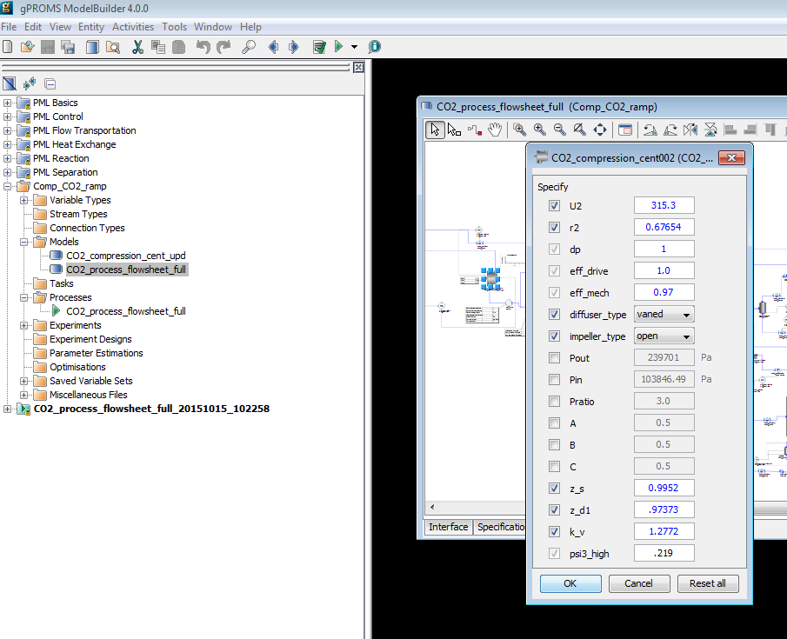

Figure : Specification box for compressor model. The process flowsheet model “CO2_process_flowsheet_full” is highlight in the “project tree” menu on the left.  
Note: Specifying the required variables is done by double-clicking each piece of process equipment under the “Topology” tab of the “CO2_process_flowsheet_full” window.  
These values are set to default values.

1. Run the model by clicking “Play” (the green button on the top of the toolbar). The “Simulate” option menu displays. Be sure the check box for “Use steady-state initial conditions” is cleared (see Figure 82). The model is setup to automatically select initial conditions. Additionally, be sure to select the “Send results trajectory to gRMS” check box. This sends the results of the simulation to gPROMS data management software, where templates for plotting the results have already been provided. Lastly, ensure that the “Ignore schedule and intrinsic tasks” check box is left cleared. This runs the schedule already set up (it introduces a disturbance) which can be viewed by opening the “CO2_process_flowsheet_full” under the “Processes” folder in the “project tree” and then navigating to the “Schedule” tab. Select the check box to run a   
   steady-state simulation. The disturbance configured is a decrease of inlet flue gas by closing the valve opening.

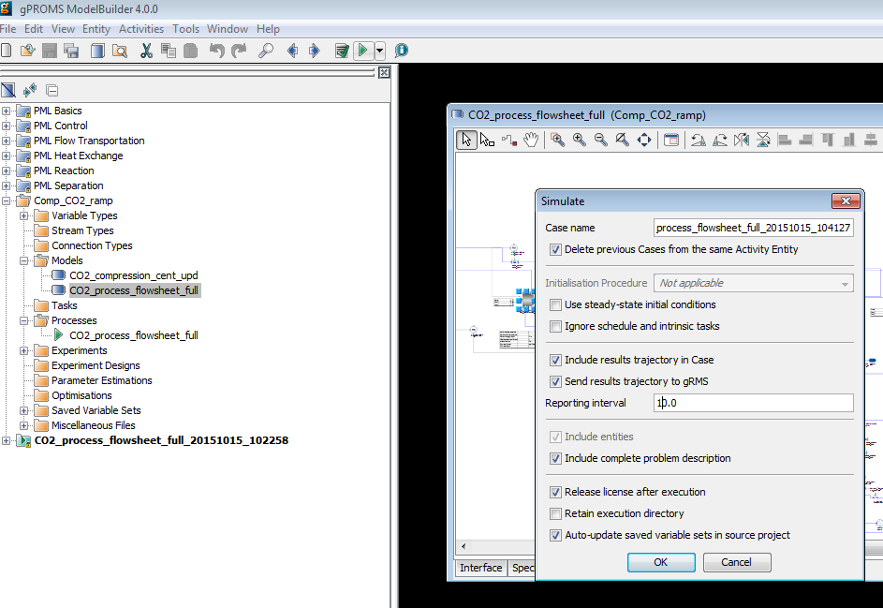

Figure : Click “Play” (the green arrow on the top toolbar while the “CO2_process_flowsheet_full Model” window is open). This opens the “Simulate” window. The “Initialisation Procedure”  
drop-down menu enables the user the option to run the initialization procedure.

1. Click “OK” on the “Simulate” options window to begin the simulation.
2. A new results window displays (listed at the bottom of the “project tree”).
3. A ramp change occurs at 10,000s and the simulation time is 107,200s.
4. To view results, navigate to the “gRMS” window that displayed once the simulation is running. gRMS is a data management program with numerous options and the ability to save a template for the plots, allowing plots to be generated quickly for new simulation results. Four of these templets’ have been provided as “.gpt” files; “elect_power.gpt,” “temperature.gpt,” “pressure.gpt,” and “inlet_gas_flowrate.gpt.” In the “gRMS” window, navigate to “Graph” → “Open Template” and then select the desired template that has been provided. A window displays asking to specify what results the user would like to plot (see Figure 83). Select the “CO2_process_flowsheet_fullxxxxxx_xxxxx” data that is currently being generated. The results will be plotted. Assuming the simulation has not completed running yet, the plots will automatically update as the simulation is solved in gPROMS.

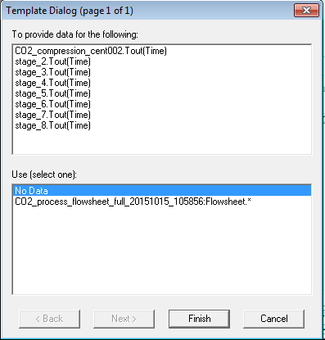

Figure : Data selection window for gRMS template.

**Note:** Results can also be viewed by navigating to the “Trajectories” → “Flowsheet” folder in the results file that is generated at the bottom of the “project tree.” Simply navigate to the desired variable within the flowsheet.

1. When the simulation completes, the results of each template provided are given in Figures 84–87.

Pressure



Figure : gPROMS dynamic simulation example: Ramp change in inlet flow rate, pressure plot.

Inlet Gas Flowrate



Figure : gPROMS dynamic simulation example: Ramp change in inlet flow rate, flow rate plot.

Temperature

Figure : gPROMS dynamic simulation example:  
Ramp change in inlet flow rate, temperature plot.

Electric Power



Figure : gPROMS **dynamic** simulation example: Ramp change in inlet flow rate, electric plot.

1. References

Aungier, R.H. (2000), “Centrifugal Compressors: A Theory for Aerodynamic Design and Analysis,” ASME Press, NY.

Ilchman, A. (1993), “Non-Identifier-Based High-Gain Adaptive Control,” Springer, NY.

Ilchman, A., and Ryan, E.P. (1994), “Universal -Tracking for Nonlinearly Perturbed Systems in the Presence of Noise,” Automatica, 30, 337-346.

Kohl, A.L., and Nielson, R. (1997), “Gas Purification,” 5th Ed., Gulf Publishing Company, Houston, TX.

Lüdtke, K.H. (2004), “Process Centrifugal Compressors: Basics, Function, Operation, Design, Application,” Springer, Berlin.

Lüdtke, K.H., “Twenty Years of Experience with a Modular Design System for Centrifugal Process Compressors,” Proceeding of the Twenty-First Turbomachinery Syposium.

Mallen, M., and Saville, G. (1977), “Polytropic Processes in the Performance of Prediction of Centrifugal Compressors,” Institute of Mechanical Engineers, Paper No. C183/77.

Span, R., and Wagner, W. (1996), “A New Equation of State for Carbon Dioxide Covering the Fluid Region from the Triple-Point Temperature to 1100 K at Pressures up to 800 MPa,” *Journal of Physical Chemistry Reference Data*, v25, 1509-1596.

Turton, R., Bailie, R.C., Whiting, W.B., Shaeiwitz, J.S., Bhattacharyya, D. (2012), “Analysis, Synthesis and Design of Chemical Processes,” 4th Edition, Prentice Hall, 2012.

U.S. Department of Energy (2010), “Cost and Performance Baseline for Fossil Energy Plants Volume 1: Bituminous Coal and Natural Gas to Electricity,” DOE/NETL-2010/1397.

Weibe, R., and Gaddy, V.L. (1941), “Vapor-Phase Composition of Carbon Dioxide Water Mixtures at Various Temperatures and Pressures to 700 Atmospheres,” *Journal of the American Chemical Society*, v63, 475-477.